**PURCHASE JOURNAL (PENDING)**

Listed in the *Figure 1* are the Purchase Invoices from the **Purchase Invoice Module**. These Items are to be reviewed and posted as Purchase Journal in Accounting.

**Figure 1**

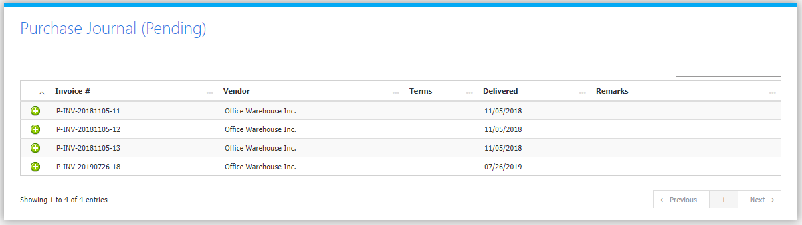

Clicking the **+ Butto**n will open the transaction. The Review Journal Tab *(Figure 2)* shows the Debit and Credit Entries and the Amounts. The Transaction Tab *(Figure 3)* shows the details of the Original Transaction. The Fixed Asset Tab *(Figure 4)* shows the Fixed Assets of the Invoice.

**Figure 2**

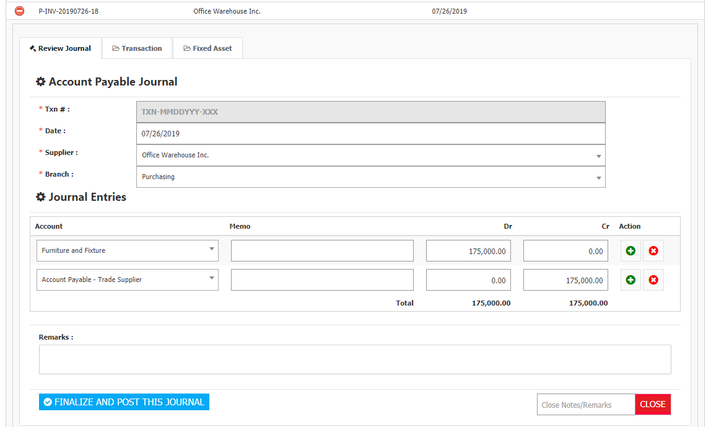

Adjust the details to your preference then click **Finalize and Post this Journal** **Button** to post the Transaction to Accounting. If you do not want to post the transaction to accounting, click the **Close Button** leaving a note in the form input field on its left.

**Figure 3**

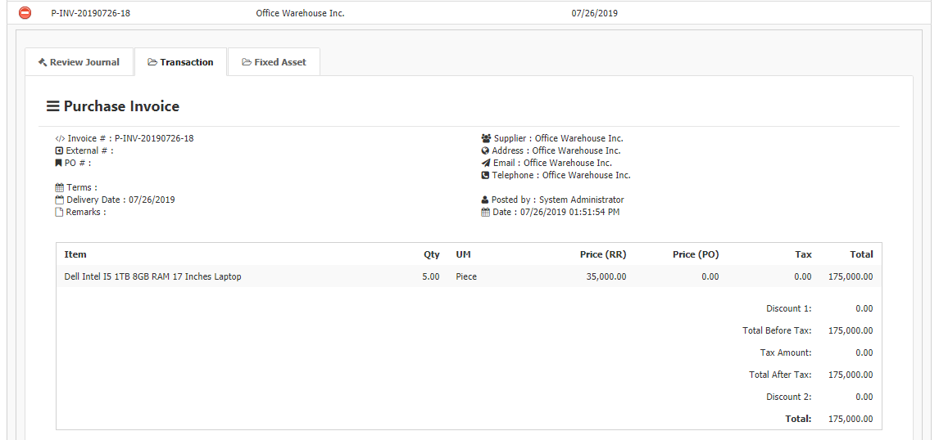

**Figure 4**

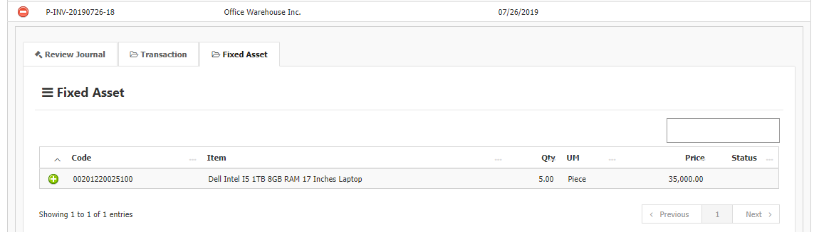

The System can detect if certain products purchased are Fixed Asset. In the **Fixed Asset Tab**, fixed assets are shown. Clicking the **+ Button** will show the details of the Product as shown in *Figure 5*.

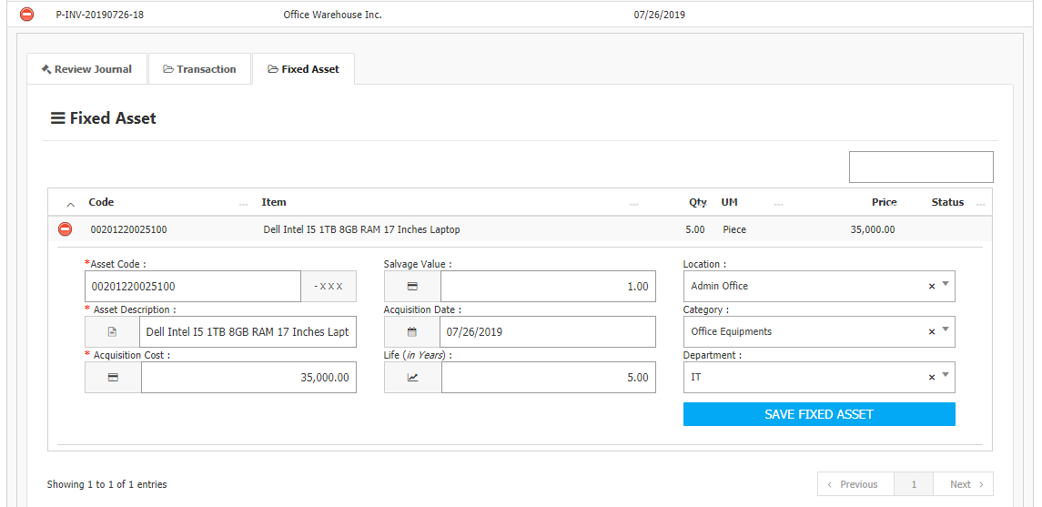

Fill up all the fields then click the **Save Fixed Asset Button** to automatically generate and add the Product on the **Master List** of the Fixed Assets which can be found in the **Asset Management Menu -> Fixed Asset Management** as shown in *Figure 6.* The system will generate and add the product depending on the *quantity* of the item. In this case, the system generated five (5) assets of the *Dell Intel I5 1TB 8GB RAM 17 Inches Laptop* having its own unique *Asset Code.*

**Figure 6**

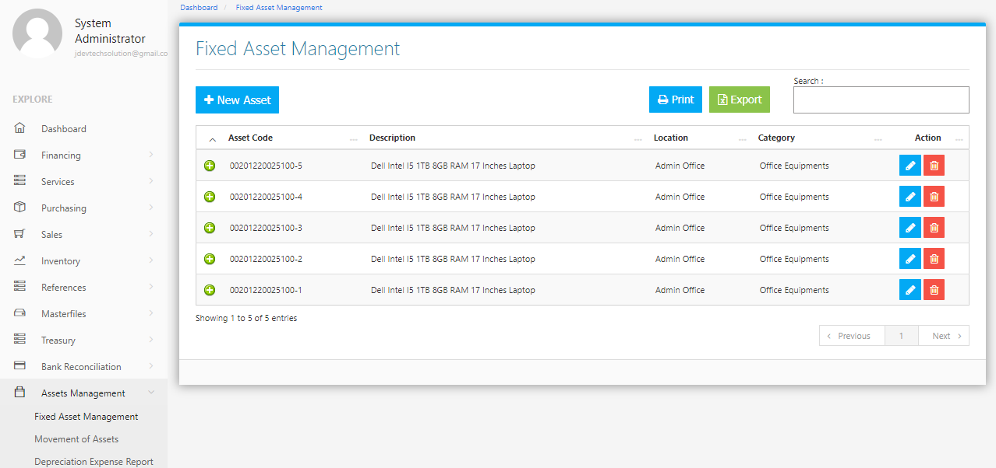

The system detects which products are Fixed Assets depending on the setup of the Product in the **Masterfiles Menu -> Product Management** as shown in *Figure 7*. Assign the appropriate **Fixed Asset Account Title** to the *Link to Debit Account (For Purchase Journal)* part of the Form. In this case, the Account Title chosen is *Furniture and Fixture*.

**Figure 7**

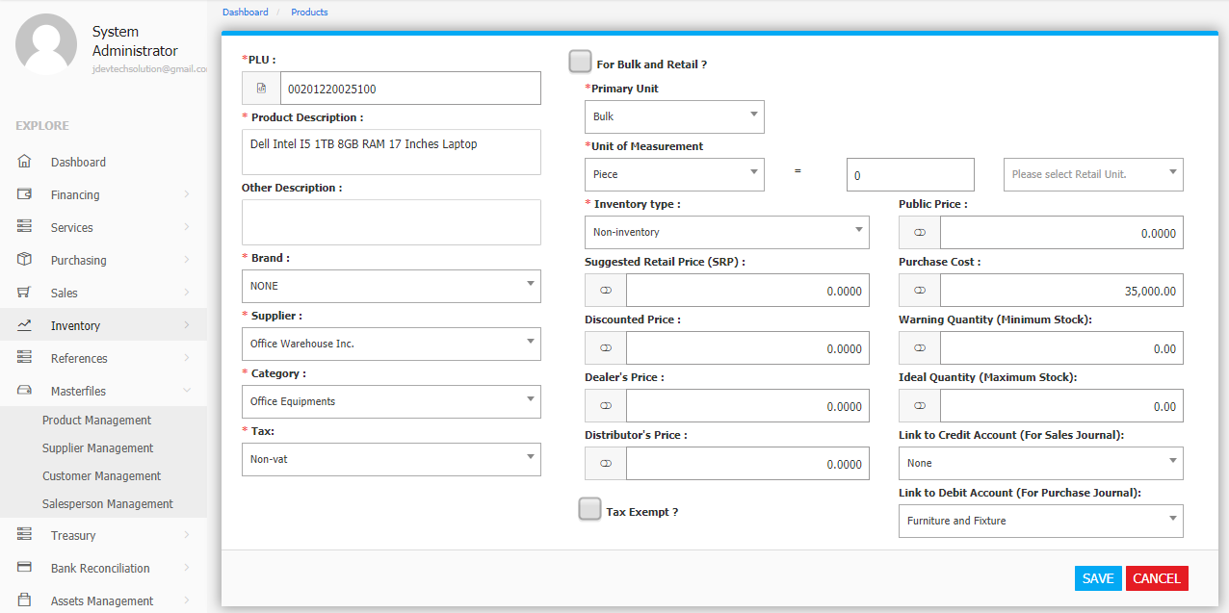

If you have more than one **Account Title** for Fixed Assets, you can set them up in **Settings -> Fixed Asset Settings** as shown in *Figure 8.* Check the Appropriate Account Titles to be regarded as Fixed Assets. In this case, **products** which are set up with the account titles of *Furniture and Fixture, Kitchen Equipment, Computer and Electronic Equipment, or Office Materials* for the ***Link to Debit Account (For Purchase Journal)***, will be regarded as fixed assets.

**Figure 8**

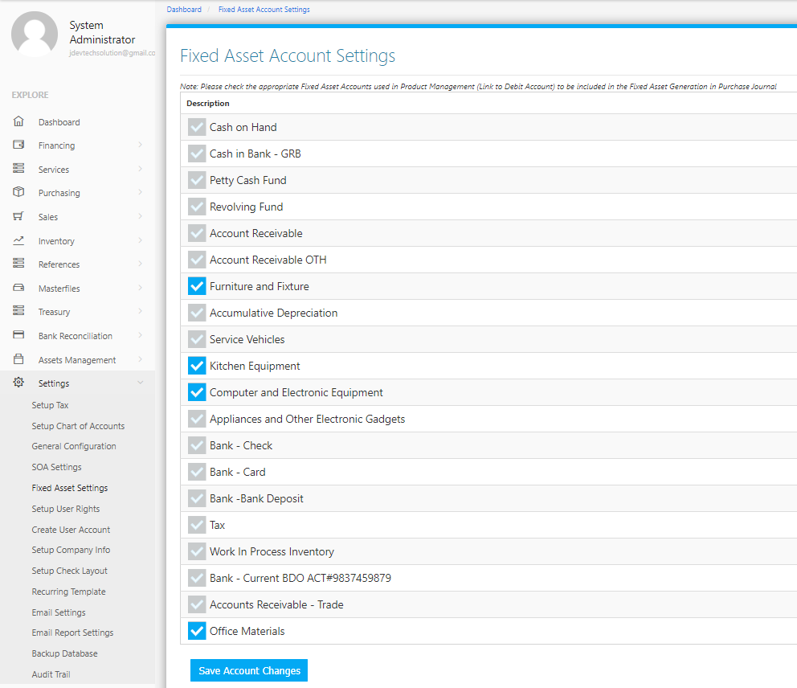

**Purchasing Flowchart**

