**REVIEW COLLECTION (PENDING)**

Listed in the *Figure 1* are the Collections recorded from the **Collection Entry Module** (Payments from the Customers which have an Outstanding Receivable recorded from the *Sales Journal / Accounts Receivable Module*). These Items are to be reviewed and posted as a Cash Receipt Journal in the Accounting.

**Figure 1**

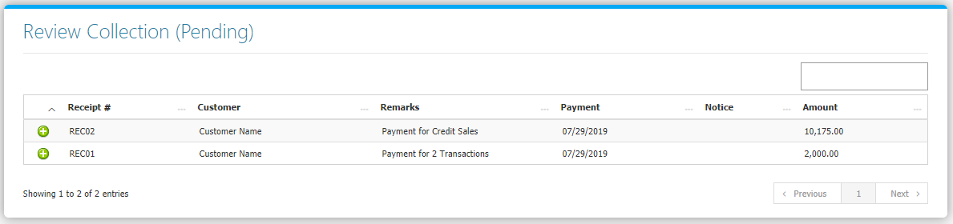

Clicking the **+** **Button** will open the transaction. The **Review Journal** **Tab** *(Figure 2)* shows the Debit and Credit Entries and the Amounts. The **Payment Tab** *(Figure 3)* shows the details of the Original Transaction. Adjust the details to your preference then click **Finalize and Post this Journal** **Button** to post the Transaction to Accounting.

**Figure 2**

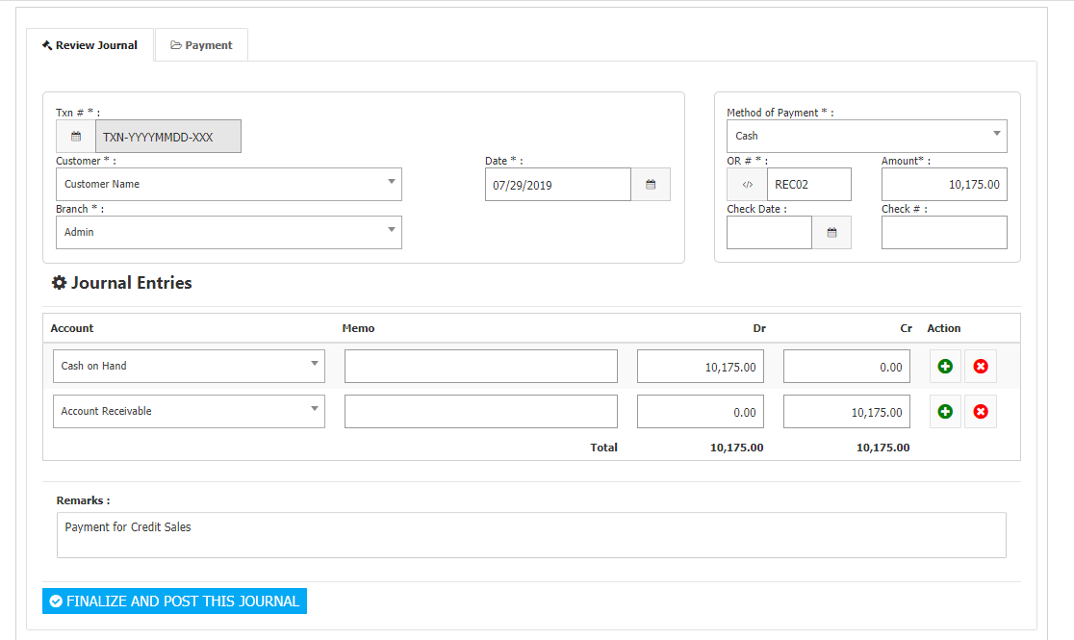

**Figure 3**

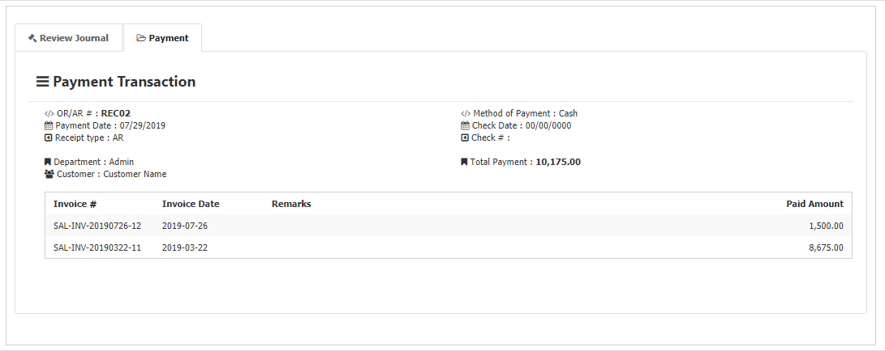

**Sales Flowchart**

