**REVIEW EXPENSE (PENDING)**

Listed in the *Figure 1* are the Payments recorded from the **Record Payments Module** (Payments to the Suppliers which have an outstanding Payable recorded from the *Purchase Journal / Accounts Payable Module*). These Items are to be reviewed and posted as a Cash Disbursement Journal in the Accounting.

**Figure 1**

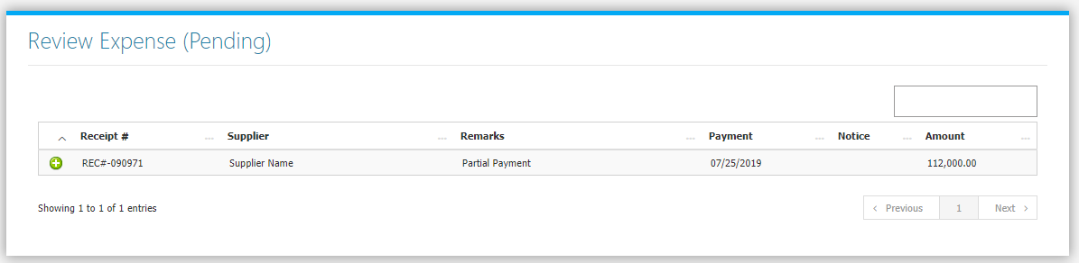

Clicking the **+** **Button** will open the transaction. The **Review Journal** **Tab** *(Figure 2)* shows the Debit and Credit Entries and the Amounts. The **Payment Tab** *(Figure 3)* shows the details of the Original Transaction.

**Figure 2**

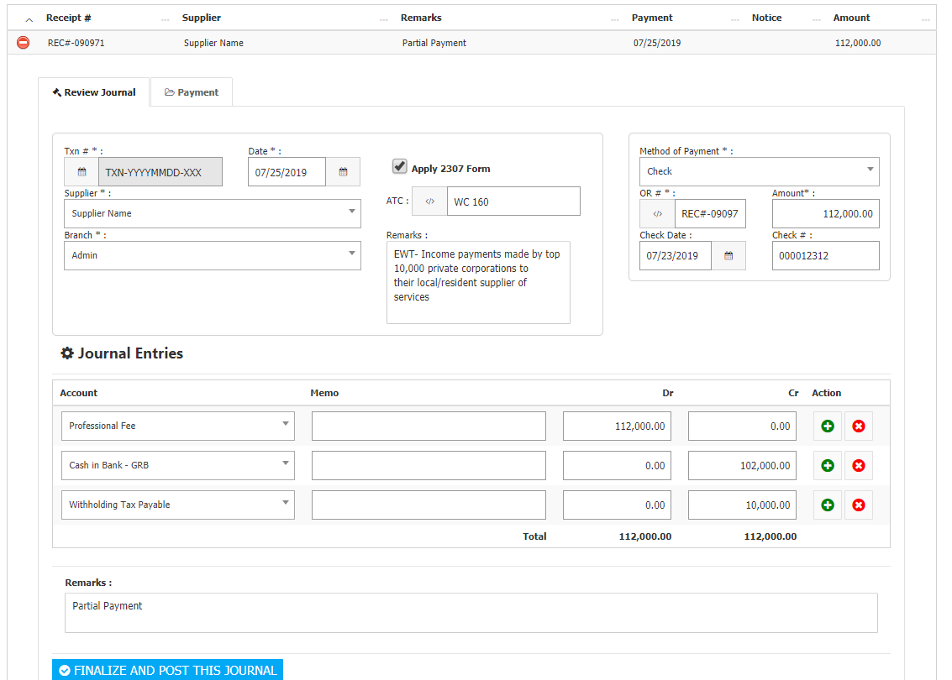

If you choose *Check* as the Payment Method, fill up the *Check Date* and *Check Number* Input Fields. If you wish to generate a **BIR FORM 2307**, click *Apply 2307 Form*, Enter the ATC, and Remarks details. Adjust the details to your preference then click **Finalize and Post this Journal** **Button** to post the Transaction to Accounting.

**Figure 3**

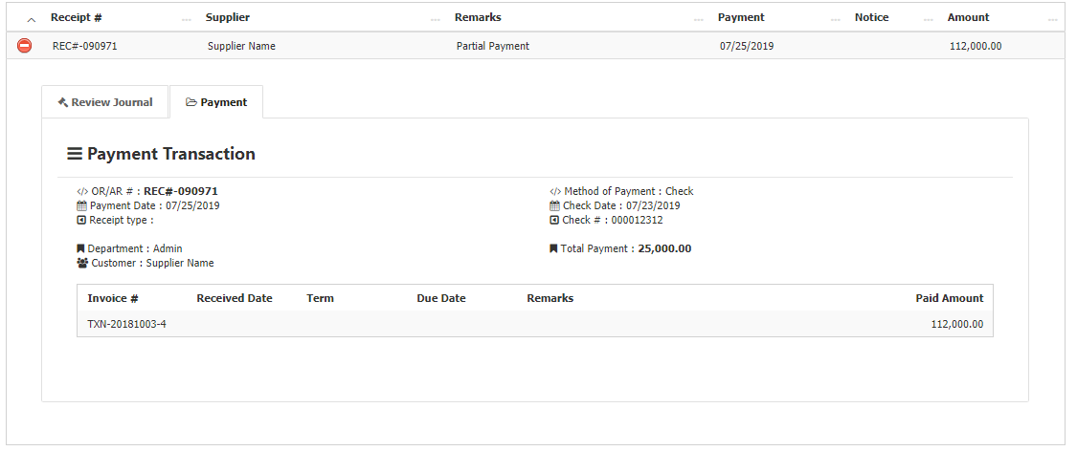

The list of Generated **BIR Form 2307** can be found in the **BIR FORMS Menu -> 2307**. Choose desired Month and Year to filter the shown list *(Figure 4)*.

**Figure 4**

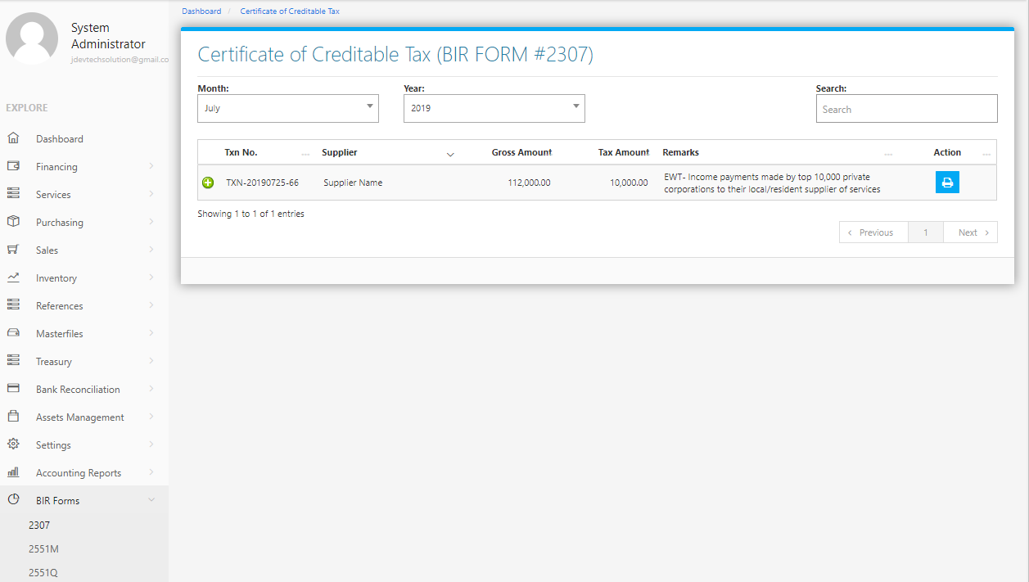

Clicking the **+ Button** will open the Transaction/Voucher as shown in *Figure 5.* TheVoucher can be printed.

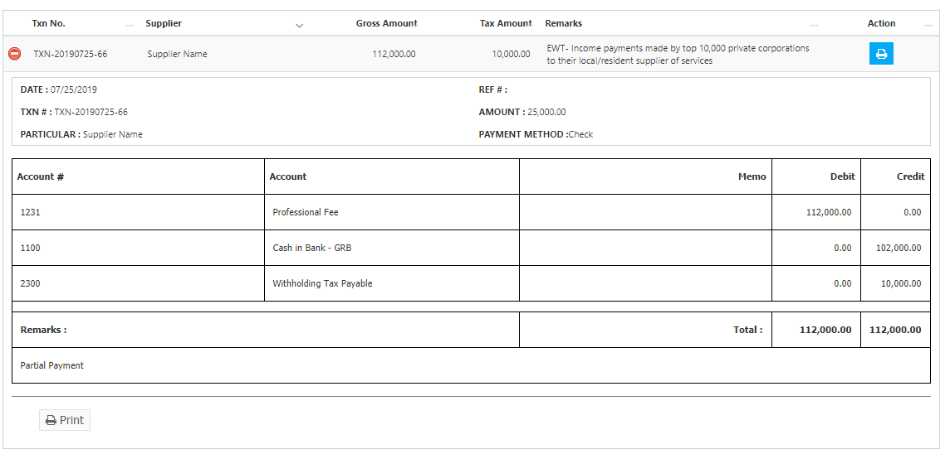

Clicking the **Print Button** located at the right side will print the 2307 Form together with the details of the transaction as shown in the *Figure 6* which can be printed and saved as a PDF File.

**Figure 6**

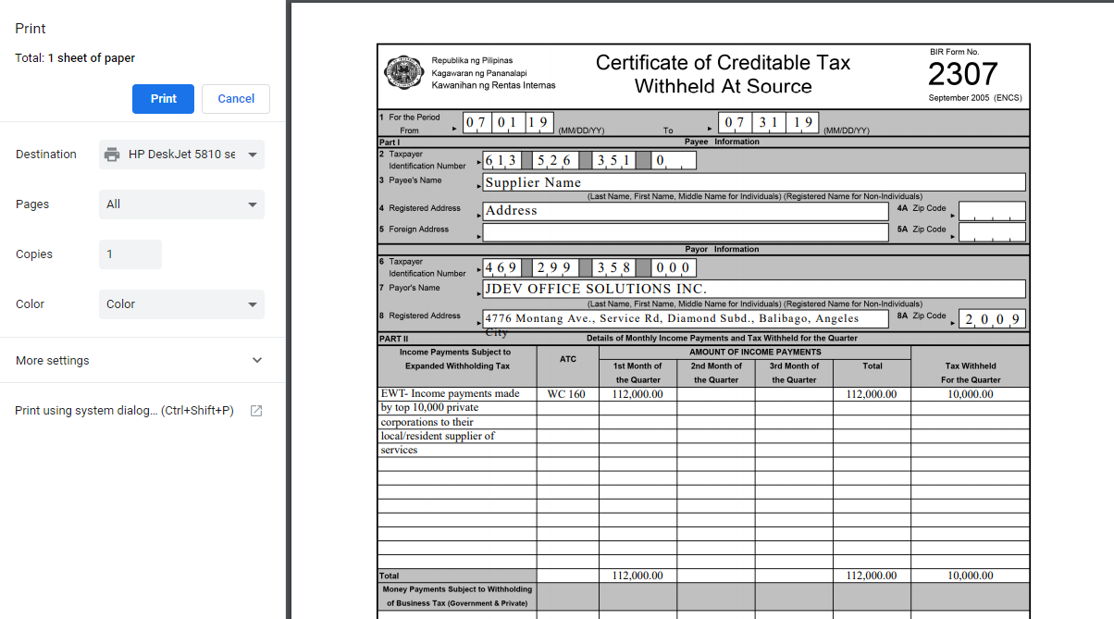

**Purchasing Flowchart**

