**REVIEW GENERAL JOURNAL (ITEM TRANFER)**

Listed in the *Figure 1* are the Invoice Entries from the **Item Transfer Module** (Issuances of Stocks to a Department). These Items are to be reviewed and posted in Accounting.

**Figure 1**

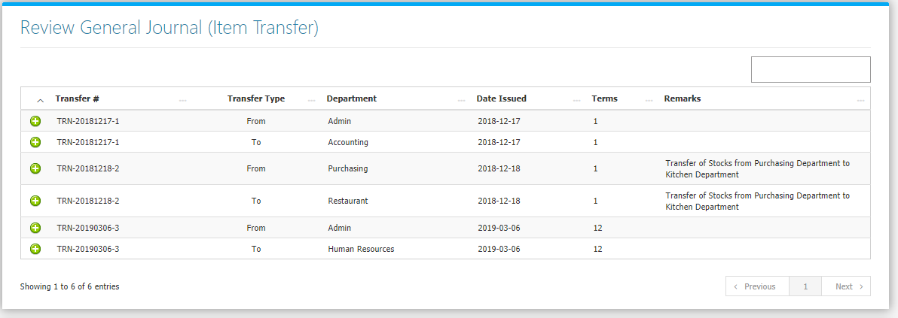

Clicking the **+ Button** will open the transaction. The **Review Journal** **Tab** *(Figure 2)* shows the Debit and Credit Entries and the Amounts. The **Transaction Tab** *(Figure 3)* shows the details of the Original Transaction.

**Figure 2**

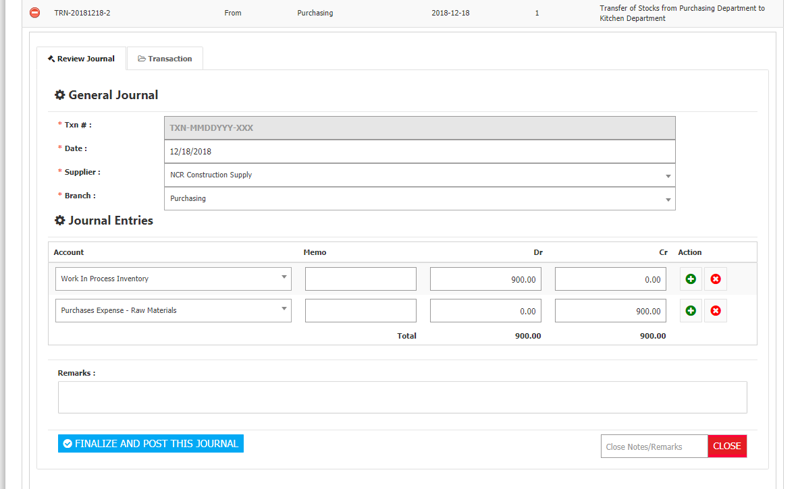

Adjust the details to your preference then click **Finalize and Post this Journal** **Button** to post the Transaction to Accounting. If you do not want to post the transaction to accounting, click the **Close Button** leaving a note in the form input field on its left.

**Figure 3**

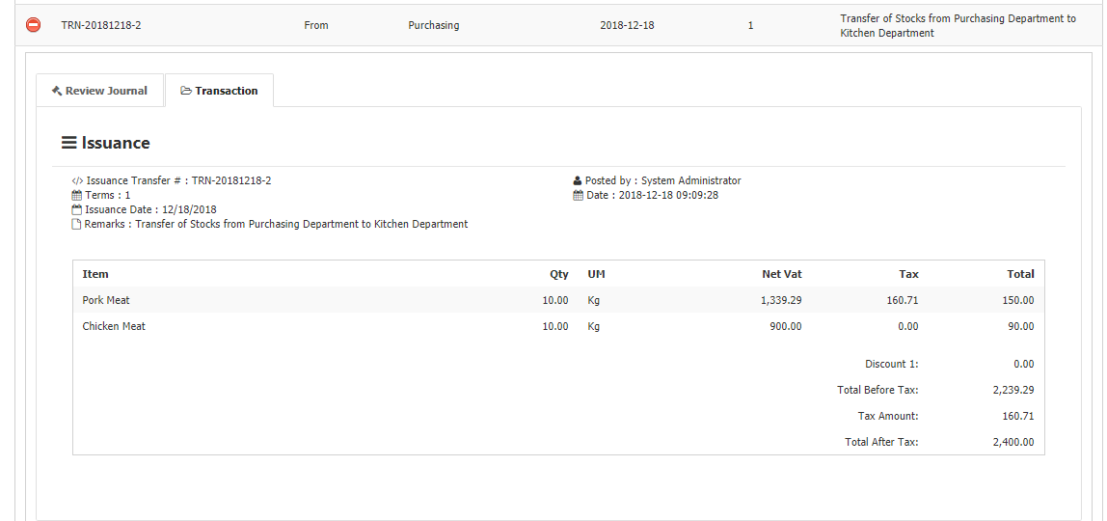

**Issuances Flowchart**

