**REVIEW SALES JOURNAL (PENDING)**

Listed in the *Figure 1* are the Sales Invoices (Credit Sales) from the **Sales Invoice Module**. These Items are to be reviewed and posted as Accounts Receivable / Sales Journal in Accounting.

**Figure 1**

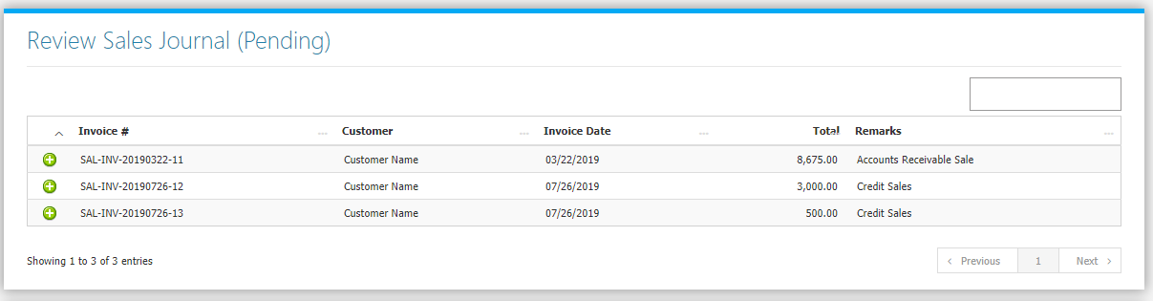

Clicking the **+ Butto**n will open the transaction. The Review Journal Tab *(Figure 2)* shows the Debit and Credit Entries and the Amounts. The Transaction Tab *(Figure 3)* shows the details of the Original Transaction.

**Figure 2**

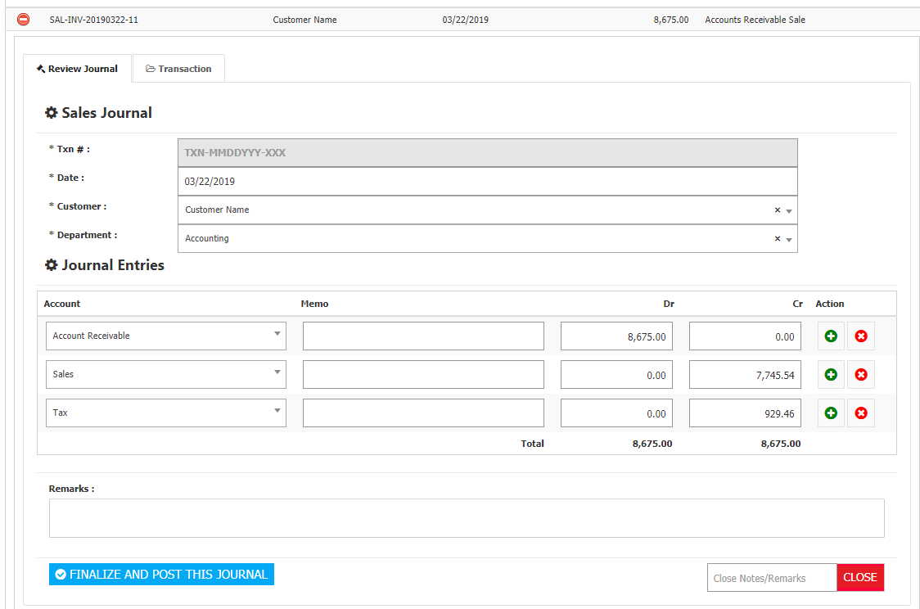

Adjust the details to your preference then click **Finalize and Post this Journal** **Button** to post the Transaction to Accounting. If you do not want to post the transaction to accounting, click the **Close Button** leaving a note in the form input field on its left.

**Figure 3**

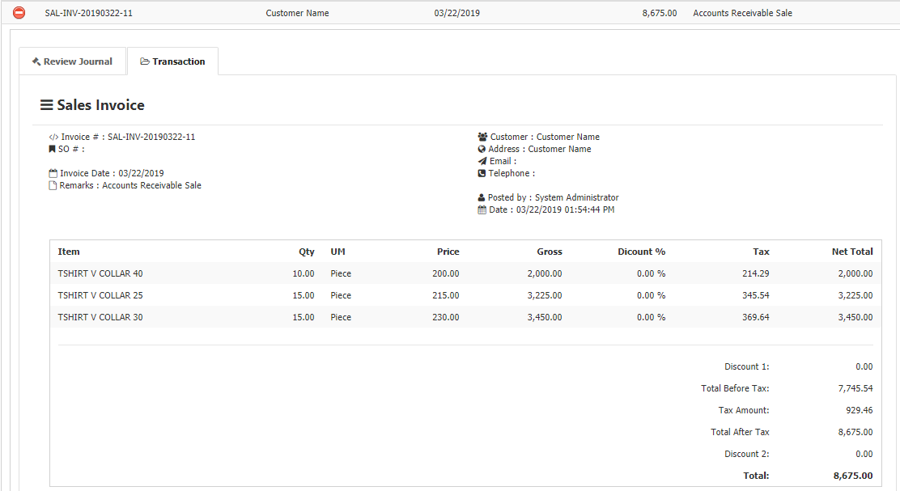

**Sales Flowchart**

