**SALES / ACCOUNTS RECEIVABLE JOURNAL**

Listed in the *Figure 1* are the Accounts Receivable Posted in the Accounting System. The ***Sales Journal*** is the master journal to where all the accounts receivable entries of the company are recorded in such as *Credit Sales Invoice, Penalties to Customers, and other Accounts Receivable from Customers.*

**Figure 1**

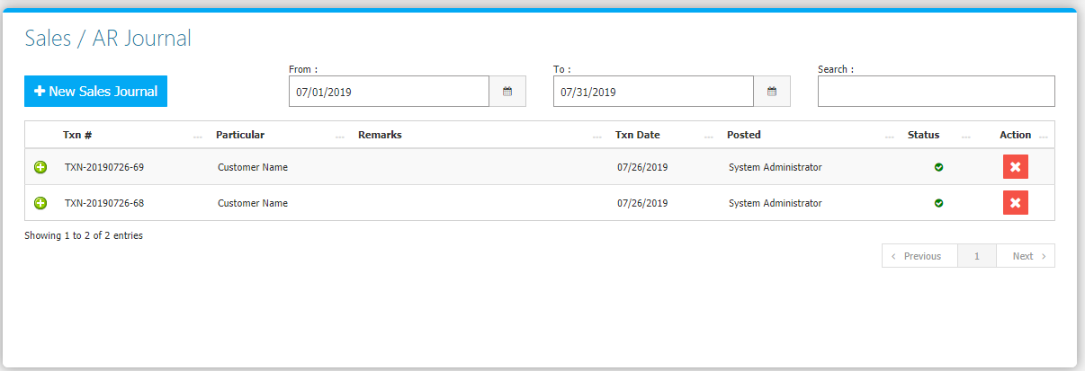

Change the **Date Range** (from and to) to your preference to filter the shown Journal Transactions. Use the **Search Field** to search for the information from inside the table. Clicking the **+ Button** will open the transaction/voucher as shown in *Figure 2.* Thevoucher can be printed and downloaded as a PDF File. Clicking the **X Button** will mark the Journal either cancelled or active.

**Figure 2**

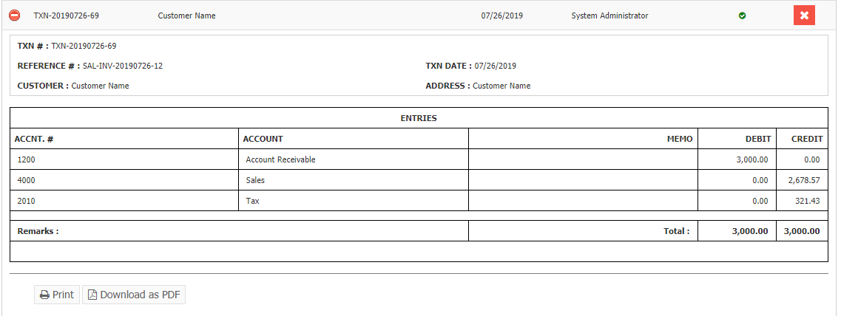

Click the New **Sales Journal Button** to create. Fill the form *(Figure 3)* then click **Save and Post Button** to save.

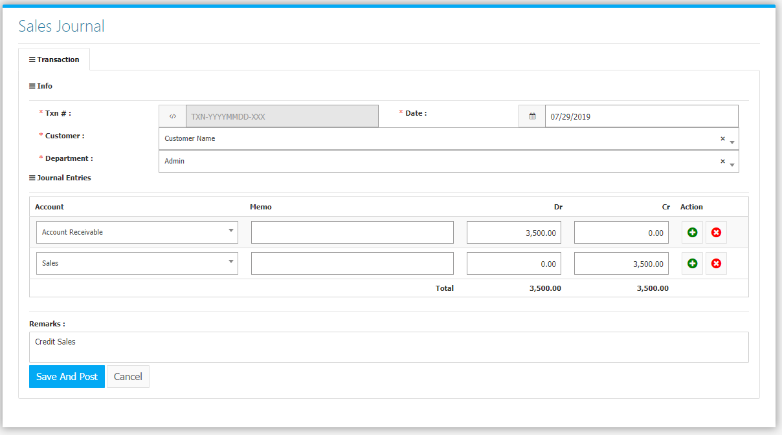

**Sales Flowchart**

