**DEPRECIATION EXPENSE**

Depreciation is defined as the expensing of an asset involved in producing revenues throughout its useful life. Depreciation for accounting purposes refers the allocation of the cost of assets to periods in which the assets are used. Listed *in Figure 1* is the **Report** of the Depreciation Expense for the chosen **Applicable Month** and **Year.**

**Figure 1**

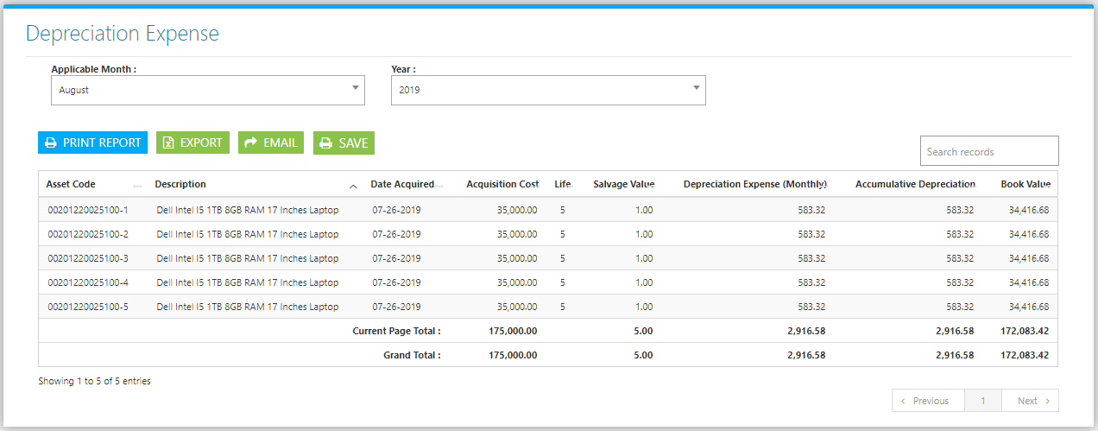

Use the **Search Field** to search for the records from inside the table. Click the **Print Button** to print the report *(Figure 2),* and **Export Button** to save the Master File to an Excel File *(Figure 3)*. Click the **Save Button** and **Confirm** *(Figure 4)* to prepare the report for review and posting in the Accounting *(Figure 5)*.

**Figure 2**

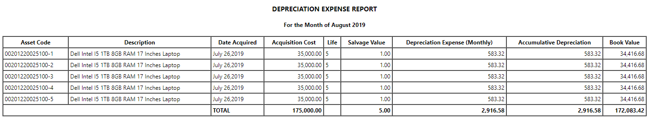

**Figure 3**

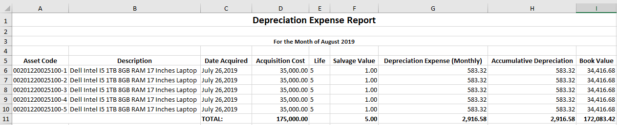

**Figure 4**

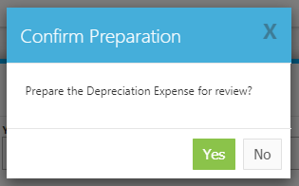

**Figure 5**

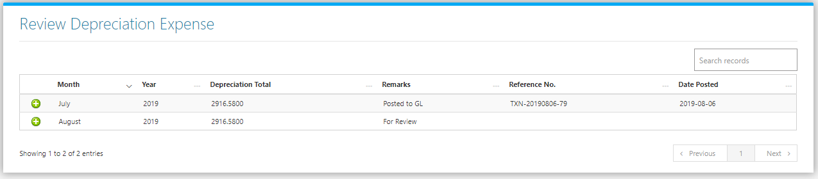

Clicking the **+ Button** will open the Expense for Review. The Review Journal Tab *(Figure 6)* shows the Debit and Credit Entries and the Amounts. Adjust the details to your preference then click **Finalize this Journal** **Button** to post the Transaction to Accounting.

**Figure 6**

