**FIXED ASSET MANAGEMENT**

A **Fixed Asset** is property with a useful life greater than one reporting period, and which exceeds an entity's minimumcapitalization limit. A fixed asset is not purchased with the intent of immediate resale, but rather for productive use within the entity. Also, it is not expected to be fully consumed within one year of its purchase. Listed in *Figure 1* are the Fixed Assets created in the Accounting System.

**Figure 1**

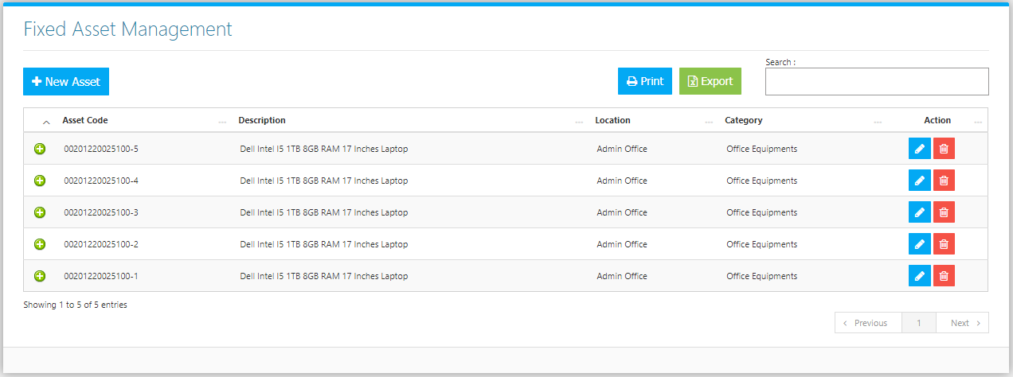

Use the **Search Field** to search for the information from inside the table. Click the **Trash Button** to delete, **Pencil Button** to edit. Clicking the **+ Button** will open the *Movement of Asset* as shown in *Figure 2.* It can be printed and downloaded as pdf. Click the **Print Button** to print the Fixed Asset Master File *(Figure 3),* and **Export Button** to save the Master File to an Excel File *(Figure 4)*.

**Figure 2**

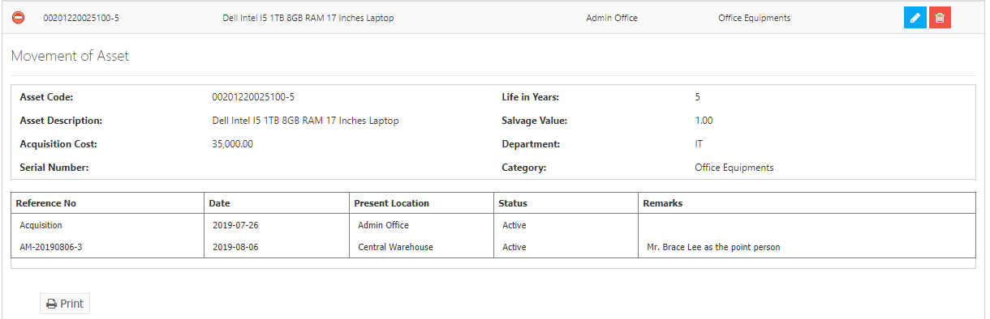

**Figure 3**

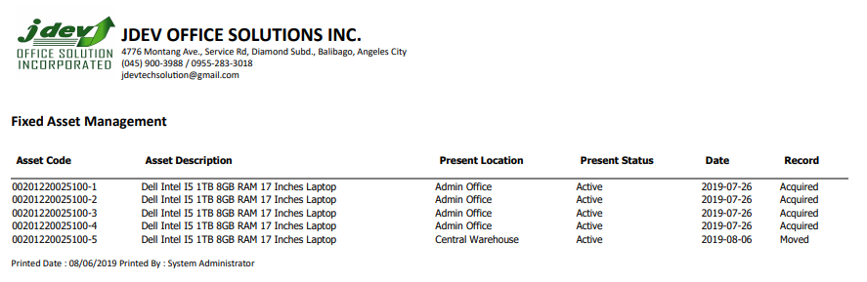

**Figure 4**

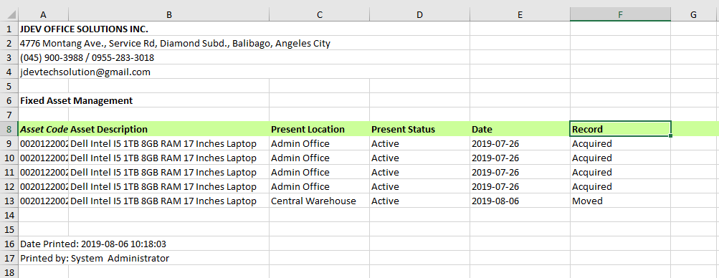

Click the **New** **Asset Button** to create. Fill the form (Figure 5) and click the **Save Button** to save.

**Figure 5**

