**MOVEMENT OF ASSETS**

Listed in the *Figure 1* are the *Movement of Assets* recorded in the Accounting System. Click the **Record Movement Button** to create new. Click the **… Button** as shown in *figure 2* to choose from the fixed assets list in *figure 3.*

**Figure 1**

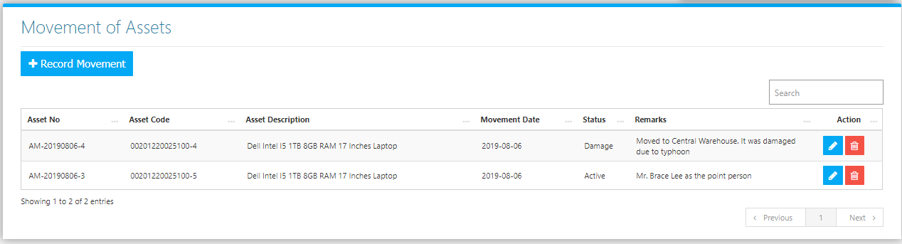

**Figure 2**

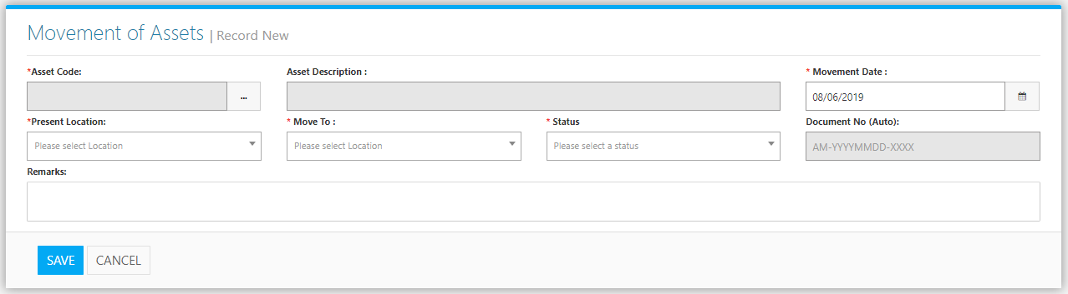

**Figure 3**

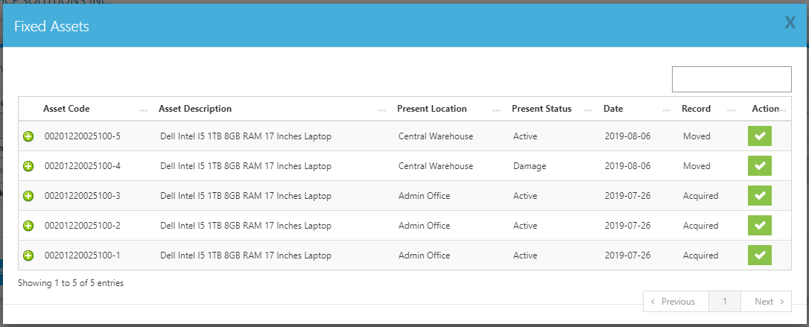

Clicking the **+ Button** in this interface will show the *Movement of the Asset*. Click the **Check Button** to use the Asset in the Record. Then the **Details** of the Fixed Asset will be dropped down in the invoice *(Figure 4)*. Click the **Save Button** to save the record.

**Figure 4**

