**INVENTORY REPORT**

Listed in Figure 1 are the products with their *current on hand stocks*. Change the **Department**, **As of Date**, and Current **Count Filter** *(All Items, Items Greater than Zero, Items Less than Zero, Items Equal to Zero)* to your preference to filter the shown report.

**Figure 1**

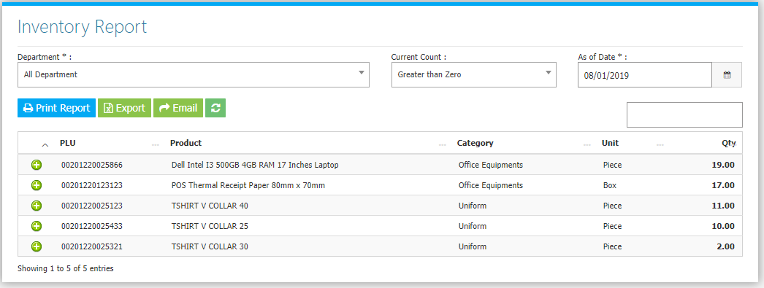

Use the **Search Field** to search for the information from inside the table. Clicking the **+ Button** will open the transaction History of the product as shown in *Figure 2.*

**Figure 2**

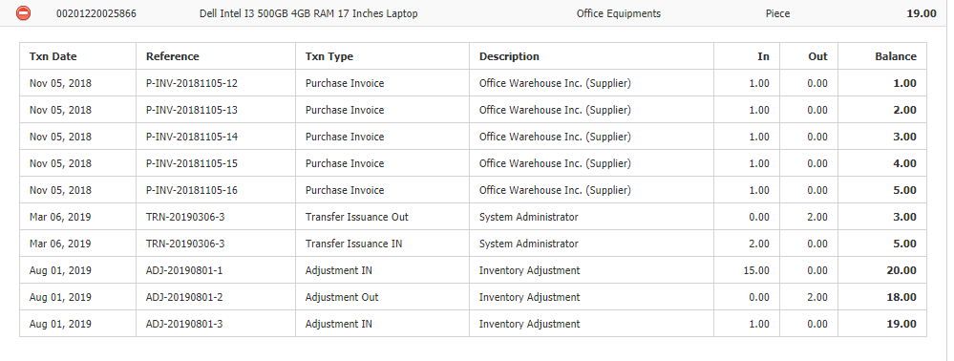

**INVENTORY SETTINGS**

Inventory Settings located from the **Settings Menu -> General Configuration -> Inventory**. These settings will determine which modules are included in the computation of the Inventory. Click **Save Inventory Configuration Changes Button** to apply changes.

