**ISSUANCE TO DEPARTMENT**

Listed in the *Figure 1* are the list of Issuances. The **Issuance to Department Module** is used to transfer stock items from one department to another.

**Figure 1**

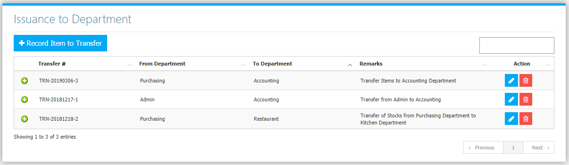

Use the **Search Field** to search for the information from inside the table. Click the **Trash Button** to delete, **Pencil Button** to edit. Clicking the **+ Button** will open the transaction/ Issuance as shown in *Figure 2.* It can be printed and downloaded as pdf.

**Figure 2**

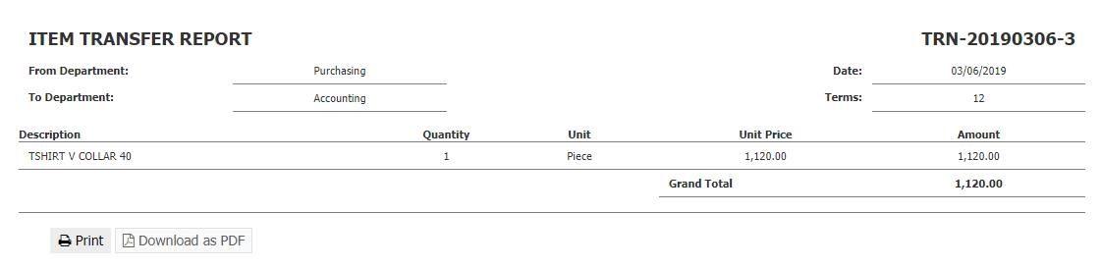

Click the **Record Items to Transfer Button** to create. Fill the form and select items to transfer then click the **Save Changes Button** to save *(Figure 3)*.

**Figure 3**

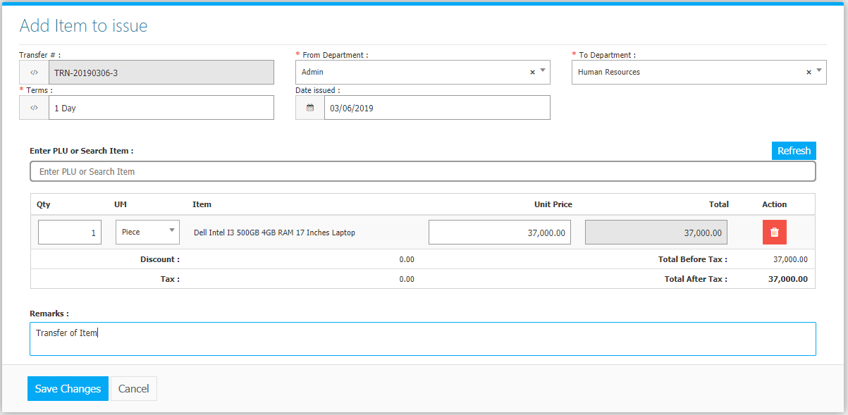

**Issuances Flowchart**

