**ADJUSTMENTS**

Listed in the *Figure 1* are the list of Inventory Adjustments. **Adjustments** are increases or decreases made in inventory to account for theft, loss, breakages, and errors in the amount or number of items received. This module is used to correct stock records to match an item’s actual on hand quantity. It is also used to record the Beginning Inventory of a warehouse.

**Figure 1**

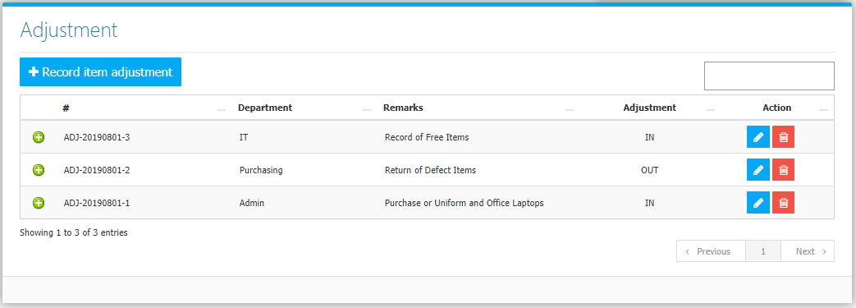

Use the **Search Field** to search for the information from inside the table. Click the **Trash Button** to delete, **Pencil Button** to edit. Clicking the **+ Button** will open the transaction/ adjustment as shown in *Figure 2.* It can be printed and downloaded as pdf.

**Figure 2**

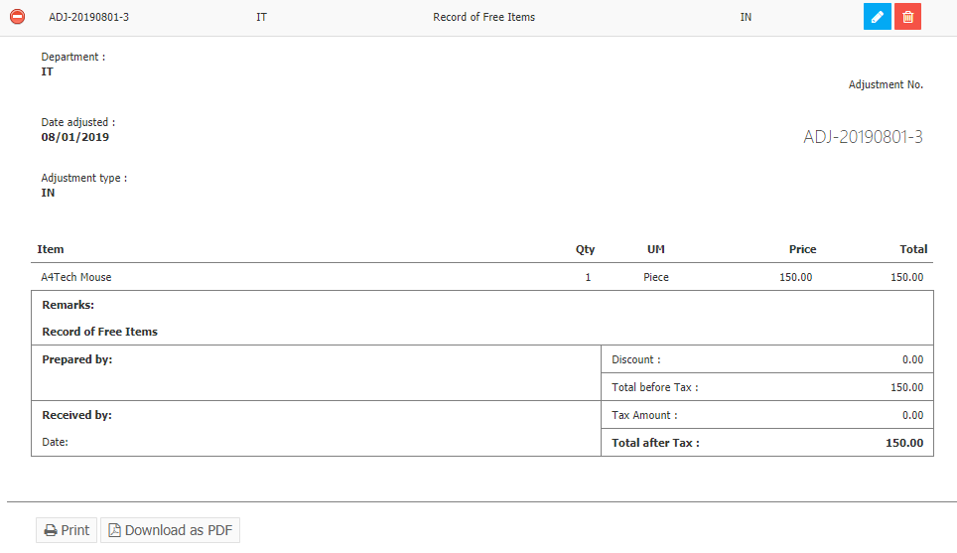

Click the **Record Item Adjustment Button** to create. Fill the form, select adjustment type, and items to adjust then click the **Save Changes Button** to save *(Figure 3)*.

**Figure 3**

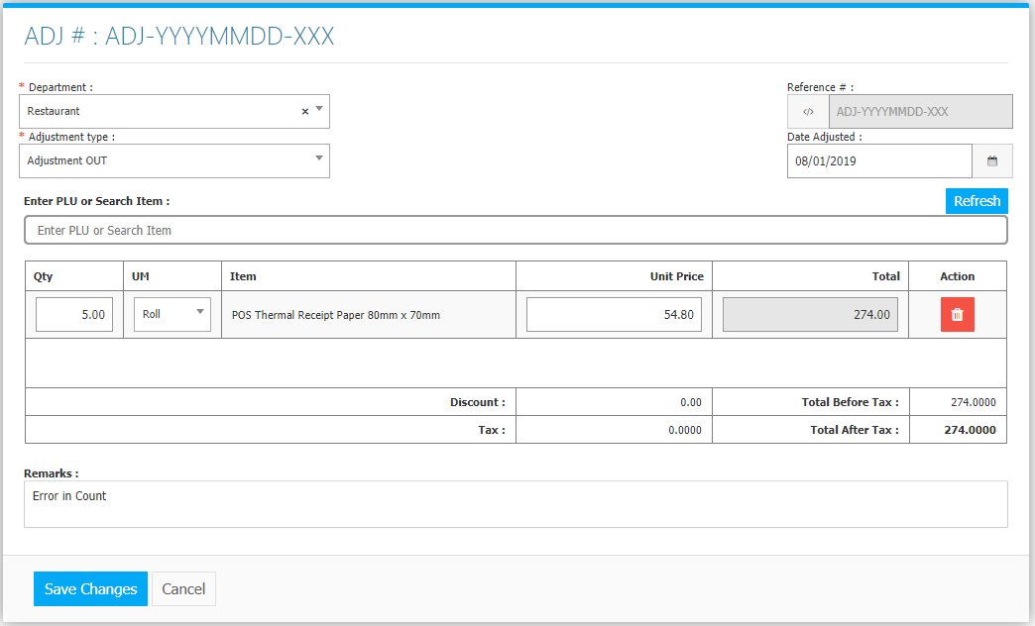

**Adjustments Flowchart**

