**PRODUCT LIST REPORT (DETAILED)**

Listed in *Figure 1* is the **Product List Report**. The Report holds more specific information about the *products of the Accounting System*. Choose the **Category, Supplier**, and **Inventory Type** as per your preference to filter the shown products. Click the **Print Report Button** to print *(Figure 2)*, **Export Button** to save the report to an Excel File *(Figure 3)*, and **Email Button** to email the excel file to the designated address in the **Settings -> Email Report Settings**.

**Figure 1**

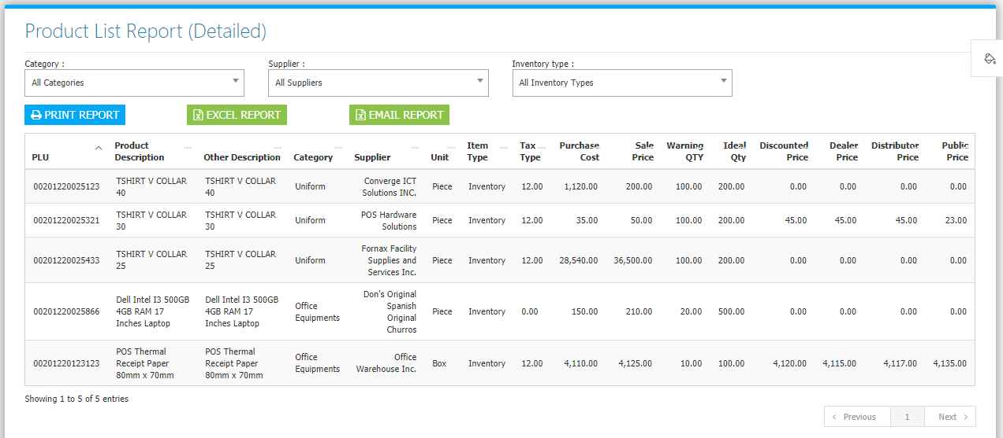

**Figure 2**

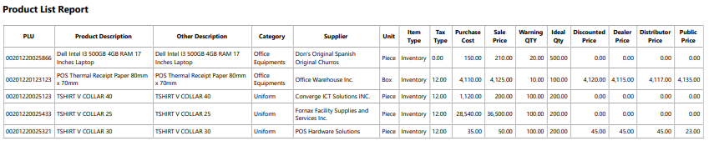

**Figure 3**

