**PRODUCT REORDER (PICK-LIST)**

Listed in the Figure 1 are the Products which current *On Hand Stocks* are below the **Warning Quantity (Minimum Stock).** The *Warning Quantity (Minimum Stock)*, and *Ideal Quantity (Maximum Stock)* must be set up for every product in the **Product Management Module** as shown in *Figure 2.* Click the **Print Report Button** to print *(Figure 3)*, **Export Button** to save the report to an Excel File *(Figure 4)*, and **Email Button** to email the excel file to the designated address in the **Settings -> Email Report Settings**.

**Figure 1**

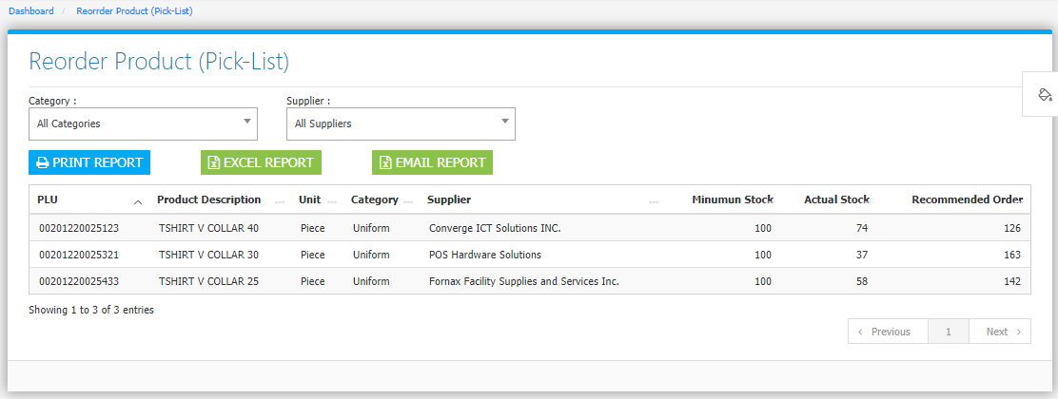

**Figure 2**

