**VOUCHER REGISTRY REPORT**

Listed in *Figure 1* is the **Voucher Registry Report**. The Report holds more specific information about the *supplier* and the *vouchers* created. Choose the **Bank**, and **Date Range** as per your preference to filter the shown checks. Click the **Print Report Button** to print *(Figure 2)*, **Export Button** to save the report to an Excel File *(Figure 3)*, and **Email Button** to email the excel file to the designated address in the **Settings -> Email Report Settings**.

**Figure 1**

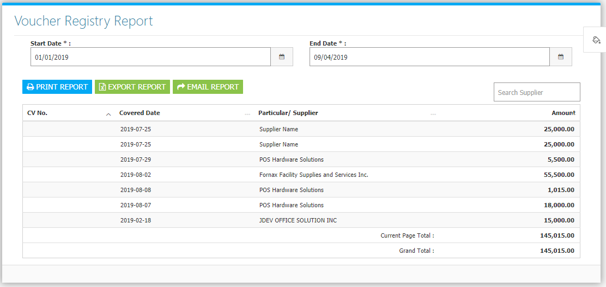

**Figure 2**

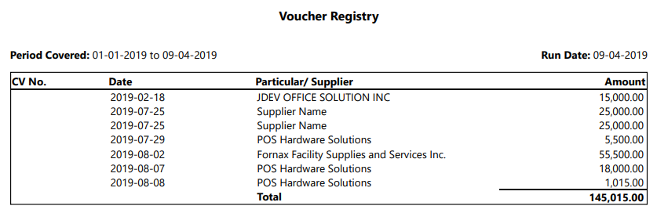

**Figure 3**

