**CUSTOMER MANAGEMENT**

Listed on the Figure 1 are Suppliers created in the Accounting System. These customers are used in Sales Modules, Accounting Entry Modules, and as Filter to reports.

**Figure 1**

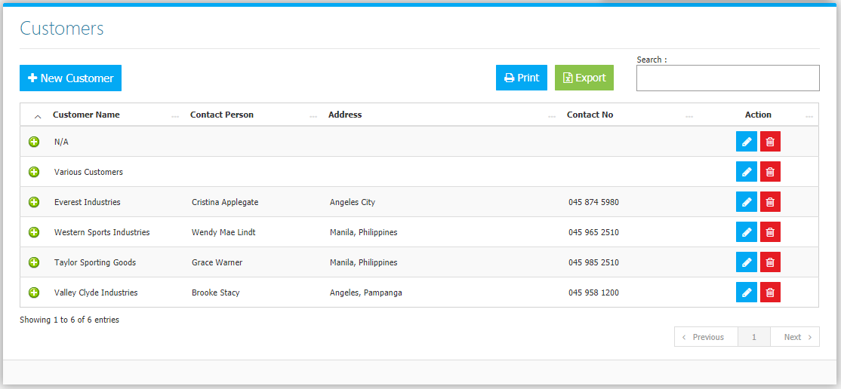

Use **Search Field** to search for the information from inside the table. Click the **Trash Button** to delete, **Pencil Button** to edit. Click the **Print Button** to print the supplier Master File *(Figure 2)*, and Export Button to save the Master File to an Excel File (Figure 3).

**Figure 2**

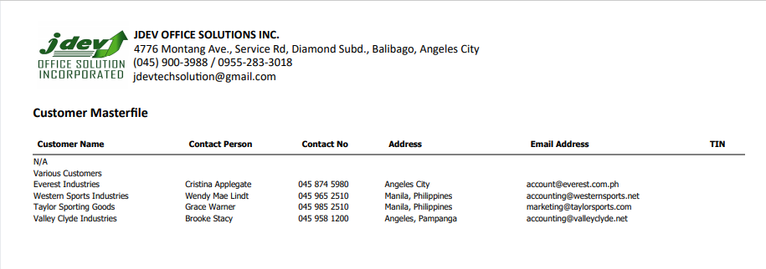

**Figure 3**

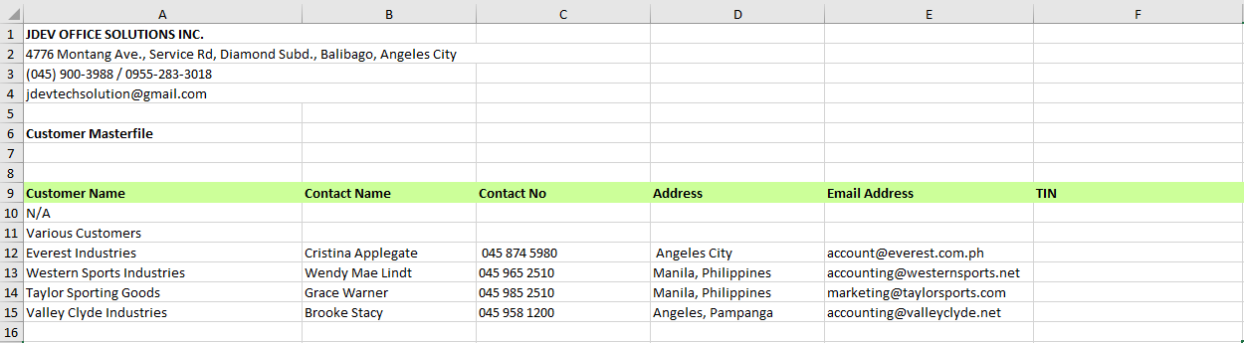

Clicking the + Button will open the Information, Invoices, and Payments from the Customer. **Information Tab** *(Figure 4)* shows the Information of the Customer with the photo if uploaded, the latest transaction made, and the *open*, and *partially* *received* Sales Orders. The **Customer** **Invoice Tab** *(Figure 5)* are Sales Invoices made, together with their amounts and payment statuses. The **Payment Details Tab** *(Figure 6)* lists all the payments made by the customers.

**Figure 4**

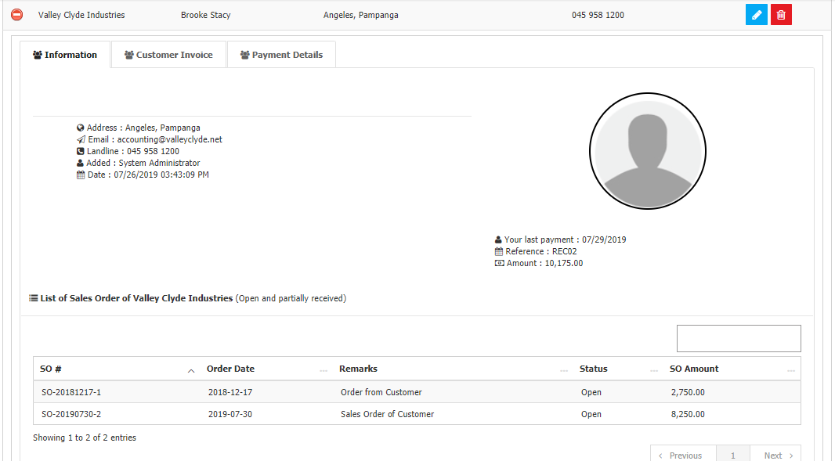

**Figure 5**

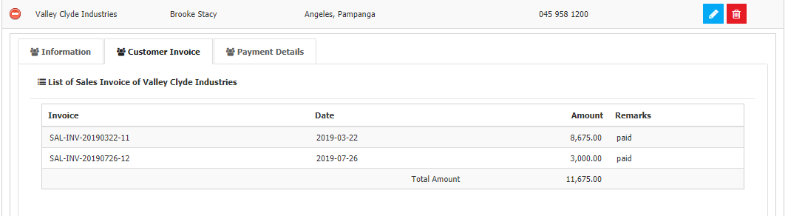

**Figure 6**

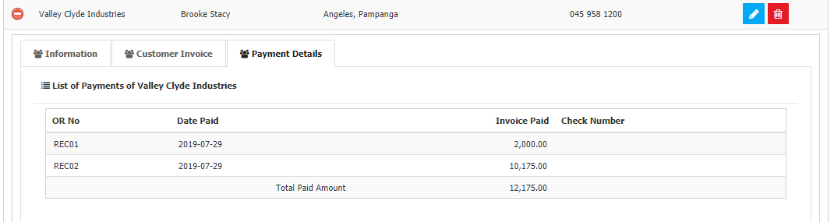

Click the **New** **Customer Button** to create. Fill the form *(Figure 7)* and select the Customer Type, then click the **Save Button** to save. The *Customer Type* is used in creating Invoices from the *Sales Modules,* the unit price will depend on what type the customer is.

**Figure 7**

