**PRODUCT MANAGEMENT**

Listed in the *Figure 1* are list of your products. These products can be used to create a *Purchase Order, Purchase Invoice, Sales Order, Sales Invoice, Cash Invoice, Item Adjustment, Item Transfer, and Dispatching Invoice.*

**Figure 1**

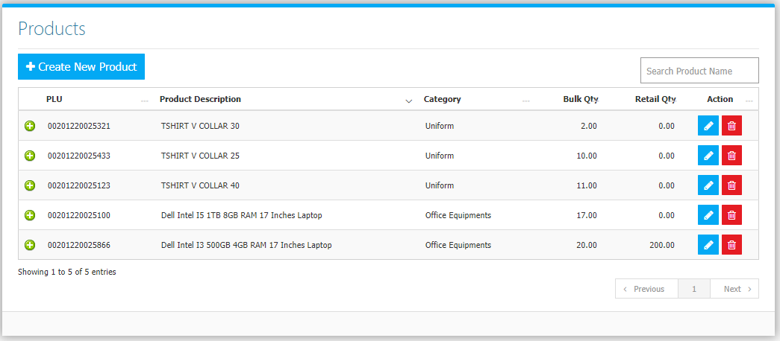

Use the **Search Field** to search for the information from inside the table. Click the **Trash Button** to delete, **Pencil Button** to edit. Clicking the **+ Button** will open the transaction History of the product as shown in *Figure 2.* It can be printed and exported to excel.

**Figure 2**

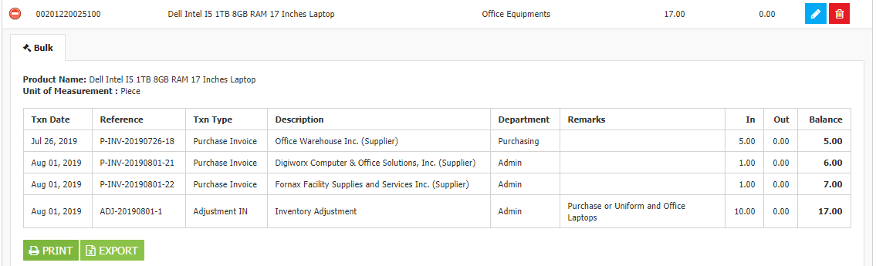

The **Transaction History** or the **Bin Card** shows the in and out flow of a certain product. It details the type and date of transactions it went through and features a running balance in every transaction made.

Click the **Create** **New Product Button** to create.

**Figure 3**

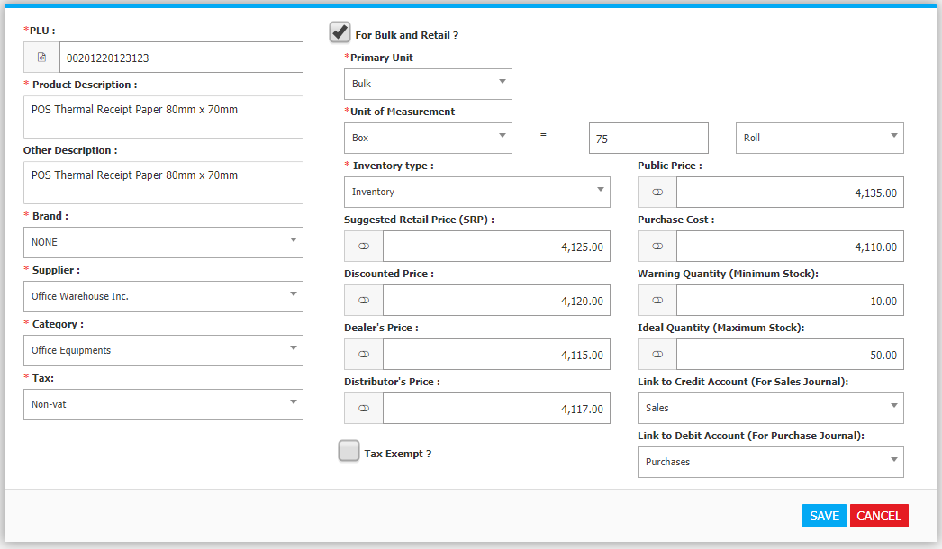

Fields with *asterisks \** are required. **PLU** stands for Product Look Up/ Barcode. **Click** (put a check mark) on the **For Bulk and Retail?** part to use the item either for bulk or retail when creating transactions such as invoices. Choose a **Unit of Measurement** for the *bulk unit* and its equivalency for the *retail unit*. In the *Figure 3,* the unit of measurement set for the item *(POS Thermal Receipt Paper 80mm x 70mm)* is **1 Box equals to 75 Rolls**. Select the **Inventory Type**, *Non-inventory and services* will not be included in the **Inventory List Report**.

The **Prices**: *Suggested Retail Price, Discounted Price, Dealer’s Price, Distributor’s Price* are used for **customers** in the Sales Modules while the *Purchase Cost* is usedfor **suppliers** in the Purchasing Modules. The Public Price is used for record only.

The *Warning Quantity (Minimum Stock)*, and *Ideal Quantity (Maximum Stock)* are used for the **Product Reorder Module** (Pick List Module) which shows the products with **On Hand Quantity** below the Warning Quantity. The Warning Quantity is also used when creating an invoice in the Sales Modules, the system will warn the creator that the On Hand Quantity is **below the warning level** or **no stock is on hand.**

Set the **Link to Credit Account (For Sales Journal)** to the appropriate Account Title available from the Chart of Accounts. This account title will be used when a *Sales or Cash Invoice* is to be reviewed for posting in the Accounting Module. For instance, when an invoice is made and this item is used, it will be reviewed in the accounting with this entry *(Figure 4).*

**Figure 4**

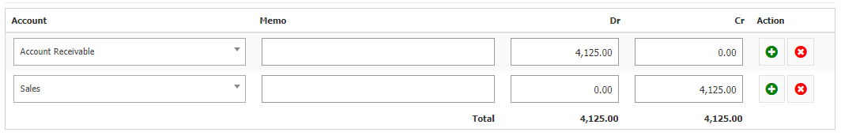

Set the **Link to Debit Account (For Purchase Journal)** to the appropriate Account Title available from the Chart of Accounts. This account title will be used when a *Purchase Invoice* is to be reviewed for posting in the Accounting Module. For instance, when an invoice is made and this item is used, it will be reviewed in the accounting with this entry *(Figure 5).*

**Figure 5**

