**SALESPERSON MANAGEMENT**

Listed on the Figure 1 are Salespersons created in the Accounting System. These salespersons are used in the Sales Modules, both Sales and Cash Invoices.

**Figure 1**

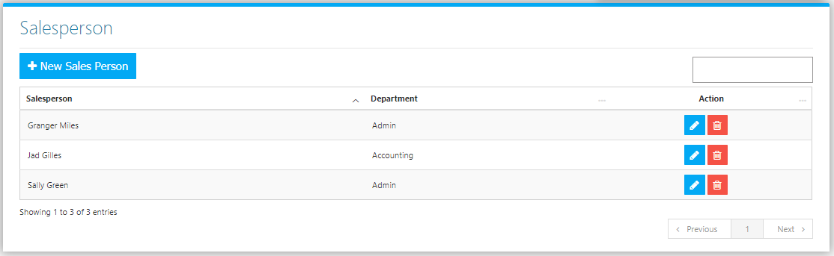

Use the **Search Field** to search for the information from inside the table. Click the **Trash Button** to delete, **Pencil Button** to edit. Click the **New** **Sales Person Button** to create. Fill the form *(Figure 2)* and click the **Save Button** to save.

**Figure 2**

