**SUPPLIER MANAGEMENT**

Listed in the *Figure 1* are the Suppliers created in the Accounting System. These suppliers are used in Purchasing Modules, Accounting Entry Modules, and as Filter to reports.

**Figure 1**

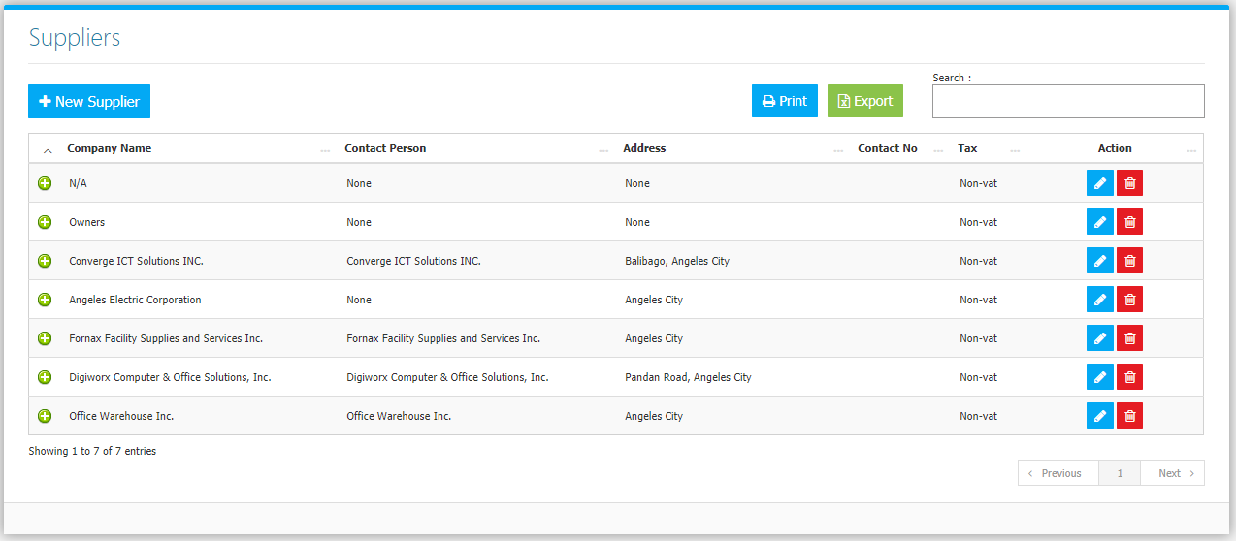

Use the **Search Field** to search for the information from inside the table. Click the **Trash Button** to delete, **Pencil Button** to edit. Click the **Print Button** to print the supplier Master File *(Figure 2),* and **Export Button** to save the Master File to an Excel File *(Figure 3)*.

**Figure 2**

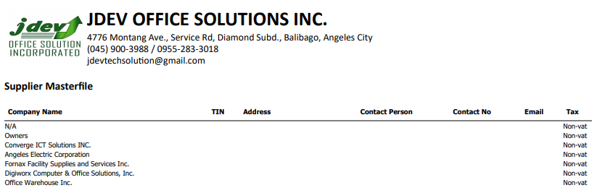

**Figure 3**

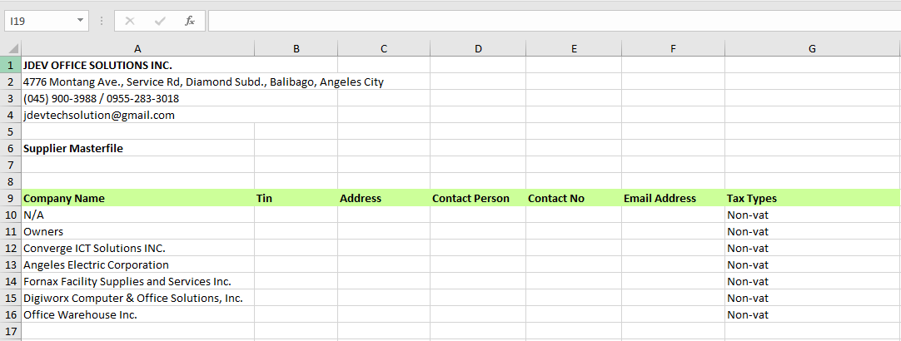

Clicking the **+ Button** will open the Information, Invoices, and Payments of the supplier*.* **Information Tab** *(Figure 4)* shows the Information of the Supplier with the photo if uploaded, the latest transaction made, and the *open*, and *partially received* Purchase Orders. The **Invoices Tab** *(Figure 5)* are the Purchase Invoices made, together with their amounts and payment statuses. The **Invoice Payments Tab** *(Figure 6)* lists all the payments made by the supplier.

**Figure 4**

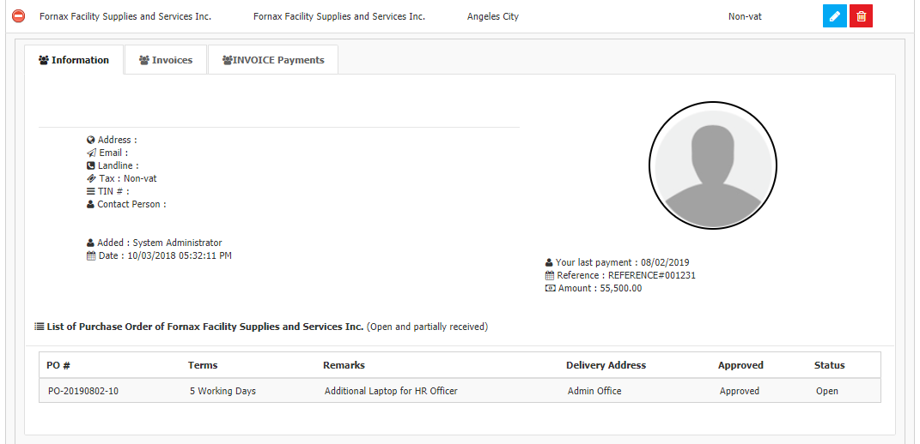

**Figure 5**

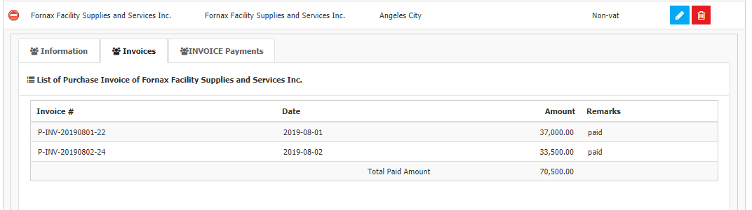

**Figure 6**

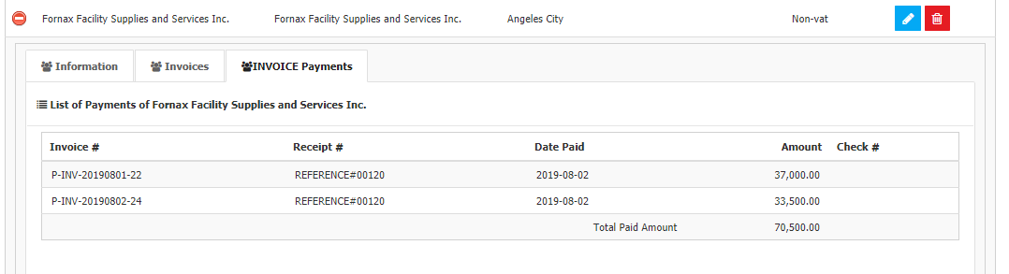

Click the **New** **Supplier Button** to create. Fill the form *(Figure 7)*, then click the **Save Button** to save. Note: *TIN, Payee’s Name (Company Name), Registered Address* will be used in generating BIR Form 2307. Suppliers which Tax types are set as **Vatted** will be included in generating Vat Relief Reports.

**Figure 7**

