**PURCHASE INVOICE HISTORY**

Listed in the *Figure 1* are the history of Delivered Items. Change the **Date Range** (from and to), **Supplier**, or **Department** to your preference to filter the shown Transactions. Use the **Search Field** to search for the information from inside the table. Click the **+ Button** to view the invoice *(Figure 2)*. It can be printed and downloaded as pdf.

**Figure 1**

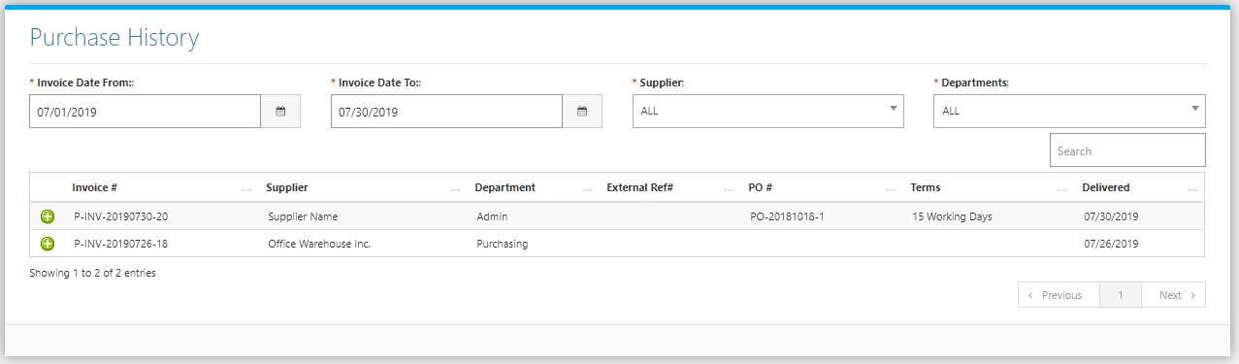

**Figure 2**

