**PURCHASE INVOICE**

Listed in the *Figure 1* are the Purchase Orders created. A **Purchase Invoice is** a document that the company receives when they buy something, giving details of price, payment condition. Here in the Purchase Invoice module, *received items* must be recorded.

**Figure 1**

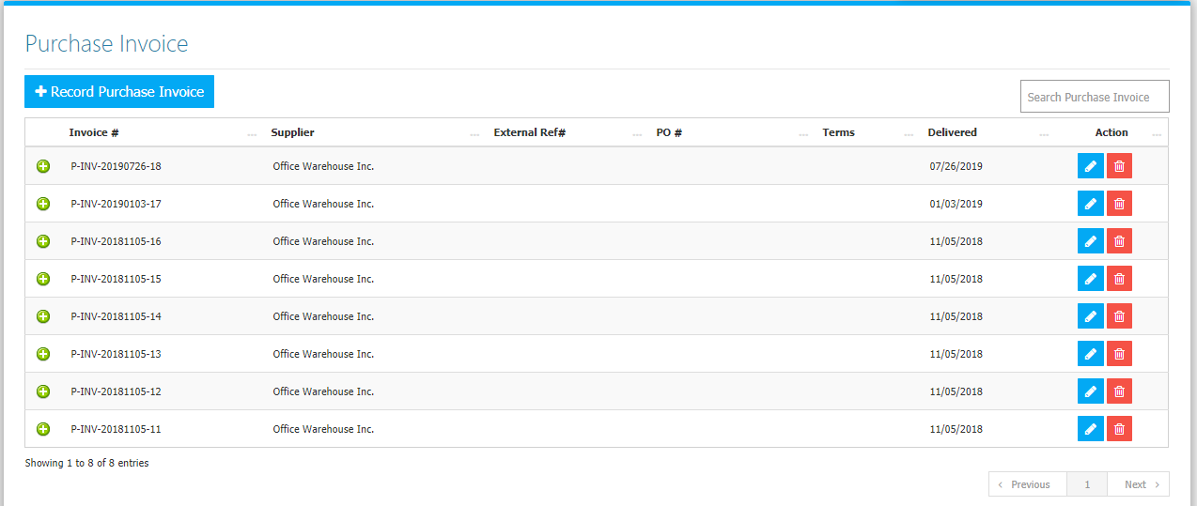

Use the **Search Field** to search for the information from inside the table. Click the **Trash Button** to delete, **Pencil Button** to edit. Clicking the **+ Button** will open the transaction/Purchase Invoice as shown in *Figure 2.* It can be printed and downloaded as pdf.

**Figure 2**

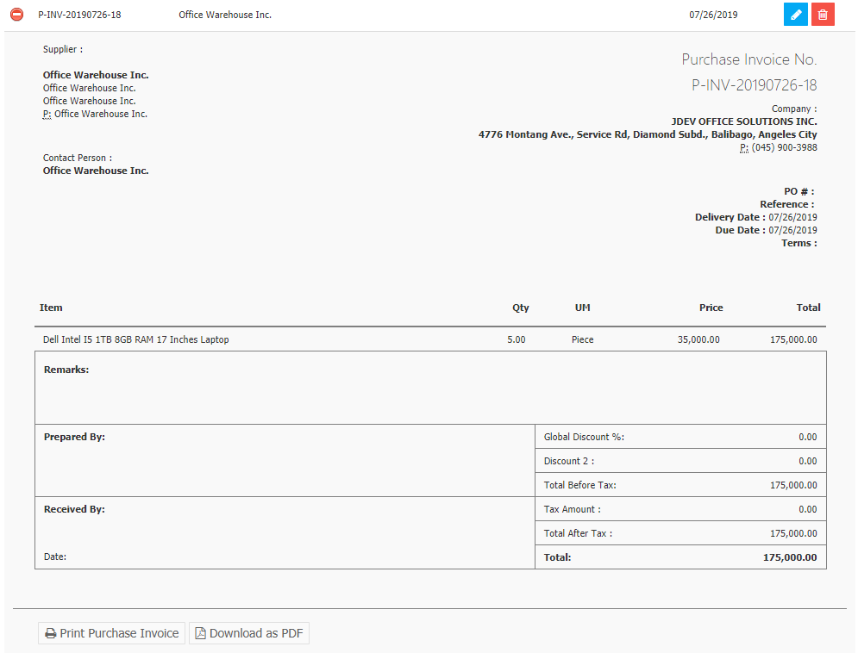

Click the **New** **Purchase Invoice Button** to create. You can use an **Approved Purchase Order** to create an invoice *(optional).* Click the **… Button** as shown in *figure 3* to choose from the approved purchase orders list in *figure 4.*

**Figure 3**

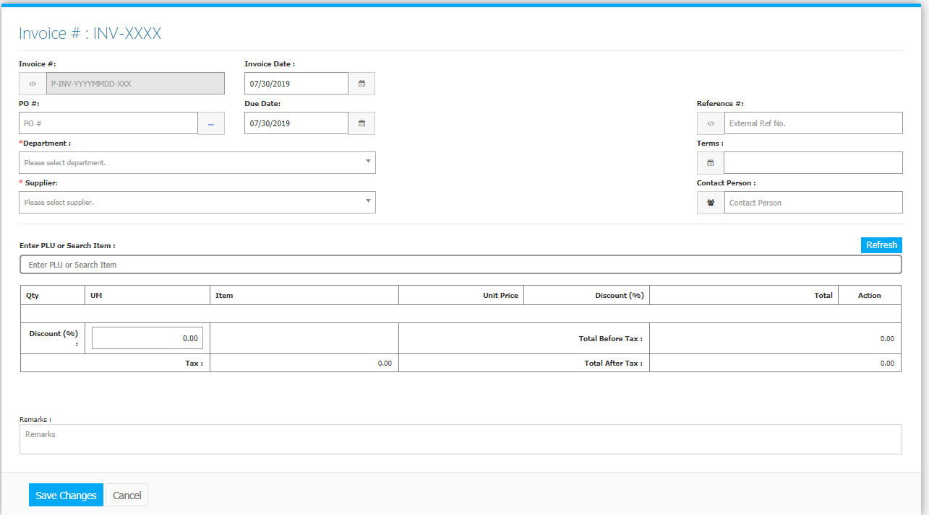

**Figure 4**

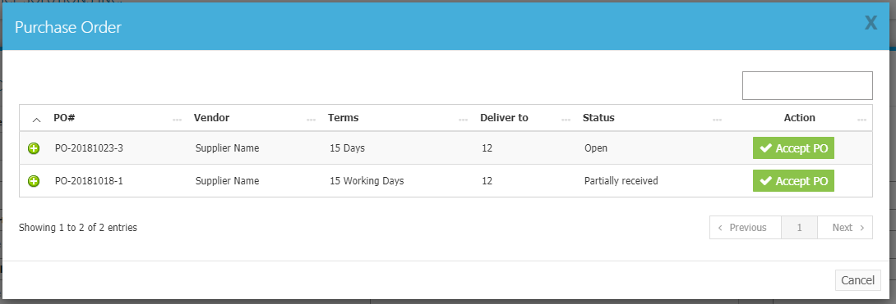

Every Purchase Order will have a status: Open, Partially Received, and Closed. **Open** means *no* item has been received yet, **Partially Received** means *some* of the items but not all, and **Closed** means *all* of the items from the Purchase Order has been received. Only *Open and Partially Received* will show in the list. Clicking the **+ Button** in this interface will show the details of the Purchase Order. Click the **Accept PO Button** to use the Purchase Order in the Invoice. Then the **items** of the Purchase Order will be dropped down in the invoice *(Figure 5)*.

**Figure 5**

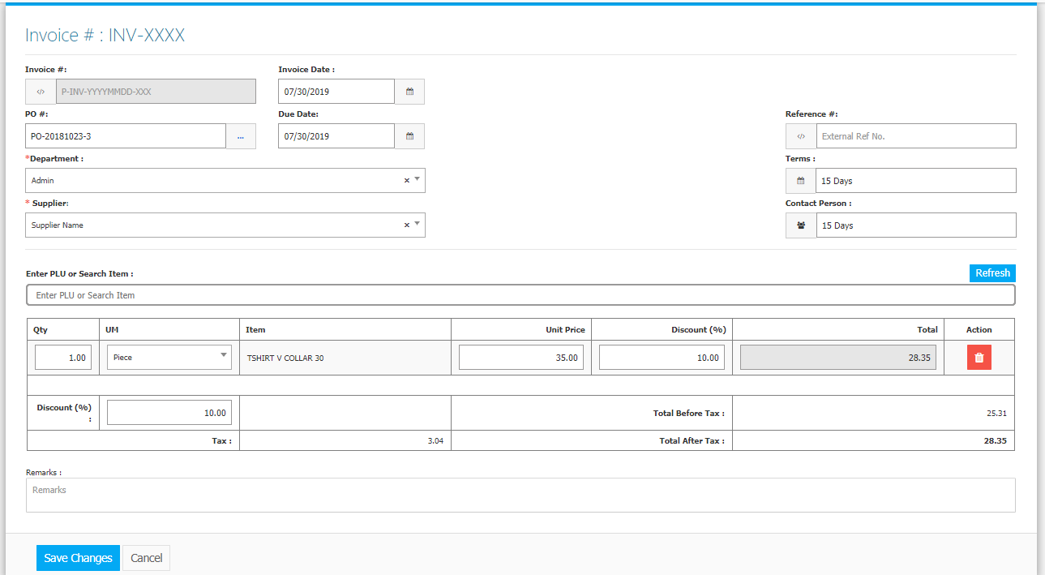

Click the **Save Changes Button** to confirm and save the invoice.

**OPEN PURCHASES REPORT**

Open Purchases report contains *Open*, and *Partially Received* Purchase Orders. Listed per Invoice are **items** together with the *Order Quantity*, *Delivered Quantity*, and *Outstanding Balance*. Located in **List Menu -> Open Purchases** (Figure 6). The list can be Printed and Exported into an Excel File

**Figure 6**

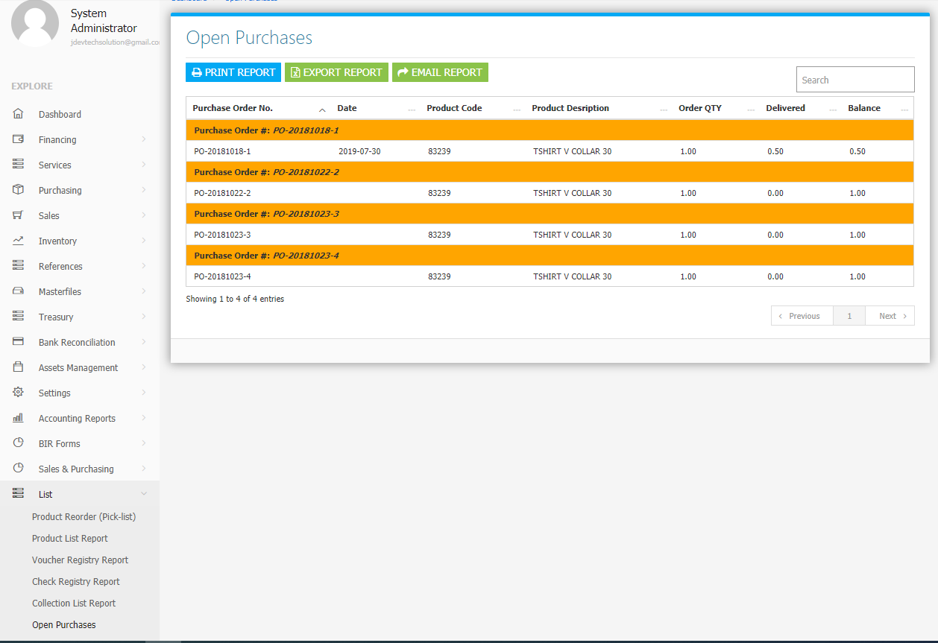

**Purchasing Flowchart**

