**PURCHASE ORDER**

Listed in the *Figure 1* are the Purchase Orders created. A **Purchase Order** is an official order that is issued by the company to a supplier. It has information on the specific products or services ordered as well as the quantities and the prices that were agreed upon. This is a legally binding agreement on the part of the purchaser to actually buy and pay for what was ordered.

**Figure 1**

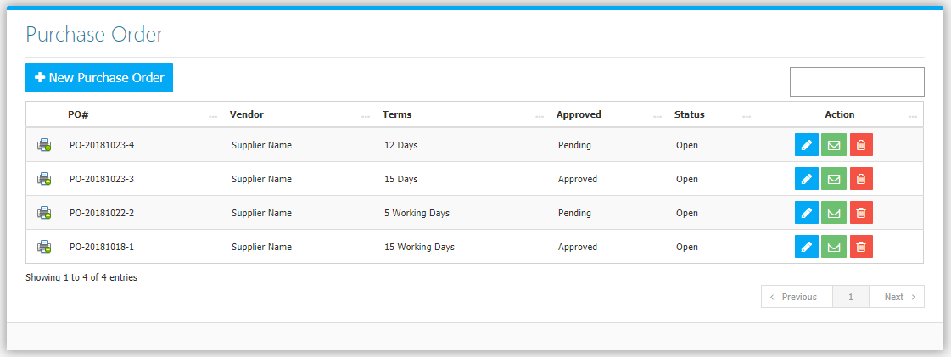

Use the **Search Field** to search for the information from inside the table. Click the **Trash Button** to delete, **Pencil Button** to edit. Click the **Message Button** to open messaging module as shown in *Figure 2.* You can send messages and attach documents to send for every user to see.

**Figure 2**

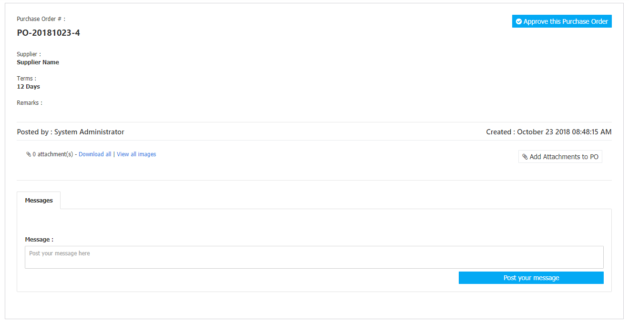

Click the **New** **Purchase Order Button** to create. Fill the form *(Figure 3)* then click **Save Changes Button** to save.

**Figure 3**

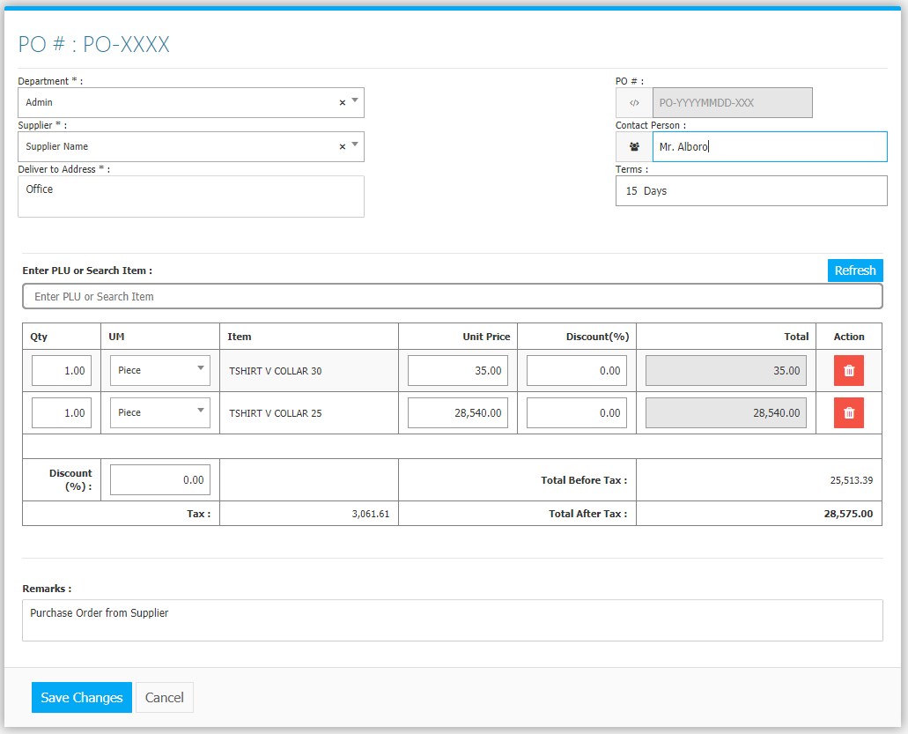

Clicking the **Print Button** will open the transaction/Purchase Order as shown in *Figure 3.* It can be printed and downloaded as pdf if it is already approved.

**Figure 3**

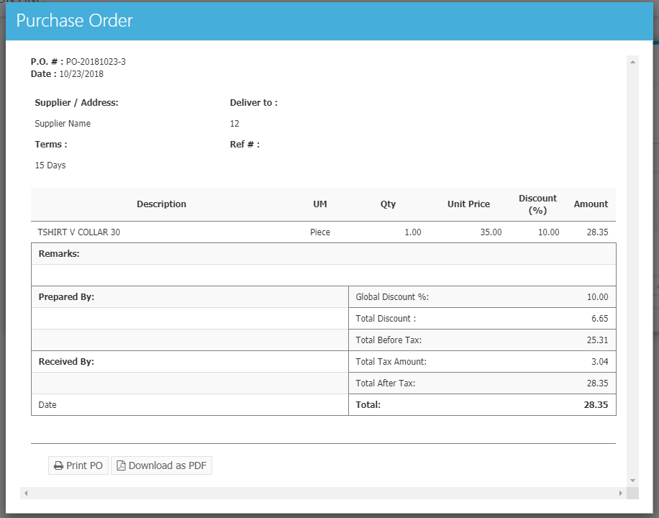

Approval of Purchase Orders is located in **Dashboard** *(Figure 4)*. Only **Authorized Users** can see and approve Purchase Orders. Click the **Check Button** to Approve, **Message Button** to see messages.

**Figure 4**

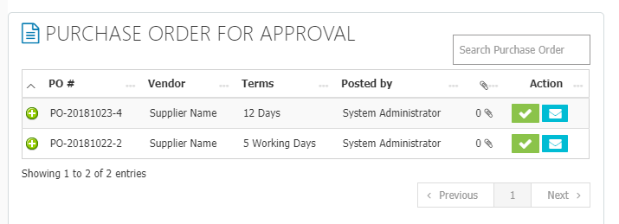

Click the **+ Button** to open or review *(Figure 5)*. You can also click **Mark this as Approved Button** to approve the Purchase Order.

**Figure 5**

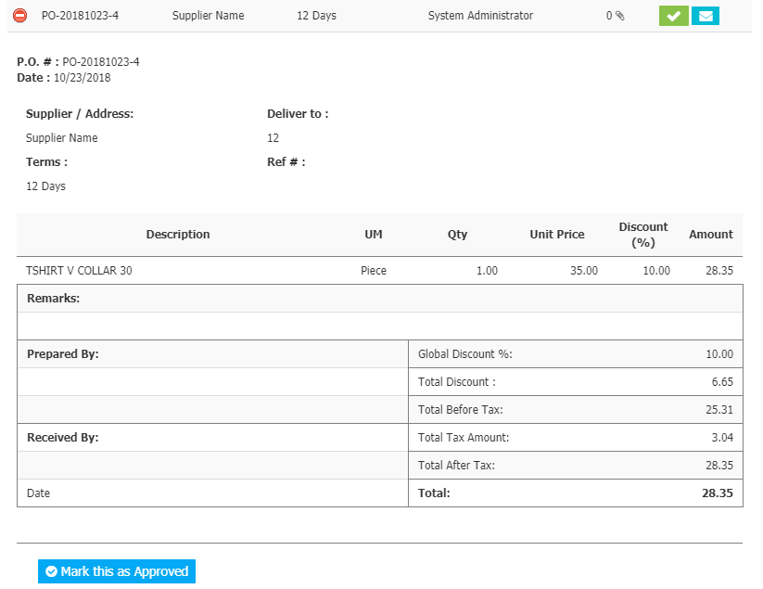

Note: Only **Approved** Purchase Order can be used in creating a Purchase Invoice. Purchase Order is an **optional** feature. If your company does not use Purchase Order, you can **skip** this module and go directly to Purchase Invoice to record Deliveries. Purchase Orders are not included in the *computation* *of Stocks On Hand or Inventory*.

**Purchasing Flowchart**

