**ACCOUNT CLASSIFICATION**

Listed in the *Figure 1* are the Account Classifications used in the Accounting System. There are five main accounting classifications namely, *Assets*, *Liabilities*, *Equity*, *Revenue*, and *Expenses*. This Module allows the user to customize the current Account Classifications listed.

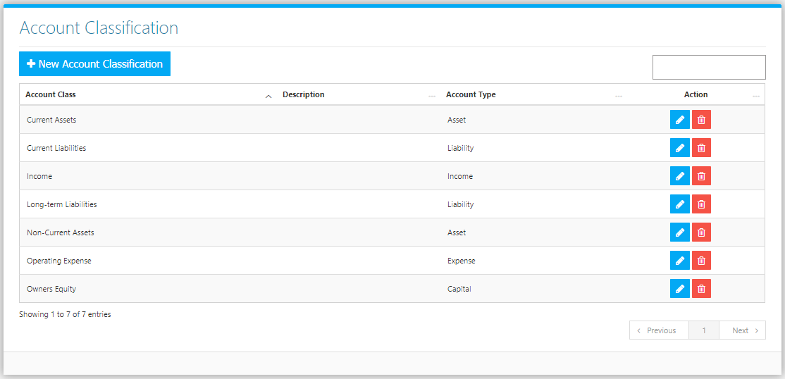

Use the **Search Field** to search for the information from inside the table. Click the **Trash Button** to delete, **Pencil Button** to edit. Click the **New Account Classification Button** to create. Fill the Form *(figure 2),* select the Account Type and click the **Save Button** to save.

**Figure 2**

