**BANK MANAGEMENT**

Listed in the *Figure 1* are the Banks created in the Accounting System. These banks are used for Journal Transactions in Accounting, and as a filter to several Accounting Reports.

**Figure 1**

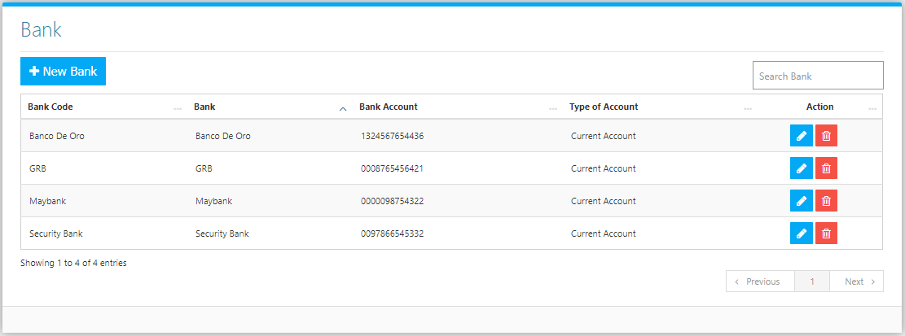

Use the **Search Field** to search for the information from inside the table. Click the **Trash Button** to delete, **Pencil Button** to edit. Click the **New Bank Button** to create. Fill the Form *(figure 2), and* click the **Save Button** to save.

**Figure 2**

