**BRANDS MANAGEMENT**

Listed in the *Figure 1* are the Brands created in the Accounting System. This reference is used as brands to the Products and filter to several reports.

**Figure 1**

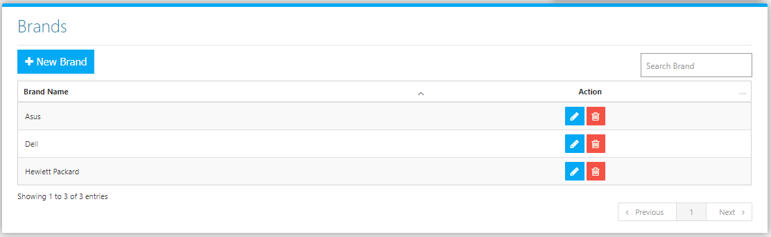

Use the **Search Field** to search for the information from inside the table. Click the **Trash Button** to delete, **Pencil Button** to edit. Click the **New Brand Button** to create. Fill the Form *(figure 2),* then click the **Save Button** to save.

**Figure 2**

