**CATEGORY MANAGEMENT**

Listed in the *Figure 1* are the Categories created in the Accounting System. This reference is used as categories to the Products and filter to several reports.

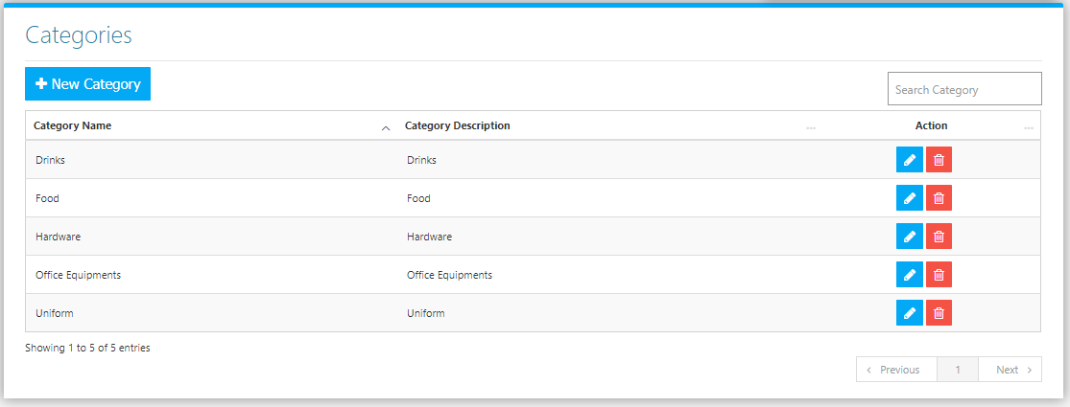

Use the **Search Field** to search for the information from inside the table. Click the **Trash Button** to delete, **Pencil Button** to edit. Click the **New Category Button** to create. Fill the Form *(figure 2),* then click the **Save Button** to save.

**Figure 2**

