**DEPARTMENT MANAGEMENT**

Listed in the *Figure 1* are the Departments created in the Accounting System. These departments will be used in creating Invoices, Accounting Journal Entries, and as filter for several Invoice, Inventory, and Accounting Reports.

**Figure 1**

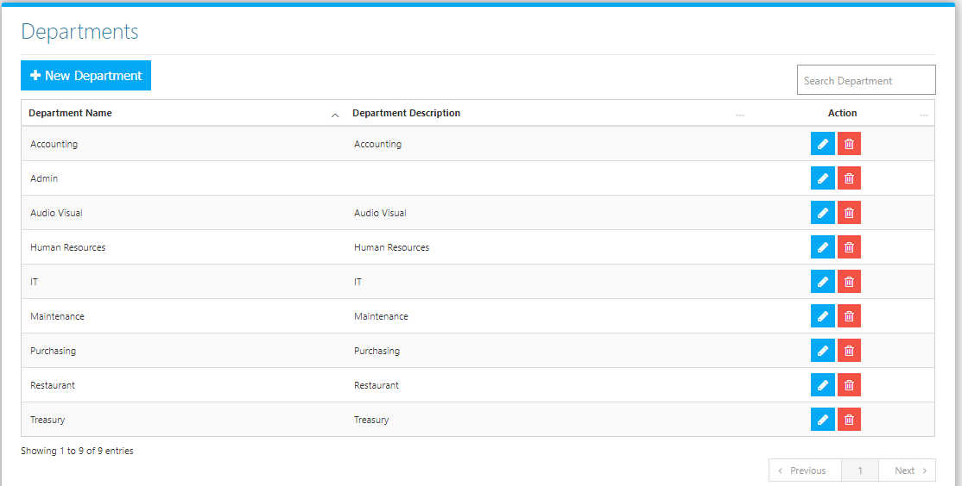

Use the **Search Field** to search for the information from inside the table. Click the **Trash Button** to delete, **Pencil Button** to edit. Click the **New Department Button** to create. Fill the Form *(figure 2), and* click the **Save Button** to save.

**Figure 2**

