**UNIT MANAGEMENT**

Listed in the *Figure 1* are the Units created in the Accounting System. These are used as Unit of Measurements for the Products.

**Figure 1**

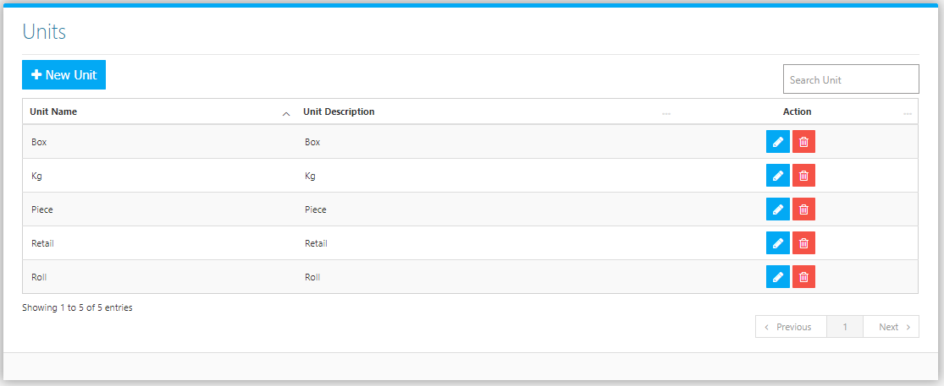

Use the **Search Field** to search for the information from inside the table. Click the **Trash Button** to delete, **Pencil Button** to edit. Click the **New Unit Button** to create. Fill the Form *(figure 2), and* click the **Save Button** to save.

**Figure 2**

