**CASH INVOICE**

Listed in the *Figure 1* are the Cash Invoices created. A **Cash Invoice** is a tool that a company uses to communicate to clients about the sums that are due in exchange for goods that have been sold. A cash invoice should include information about which items the customer has purchased, the quantities he has bought, discounts he has received, and the total amount he paid. A Cash Invoice creates an *Cash Receipt Journal* in the Accounting. Cash invoice are also considered as **Cash Sales.**

**Figure 1**

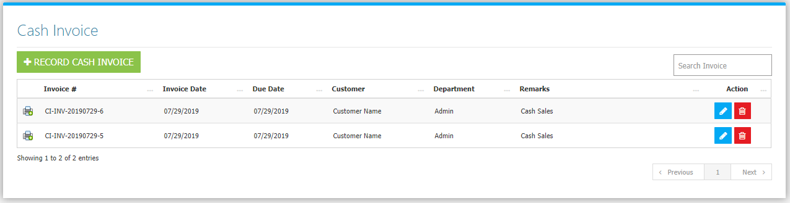

Use the **Search Field** to search for the information from inside the table. Click the **Trash Button** to delete, **Pencil Button** to edit. Clicking the **Print Button** will open the transaction/Cash Invoice as shown in *Figure 2.* It can be printed and downloaded as pdf.

**Figure 2**

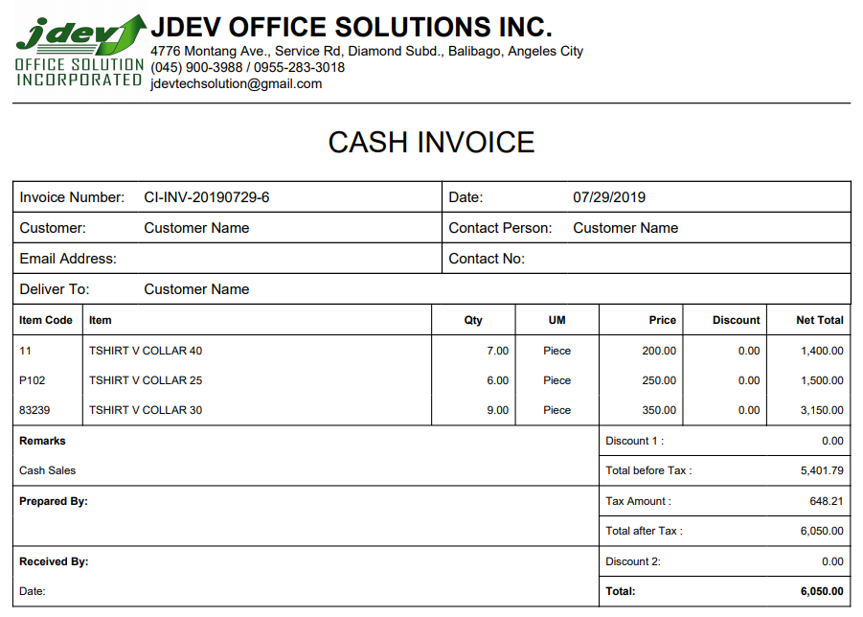

Click the **New** **Cash Invoice Button** to create. You can use a **Sales Order** to create an invoice *(optional).* Click the **… Button** as shown in *figure 3* to choose from the sales orders list in *figure 4.*

**Figure 3**

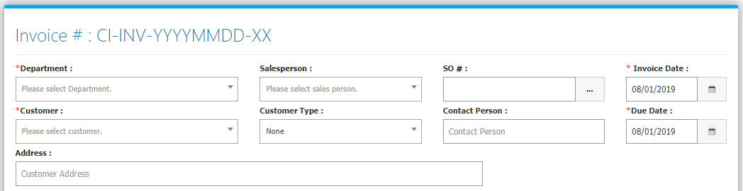

**Figure 4**

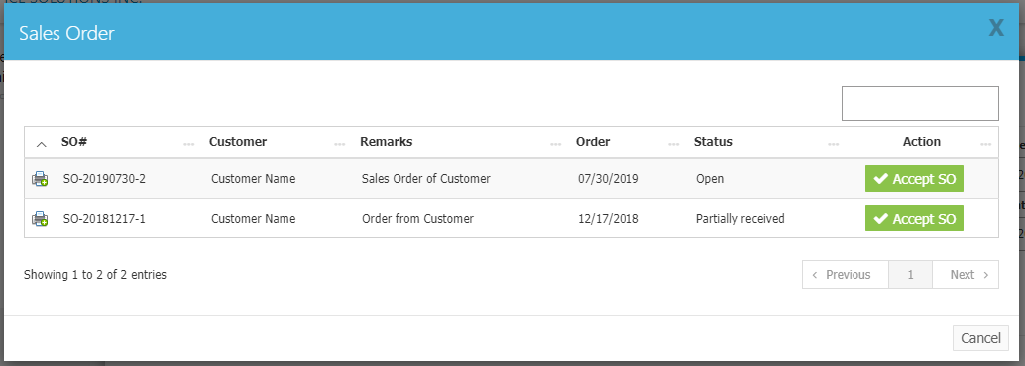

Every Sales Order will have a status: Open, Partially Received, and Closed. **Open** means *no* item has been delivered yet, **Partially Received** means *some* of the items but not all, and **Closed** means *all* of the items from the Sales Order has been delivered. Only *Open and Partially Received* will show in the list. Clicking the **Print Button** in this interface will show the details of the Sales Order. Click the **Accept SO Button** to use the Sales Order in the Invoice. Then the **items** of the Sales Order will be dropped down in the invoice *(Figure 5)*.

**Figure 5**

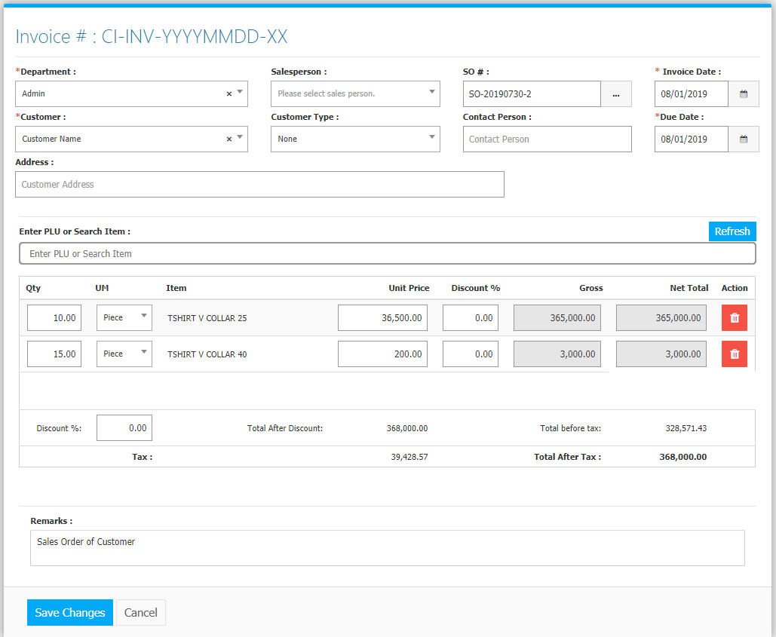

Click the **Save Changes Button** to confirm and save the invoice.

**OPEN SALES REPORT**

Open Sales report contains *Open*, and *Partially Delivered* Sales Orders. Listed per Invoice are **items** together with the *Order Quantity*, *Delivered Quantity*, and *Outstanding Balance*. Located in **List Menu -> Open Sales** (Figure 6). The list can be Printed and Exported into an Excel File.

**Figure 6**

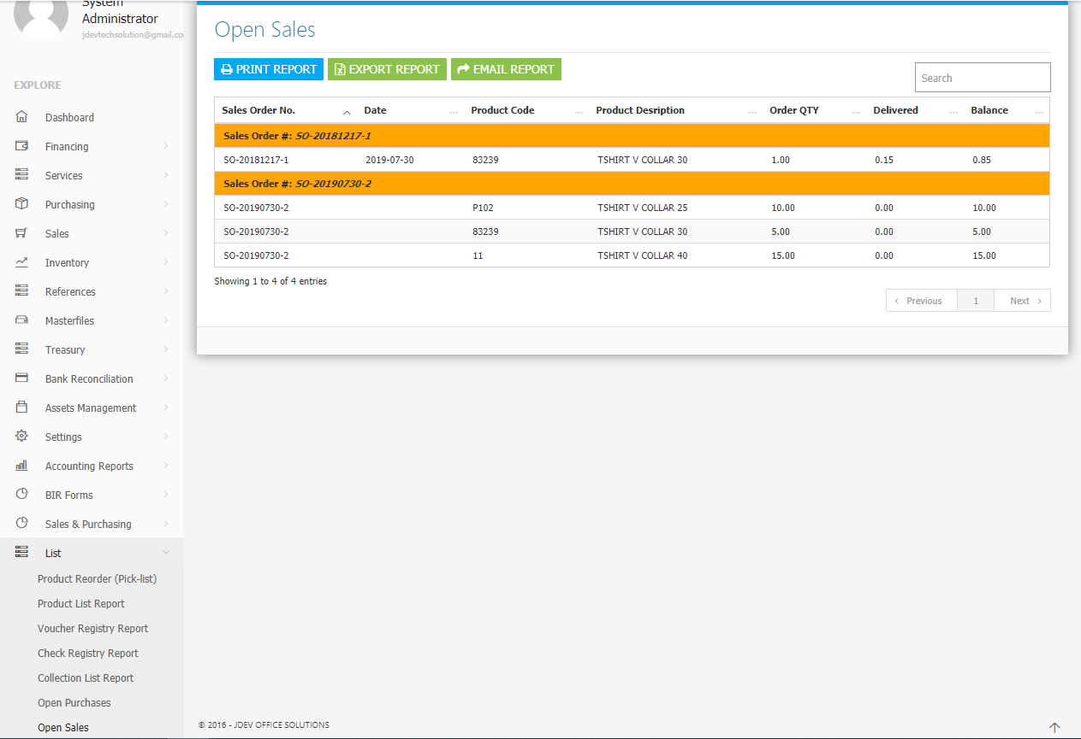

**Sales Flowchart**

