**COLLECTION ENTRY**

Listed in the *Figure 1* are the Payments posted in the Accounting System. **Post New Payments** to the Customers which have an outstanding Receivables recorded from the *Sales Journal / Accounts Receivable Module*. These Items are to be reviewed and posted later on as a Cash Receipt Journal in the Accounting.

**Figure 1**

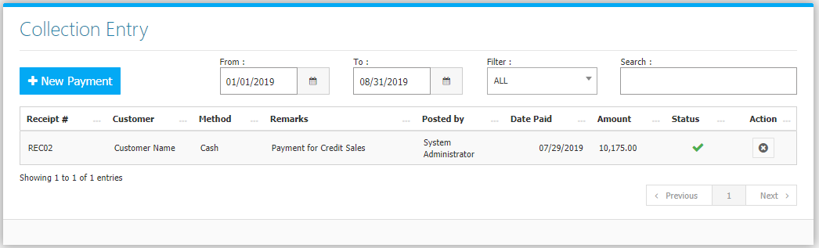

Change the **Date Range** *(from and to)*, and **Filter** *(all, active, or cancelled payments)* to your preference to filter the shown Payment Transactions. Use the **Search Field** to search for the information from inside the table. Clicking the **X Button** will mark the payment as cancelled. Click the **New** **Payment Button** to create.

**Figure 2**

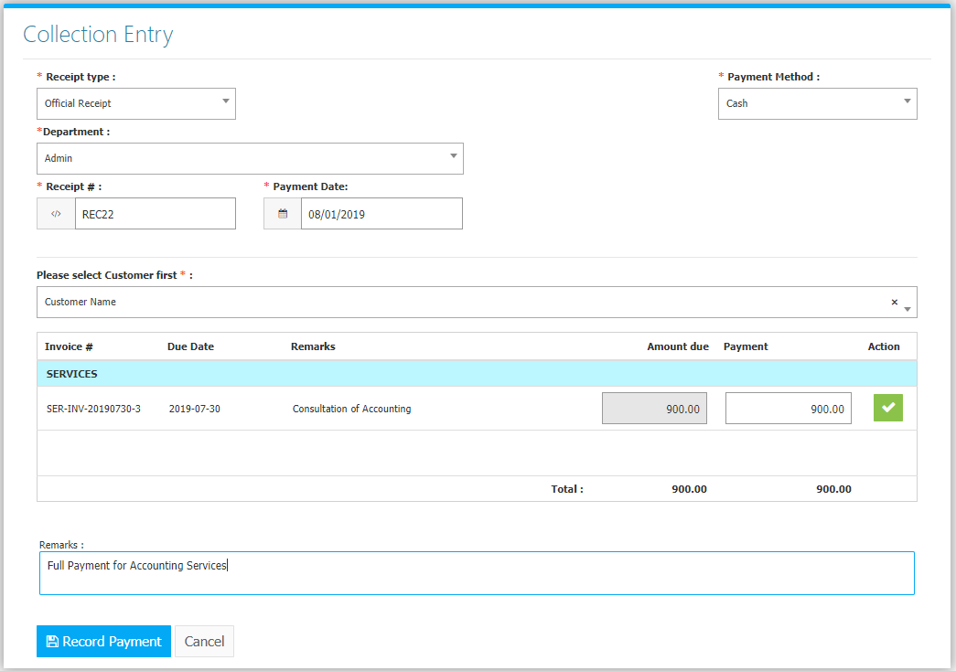

Fill the Form (Figure 2). Select a **Customer** and the system will generate outstanding receivables. Enter Payment Amount on the *Payment field* or Click the **Check Button** on the right to copy the payable amount. If Method of Payment selected is **Check**, fill *Check #* and *Check Date* as well. Click **Record Payment Button** to save.

**Sales Flowchart**

