**SALES ORDER**

Listed in the *Figure 1* are the Sales Orders created. A **Sales Order** is a confirmation document created by the company for a customer before delivering the goods or services. First, the prospective customer accepts the quote and sends a purchase order communicating that he wants to buy the product and then a sales order is created.

**Figure 1**

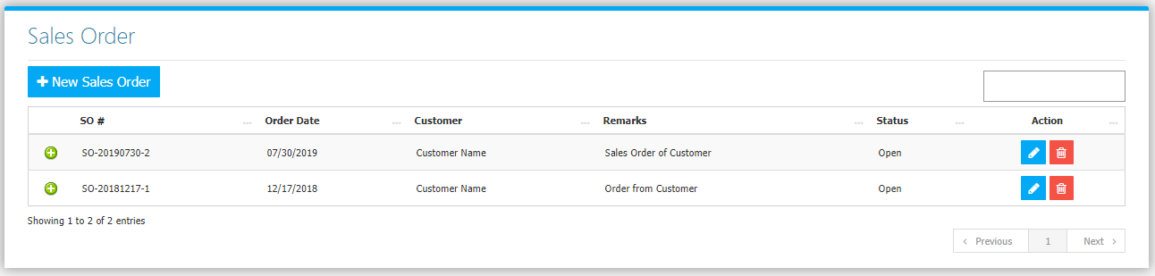

Use the **Search Field** to search for the information from inside the table. Click the **Trash Button** to delete, **Pencil Button** to edit. Clicking the **Print Button** will open the transaction/Sales Order as shown in *Figure 2.* It can be printed and downloaded as pdf.

**Figure 2**

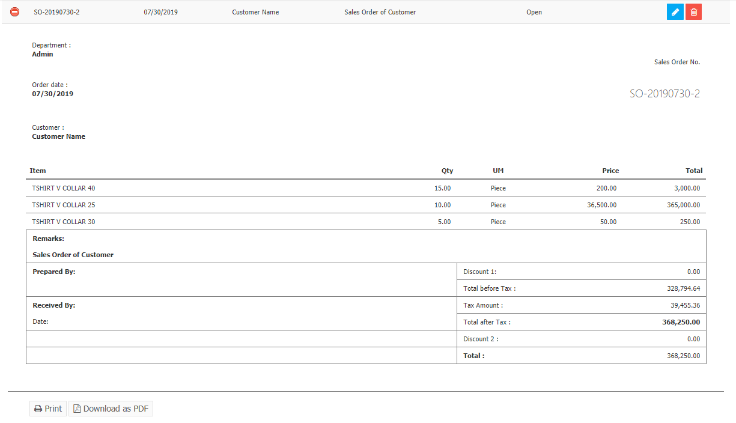

Click the **New** **Sales Order Button** to create. Fill the form *(Figure 3)* then click **Save Changes Button** to save.

**Figure 3**

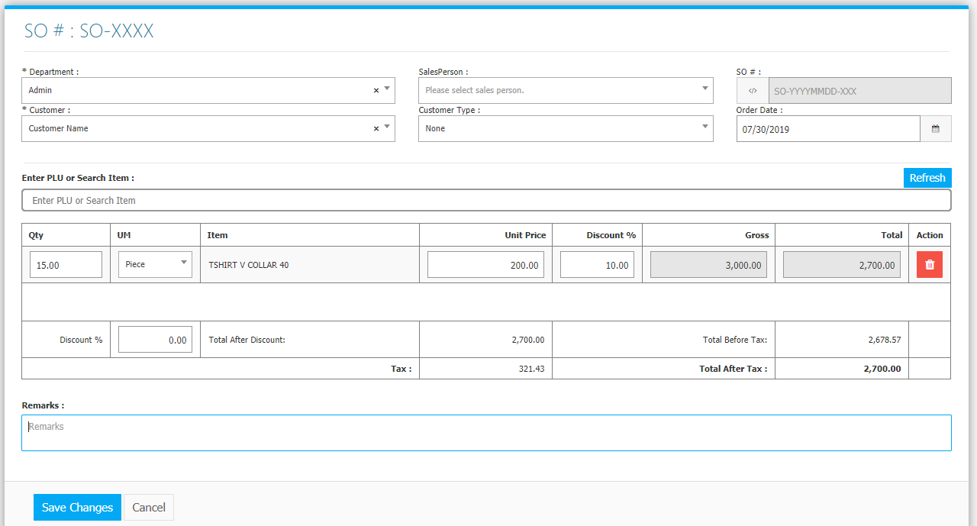

**Sales Flowchart**

