**WAREHOUSE DISPATCHING**

Listed in the *Figure 1* are the Dispatching Invoices created. A **Dispatching Invoice** is a note sent by the company to the buyer informing about the dispatch and delivery of goods. It contains the list of goods with their quantities, customer information, and delivery address. A dispatching invoice is created from the *Sales* and *Cash Invoices*.

**Figure 1**

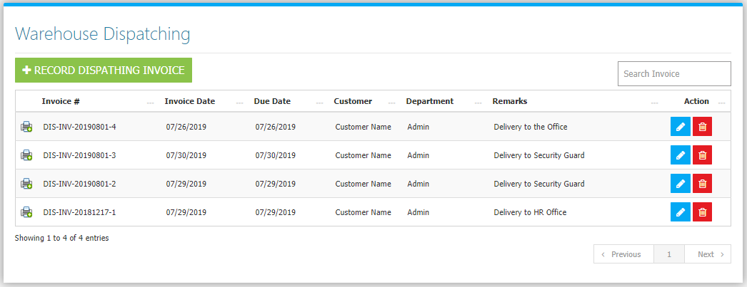

Use the **Search Field** to search for the information from inside the table. Click the **Trash Button** to delete, **Pencil Button** to edit. Clicking the **Print Button** will open the transaction/Dispatching Invoice as shown in *Figure 2.* It can be printed and downloaded as pdf.

**Figure 2**

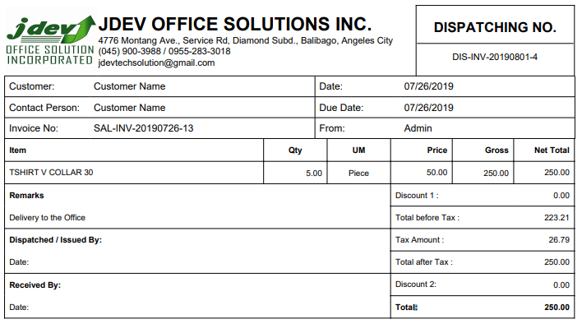

Click the **New** **Cash Invoice Button** to create. Use either a **Sales or Cash Invoice** to create a dispatching invoice*.* Click the **… Button** as shown in *figure 3* to choose from the sales orders list in *figure 4.*

**Figure 3**

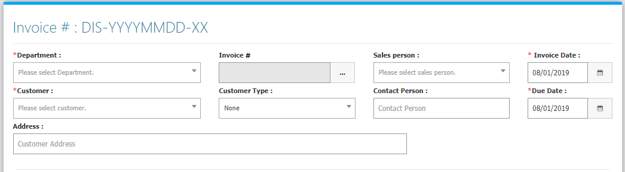

**Figure 4**

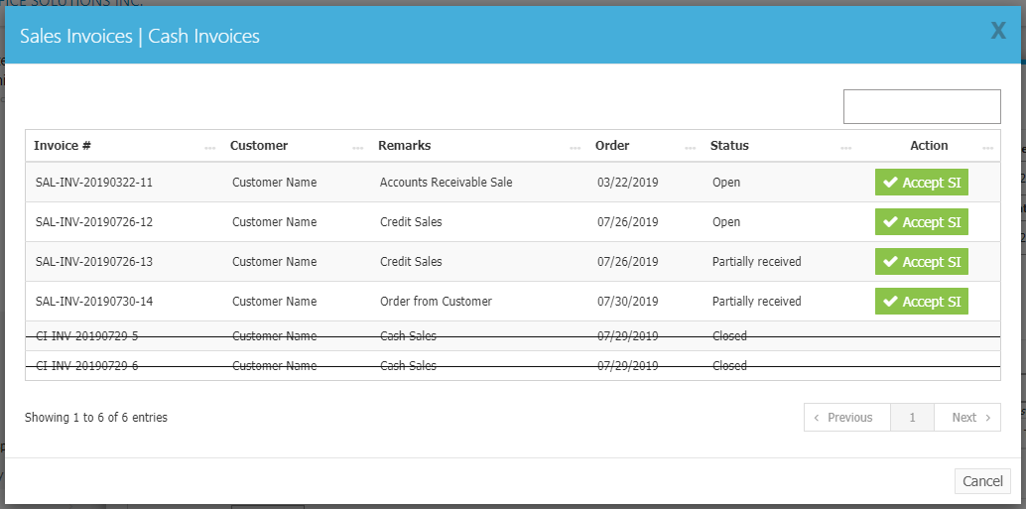

Every Sales Invoice will have a status: Open, Partially Received, and Closed. **Open** means *no* item has been dispatched yet, **Partially Received** means *some* of the items but not all, and **Closed** means *all* of the items from the Invoice has been dispatched. Click the **Accept Button** to use in the Invoice. Then the **items** of the chosen invoice will be dropped down in the form *(Figure 5)*.

**Figure 5**

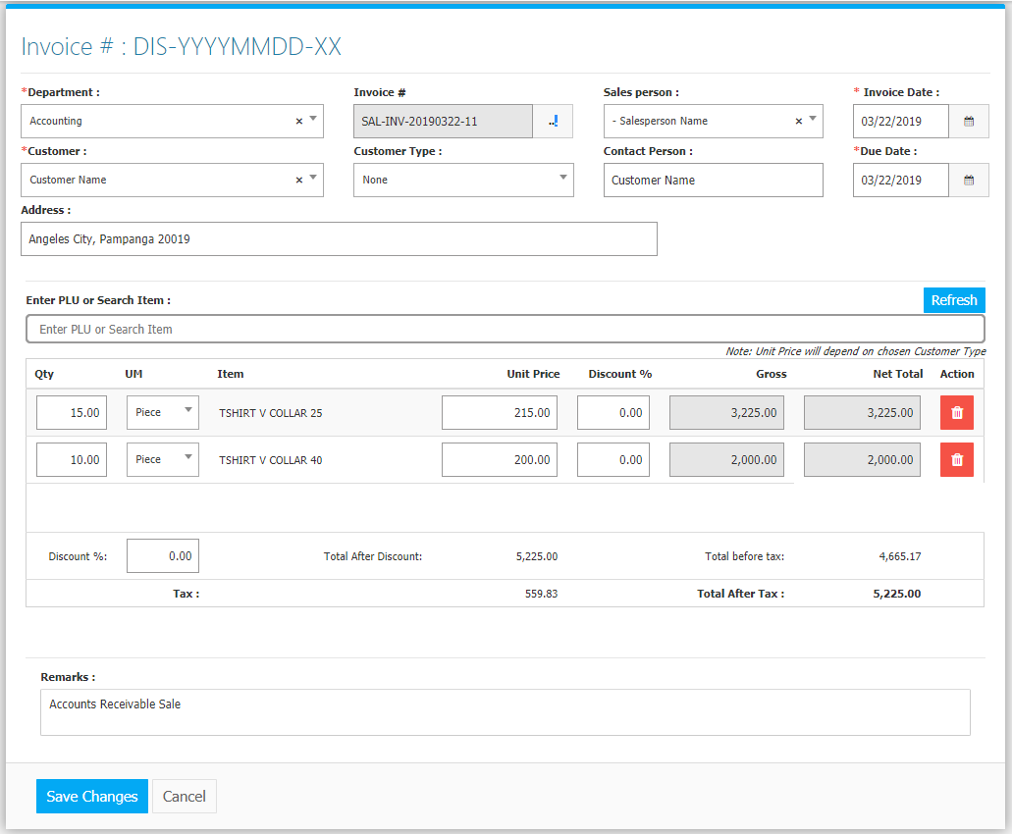

Click the **Save Changes Button** to confirm and save the invoice.