**REVIEW SERVICE JOURNAL**

Listed in the *Figure 1* are the Service Invoices from the **Service Invoice Module**. These Items are to be reviewed and posted as Accounts Receivable / Sales Journal in Accounting.

**Figure 1**

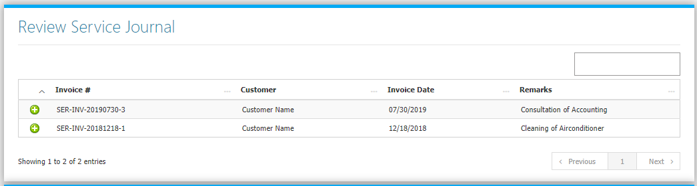

Clicking the **+ Butto**n will open the transaction. The Review Journal Tab *(Figure 2)* shows the Debit and Credit Entries and the Amounts. The Transaction Tab *(Figure 3)* shows the details of the Original Transaction. Adjust the details to your preference then click **Finalize this Journal** **Button** to post the Transaction to Accounting.

**Figure 2**

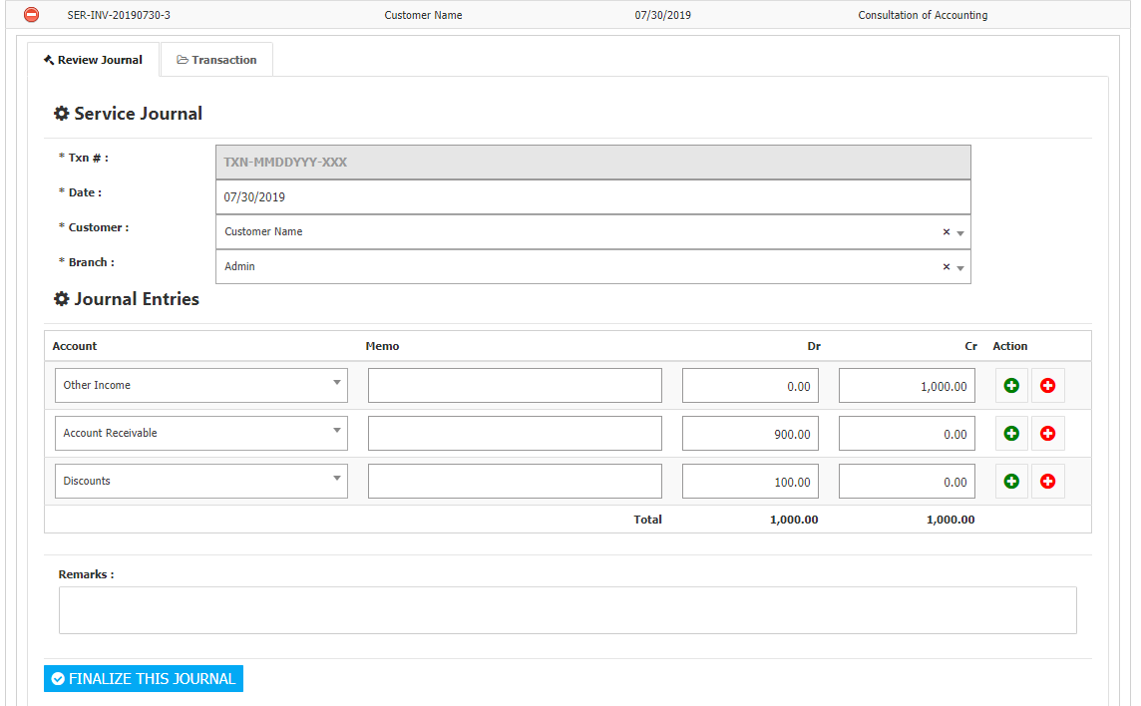

**Figure 3**

