**SERVICES /AR JOURNAL**

Listed in the *Figure 1* are the Service Journal Entries Posted in the Accounting System. The **Service *Journal*** is the master journal to where all the service transactions or entries of the company are recorded in such as *non-professional services*, *janitorial, consulting*, *architectural, or* *freelance creative professionals.*

**Figure 1**

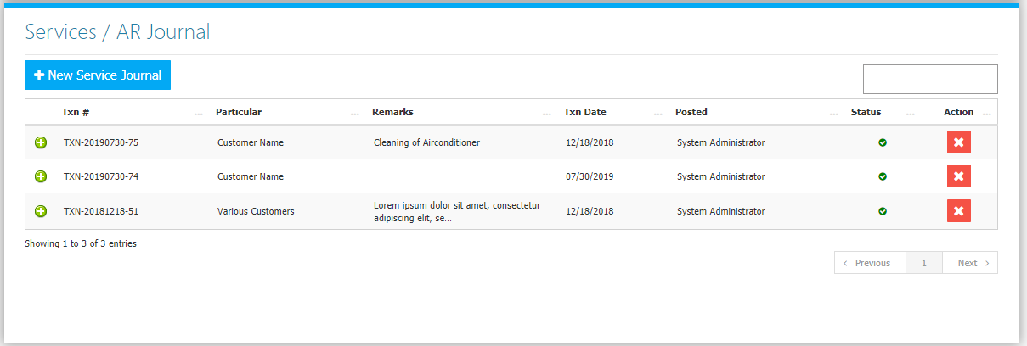 Use the **Search Field** to search for the information from inside the table. Clicking the **+ Button** will open the transaction/voucher as shown in *Figure 2.* Thevoucher can be printed and downloaded as a PDF File. Clicking the **X Button** will mark the Journal either cancelled or active.

**Figure 2**

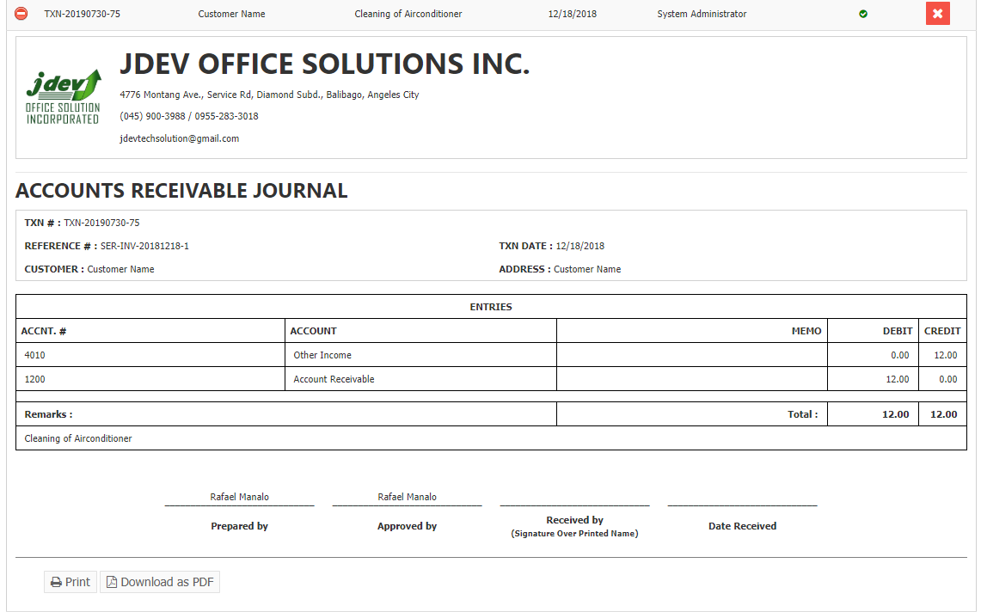

Click the **New** **Service Journal Button** to create. Fill the form *(Figure 3)* then click **Save Changes Button** to save.

