**SERVICE INVOICE**

Listed in the *Figure 1* are the Service Invoices. ***Service Invoice*** is an invoice associated with *non-professional services*, *janitorial, consulting*, *architectural, or* *freelance creative professionals.*

**Figure 1 Figure 2**

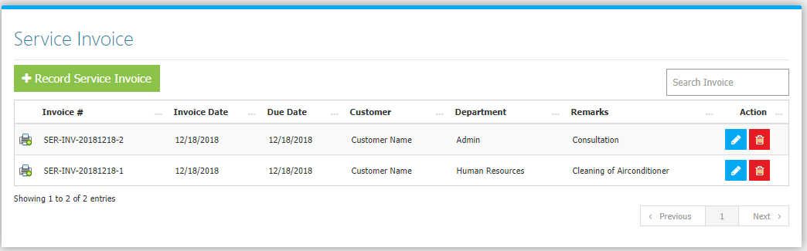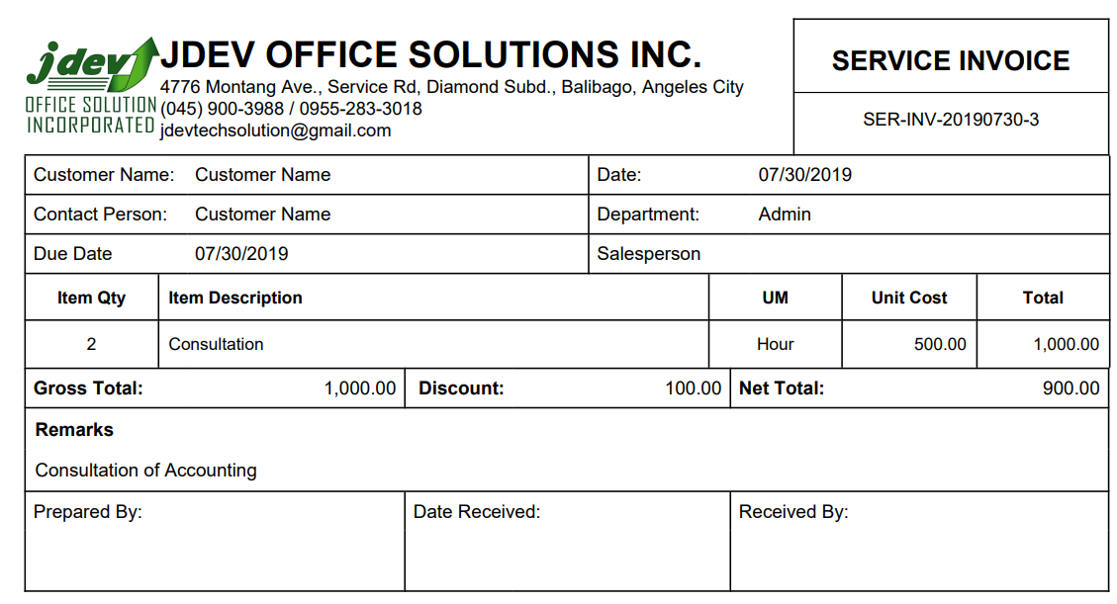

Use the **Search Field** to search for the information from inside the table. Clicking the **Printer Button** will open the transaction/voucher as shown in *Figure 2.* Thevoucher can be printed and downloaded as a PDF File. Clicking the **Trash Button** will delete the invoice. Click the **Record Service Invoice Button** to create new (Figure 3). Fill the Required information and services then click **Save Changes Button** to save.

**Figure 3**

