**SERVICE MANAGEMENT**

Listed in the *Figure 1* are the Services. Examples of these are *non-professional services*, *janitorial, consulting*, *architectural, or* *freelance creative professionals, and other services offered by your company.*

**Figure 1**

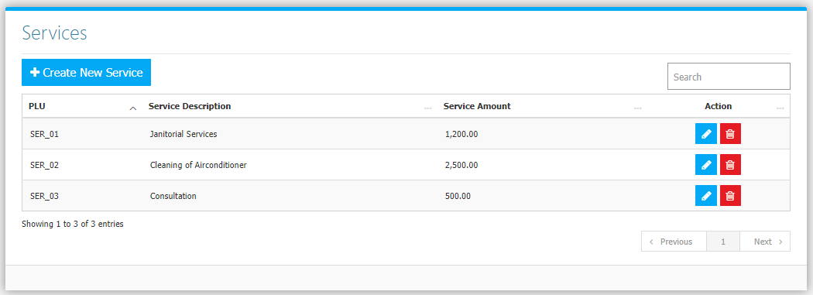

Use the **Search Field** to search for the information from inside the table. Click the **Trash Button** will delete the service, **Pencil Button** to Edit. Click the **Create New Service Button** to create new (Figure 2). Fill the Required information and choose appropriate **Link to Credit Account** *(or Income Account Title, choose* ***None*** *if the service is will not be recorded in Accounting)* then click **Save Button** to save.

**Figure 2**

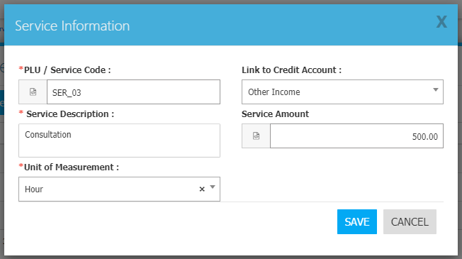

All Service Invoices created in the **Service Invoice Module** are to be posted in accounting. If the **service** created above *(Figure 2, with the Service Description of Consultation)* is used in an invoice, and reviewed in Accounting, the **Link to Credit Account** chosen (in this case **Other Income**) will be the **Credit Account Title** default *(Figure 3)*.

**Figure 3**

