**SERVICE UNITS**

Listed in the *Figure 1* are the Service Units. ***Service Units*** are used in Service Management as *Unit of Measurement* for each Service*.*

**Figure 1**

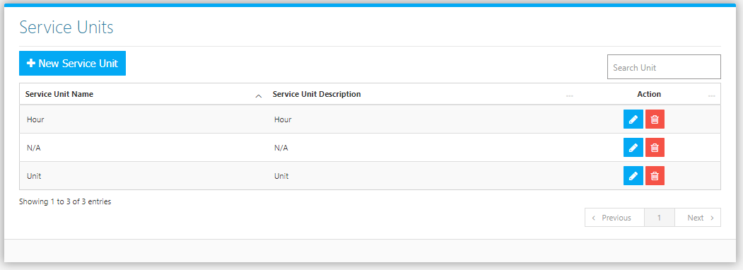

Use the **Search Field** to search for the information from inside the table. Click the **Trash Button** to delete the unit, **Pencil Button** to edit the unit. Click the **Record Service Invoice Button** to create new (Figure 2). Fill the Required information and services then click **Save Button** to save.

**Figure 2**

