**CHART OF ACCOUNTS**

A **Chart of Accounts** (COA) is a financial organizational tool that provides a complete listing of every account in an accounting system. An account is a unique record for each type of asset, liability, equity, revenue and expense. A COA, which lists the names of the accounts that a company has identified and made available for recording transactions in its *General Ledger*, establishes the level of detail tracked in a record-keeping system. Typically, a COA contains the accounts’ names, brief descriptions and identification codes. Listed in *Figure 1* are the Chart of Accounts created in the Accounting System.

**Figure 1**

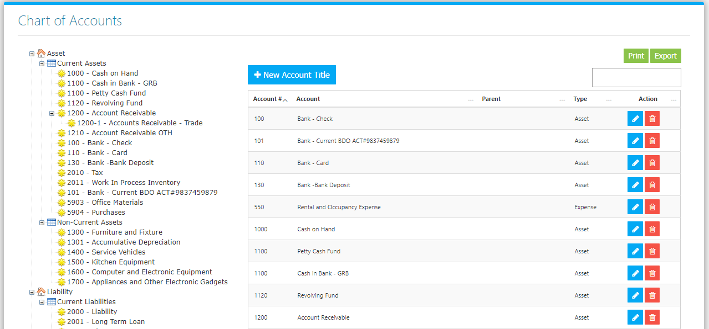

Use the **Search Field** to search for the information from inside the table. Click the **Trash Button** to delete, **Pencil Button** to edit. Click the **Print Button** to print the COA Master File *(Figure 2),* and **Export Button** to save the Master File to an Excel File *(Figure 3)*.

**Figure 2 Figure 3**

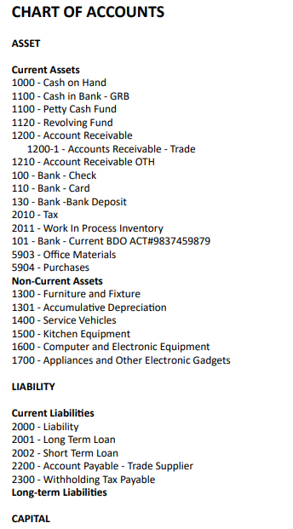 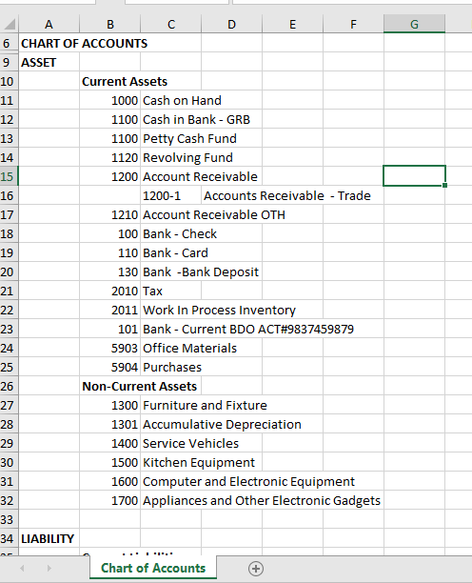

Click the **New Account Title Button** to create. Fill the Form *(figure 4),* select the Classification, and Parent Account, then click the **Save Changes Button** to save.

**Figure 4**

