**USER ACCOUNTS**

Listed in Figure 1 are the users created in the Accounting System. Use the **Search Field** to search for the information from inside the table. Click the **Trash Button** to delete, **Pencil Button** to edit.

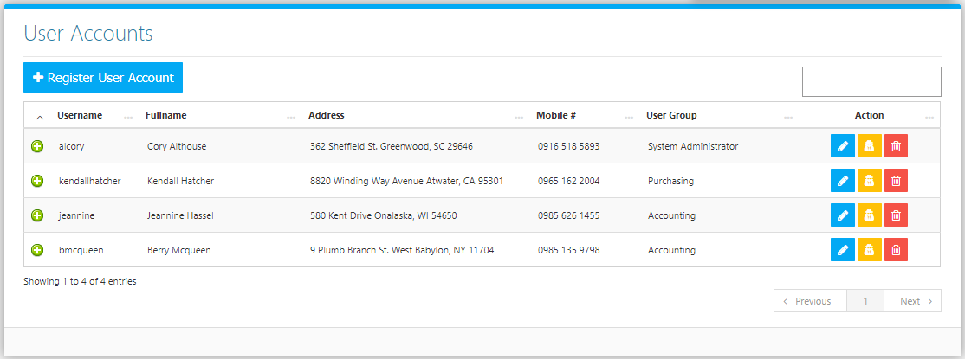

Click the **User** **(Yellow) Button** to change the Password of the User (Figure 2).

**Figure 2**

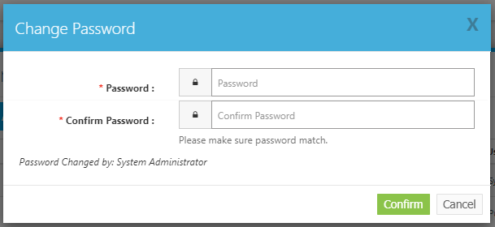

Click the **+ Button** to show the details of the user. (Figure 3).

**Figure 3**

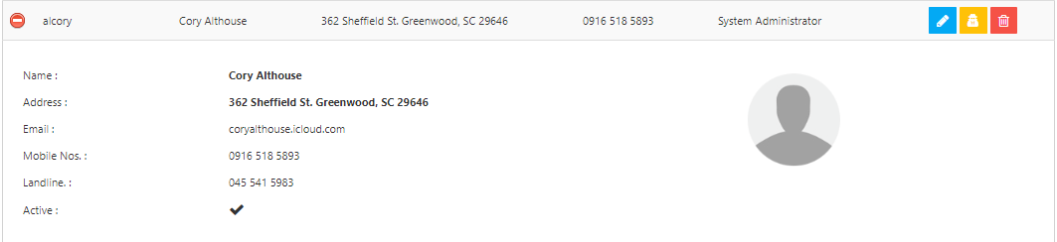

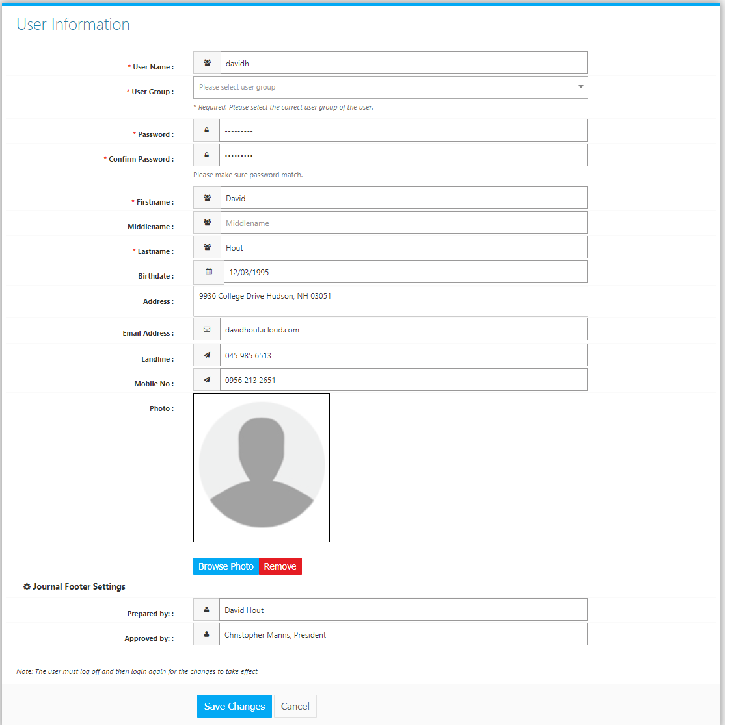Click the **Register User Account Button** to create new. Fill the Form *(Figure 4)*, and click **Save** **Changes Button** to save new user. **Journal Footer Settings** are used as default *prepared by* and *approved b*y when printing Journal Vouchers.