**FIXED ASSET SETTINGS**

The Fixed Asset Module is used to *automatically generate* fixed assets in the Fixed Asset Masterfile Module thus reducing the time of the user encoding many individual fixed assets. To begin, Check the Appropriate Account Titles to be regarded as Fixed Assets *(Figure 1).* In this case, **products** which are set up with the account titles of *Furniture and Fixture, Kitchen Equipment, Computer and Electronic Equipment, or Office Materials* for the ***Link to Debit Account (For Purchase Journal)***, will be regarded as fixed assets.

**Figure 1**

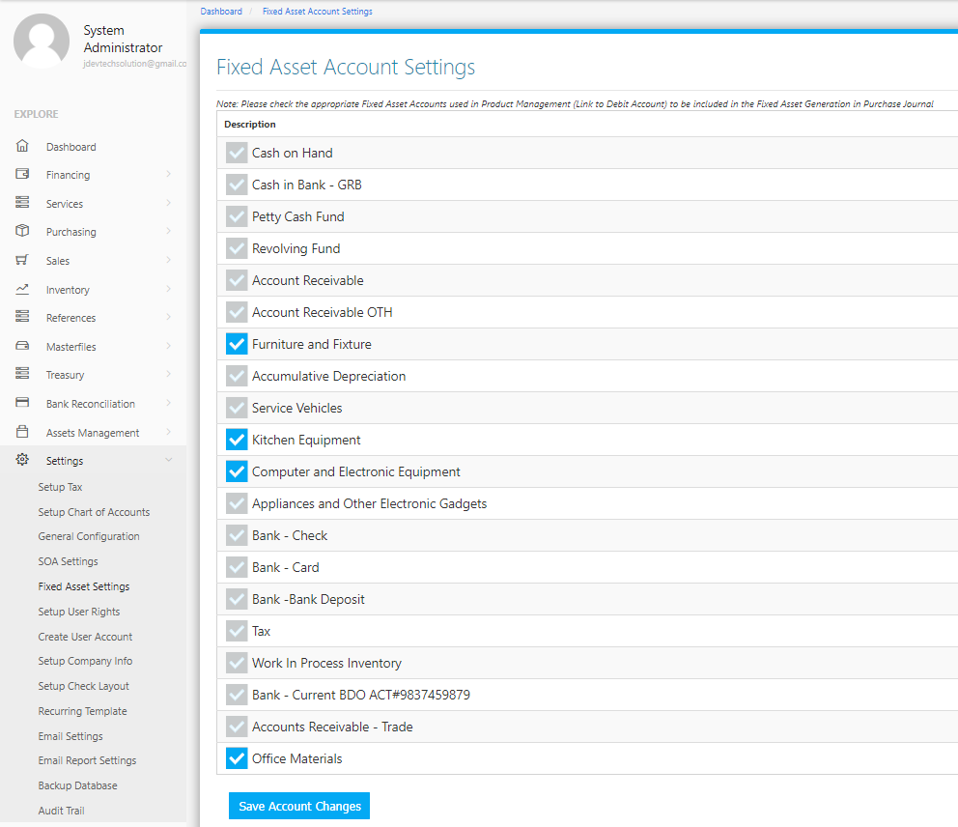

The system detects which products are Fixed Assets depending on the setup of the Product in the **Masterfiles Menu -> Product Management** as shown in *Figure 2*. Assign the appropriate **Fixed Asset Account Title** to the *Link to Debit Account (For Purchase Journal)* part of the Form. In this case, the Account Title chosen is *Furniture and Fixture*.

**Figure 2**

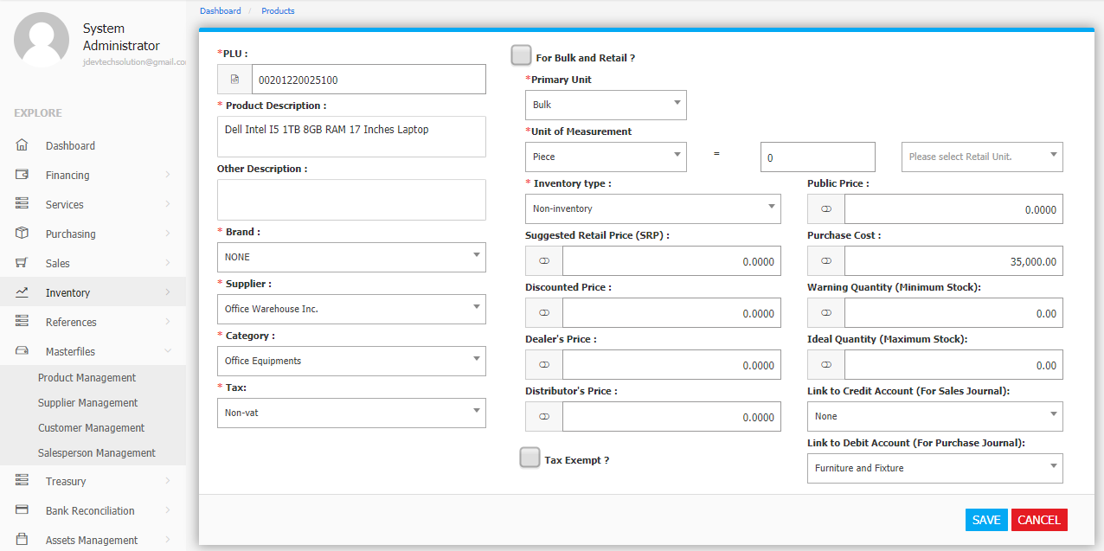

Upon *reviewing* and *posting* Purchase Invoices in the Purchase Journal Module (Figure 3), the System can detect if certain products purchased are Fixed Asset. In the **Fixed Asset Tab**, fixed assets are shown. Clicking the **+ Button** will show the details of the Product as shown in *Figure 3*.

**Figure 3**

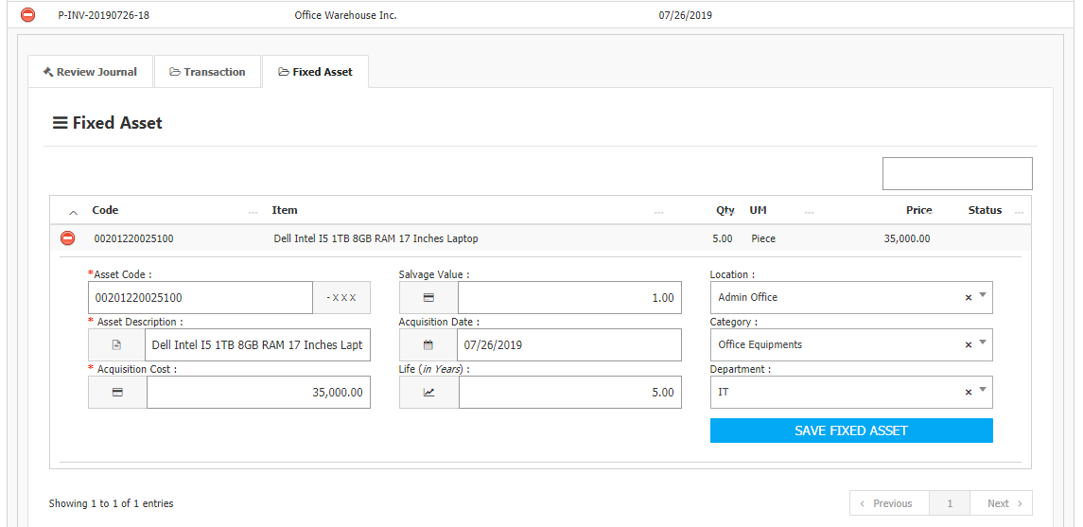

Fill up all the fields then click the **Save Fixed Asset Button** to automatically generate and add the Product on the **Master List** of the Fixed Assets which can be found in the **Asset Management Menu -> Fixed Asset Management** as shown in *Figure 6.* The system will generate and add the product depending on the *quantity* of the item. In this case, the system generated five (5) assets of the *Dell Intel I5 1TB 8GB RAM 17 Inches Laptop* having its own unique *Asset Code.*

