**GENERAL CONFIGURATION**

The General Configuration Settings contains the Account Title (Chart of Accounts) **Defaults** to be used in various Accounting Modules. These accounts are crucial in the Accounting System so we suggest that you set up with great caution. Always Click the **Save Button** for Every *Menu Tab* to save configuration changes for every category.

**SUPPLIER INTEGRATION ACCOUNT**

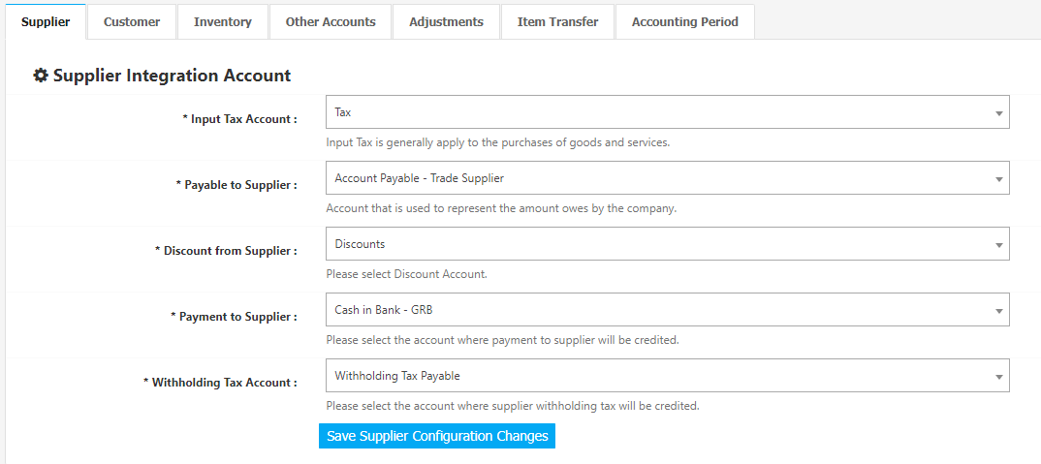

Accounts **Set** for *Input Tax Account, Payable to Supplier* in the **Supplier Integration Account** are used in *reviewing* and *posting* of Purchase Invoices in the Purchase Journal Module *(Figure 2).* **Debit** for the *Input Tax Account*, **Credit** for *Payable to Supplier. Payable to Supplier Account* is also used in the **Computation of Outstanding Payables** for the *Record Payment Module* in the Purchases Modules, and *Aging of Payable Report*.

**Figure 2**

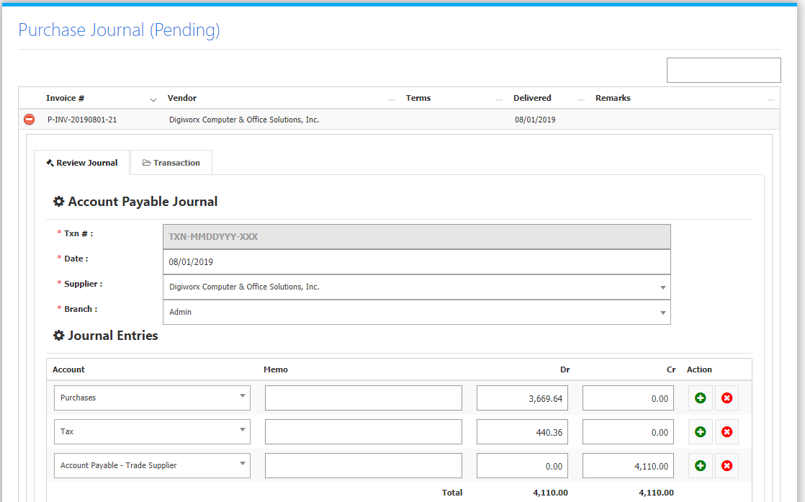

Accounts **Set** for *Payment to Supplier, Withholding Tax Account* in the **Supplier Integration Account** are used in *reviewing* and *posting* of Payments in the Cash Disbursement Journal Module *(Figure 3).* *Withholding Tax Account* is used when **Applying 2307 Form** in Cash Disbursement Journal. **Credit** for both *Payment to Supplier*, and *Withholding Tax Account*.

**Figure 3**

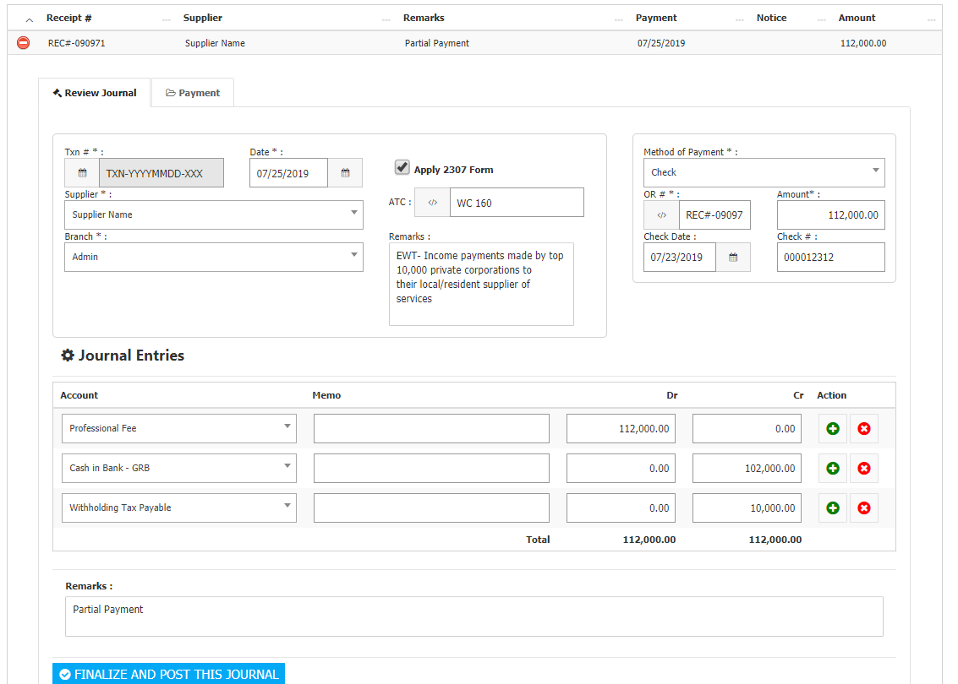

**CUSTOMER INTEGRATION ACCOUNT**

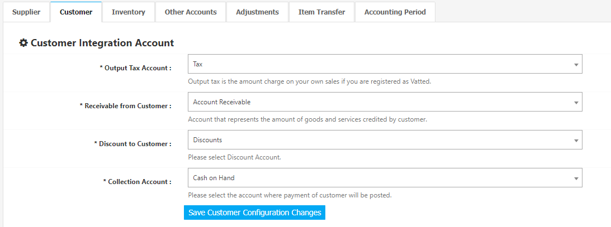

Accounts **Set** for *Output Tax Account, Receivable from Customer, Discount to Customer (if any)* in the **Customer Integration Account** are used in *reviewing* and *posting* of Sales Invoices in the Sales Journal Module *(Figure 5),* andCashInvoice in the Cash Receipt Journal Module *(Figure 6).* **Debit** for *Receivable from Customer*, *Discount*, and *Collection Account*. **Credit** for *Output Tax Account*.

**Figure 5**

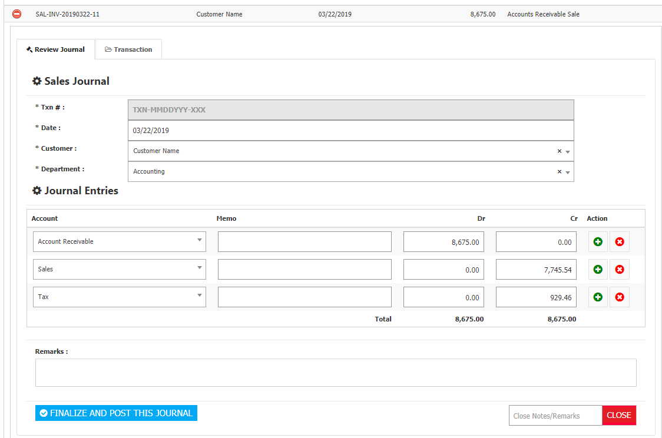

**Figure 6**

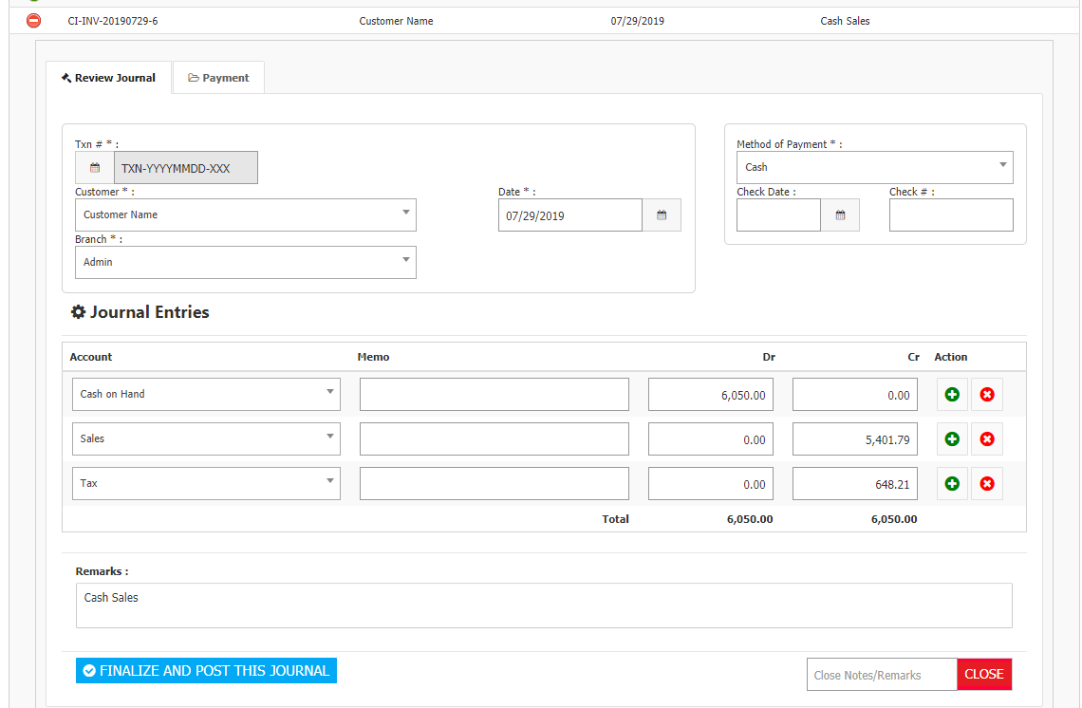

**INVENTORY INTEGRATION ACCOUNT**

**Figure 7**

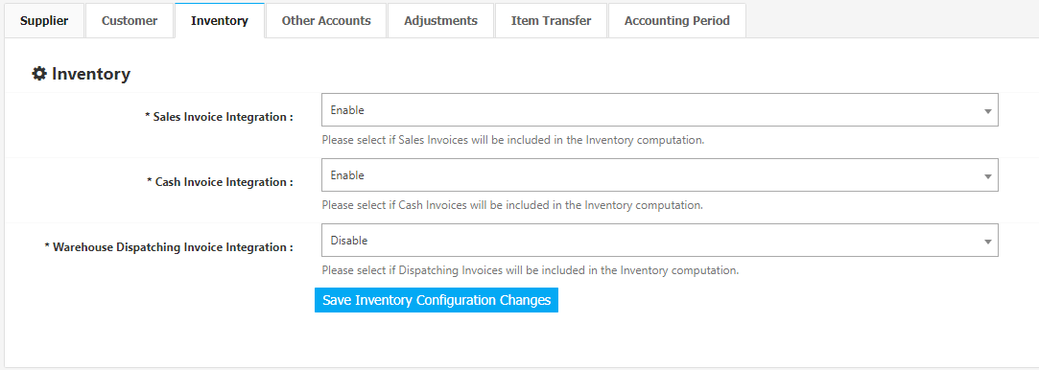

These settings will determine which modules are included in the computation of the **Inventory** *(Figure 7)*.

**OTHER ACCOUNTS SETTINGS**

**Figure 8**

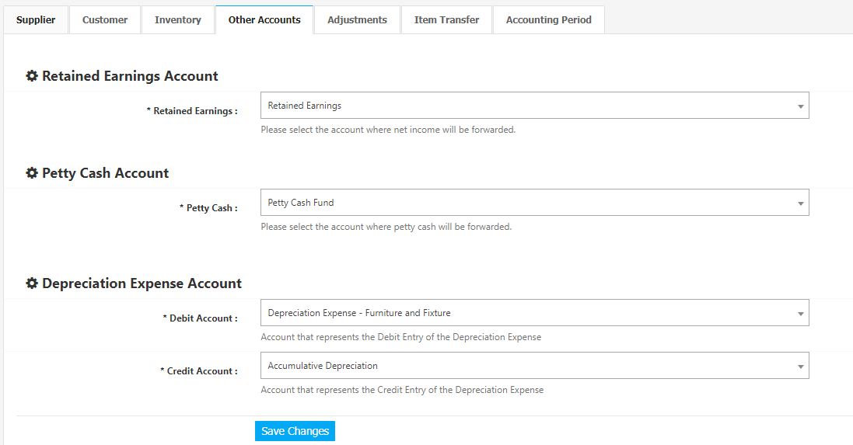

Accounts **Set** *(Figure 8)* for *Petty Cash Account* will be used in the computation of balances for the Petty Cash Module. *Depreciation Expense Account* are used in *reviewing* and *posting* of **Depreciation Expense** from the Fixed Asset Module (Figure 9).

**Figure 9**

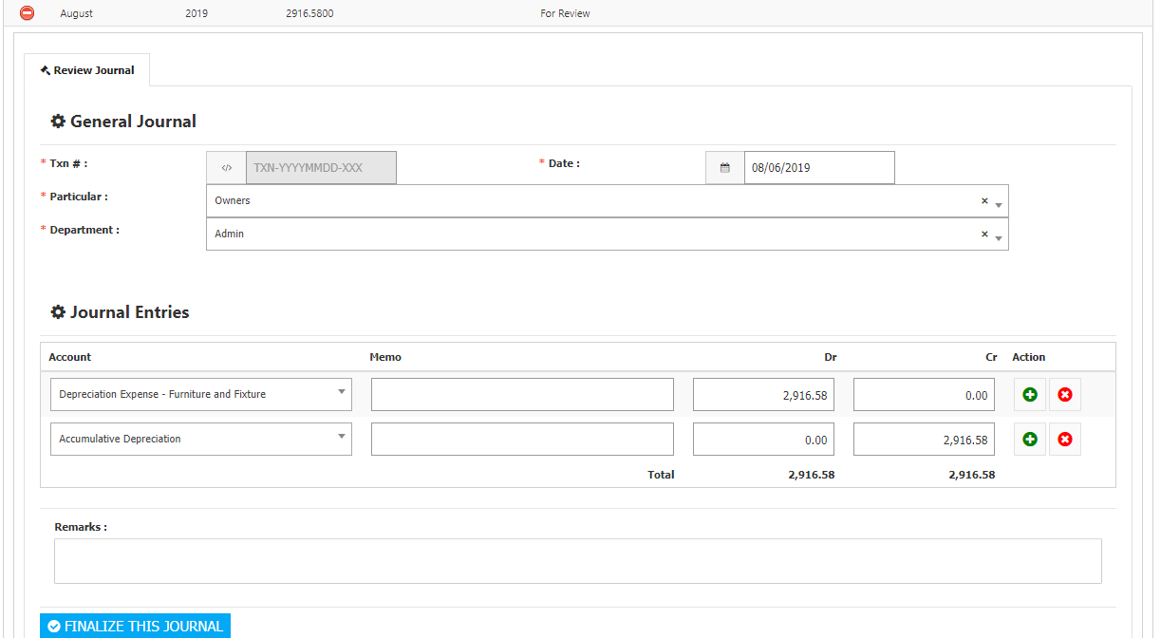

**ADJUSTMENT ACCOUNT INTEGRATION**

**Figure 10**

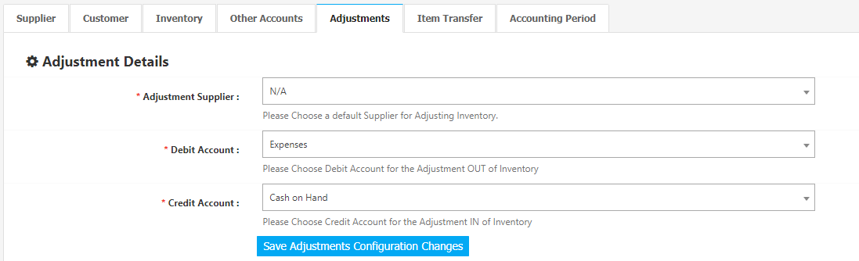

Account **Set** *(Figure 10)* for *Debit Account* is used for reviewing and posting of Adjustment OUT from the General Journal Module (Figure 11)*,* while account **Set** for *Credit Account* is used for reviewing and posting of Adjustment IN from the General Journal Module (Figure 12)*.*

**Figure 11**

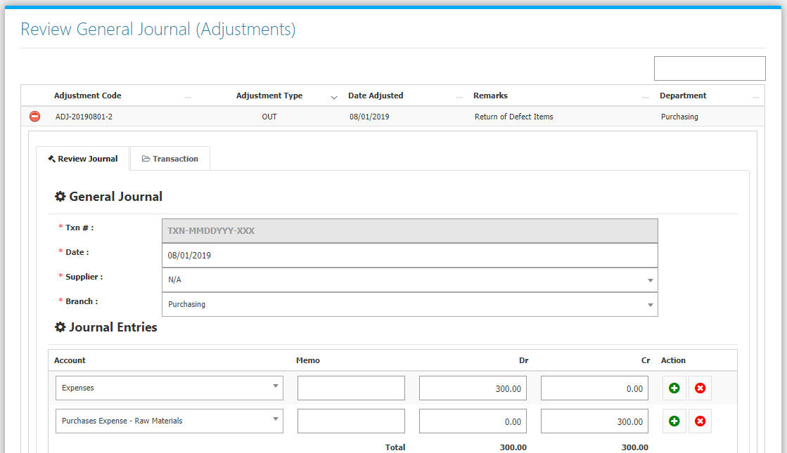

**Figure 12**

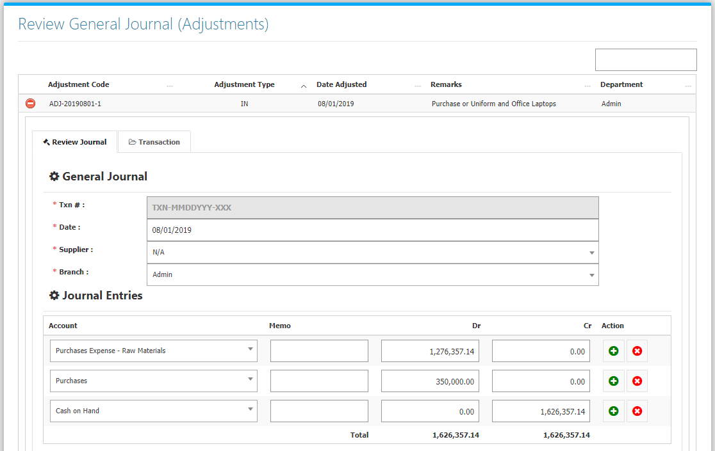

**Item Transfer** **Account Integration**

**Figure 13**

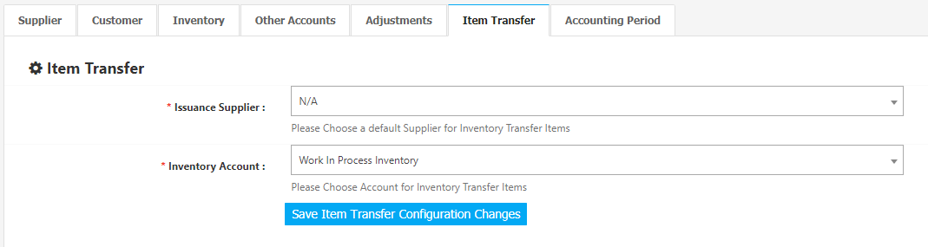

Account **Set** *(Figure 13)* for Inventory *Account, and Issuance Supplier* are used for reviewing and posting of Item Transfer Issuances from the General Journal Module (Figure 14)*.*

**Figure 14**

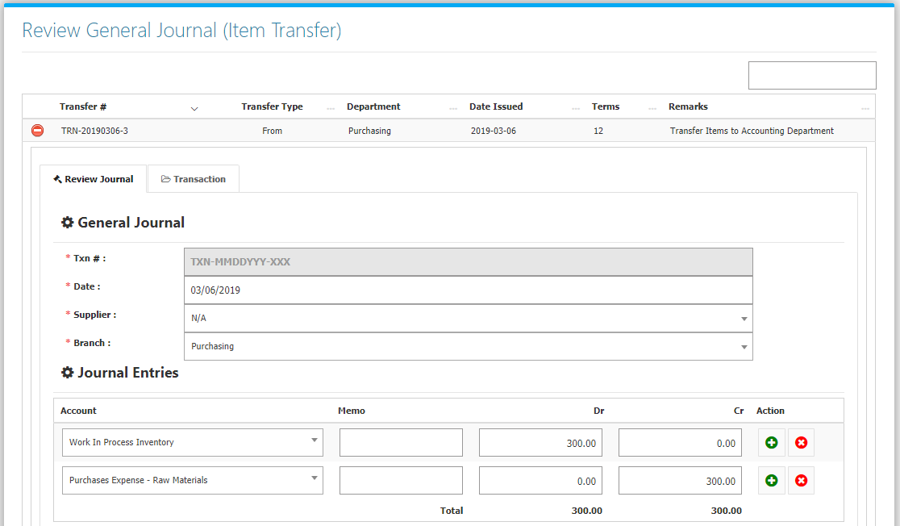

**Accounting Period**

An **Accounting Period** is an established range of time during which accounting functions are performed, aggregated, and analyzed including a calendar year or fiscal year. The accounting period is useful in investing because potential shareholders analyze a company’s performance through its financial statements that are based on a fixed accounting period. Listed in *Figure 15* are the *Closed* Accounting Periods. To close an Accounting Period, click the **Close Accounting Period Button**.

**Figure 15**

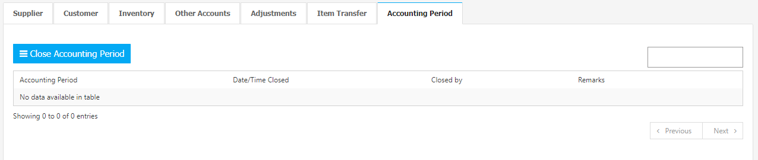

Fill the Form by selecting the last day (DATE), and Remarks of the Accounting Period. Then confirm by clicking the Close Accounting Period *(Figure 16).* After Closing, all transactions from the closed accounting period will be locked, and users will not be able to **Add** or **Cancel** Journal Transactions.

**Figure 16**

