**RECURRING TEMPLATES**

Certain Transactions repeat themselves on a regular basis. You can create or use templates for such recurring transactions (Figure 1). The template contains the *Particular*, *Debit* and *Credit Accounts* together with the *amounts*, and *Remarks*.

**Figure 1**

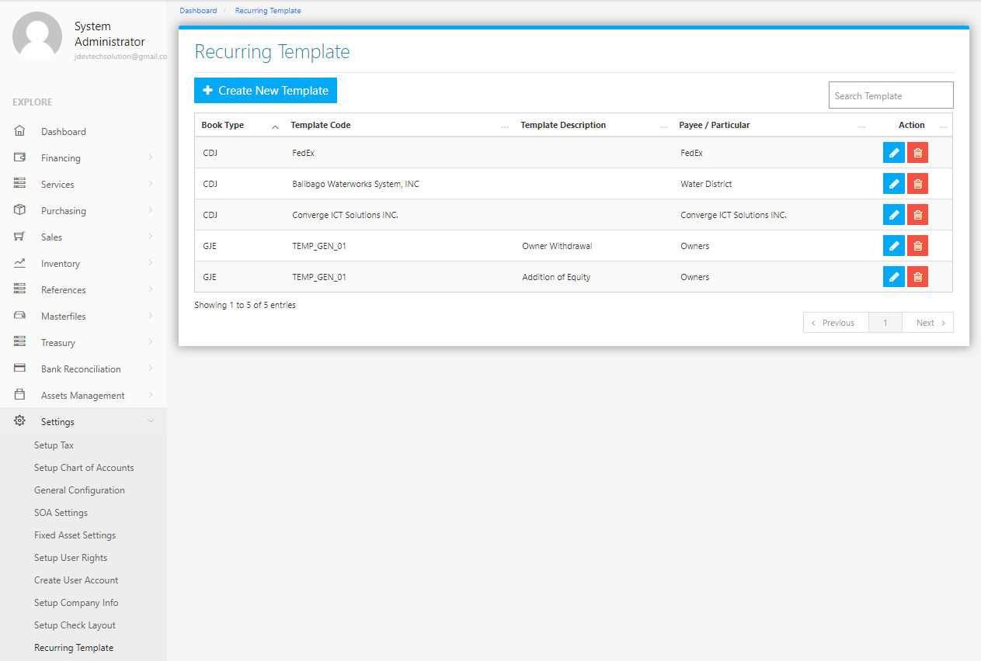

Use the **Search Field** to search for the information from inside the table. Click the **Pencil Button** to edit the template information, and **Trash Button** to delete the template. Click the **Create New Template Button** to create a new template*.* Select a Book Type and Accept *(Figure 2),* fill the form *(Figure 3)* then click the **Save Changes Button** to save.

**Figure 2 Figure 3**

