**SETUP CHECK LAYOUT**

Listed in Figure 1 are the **Check Layouts** created in the Accounting System. These Layouts can be used when printing *Checks* in the Cash Disbursement Journal Module.

**Figure 1**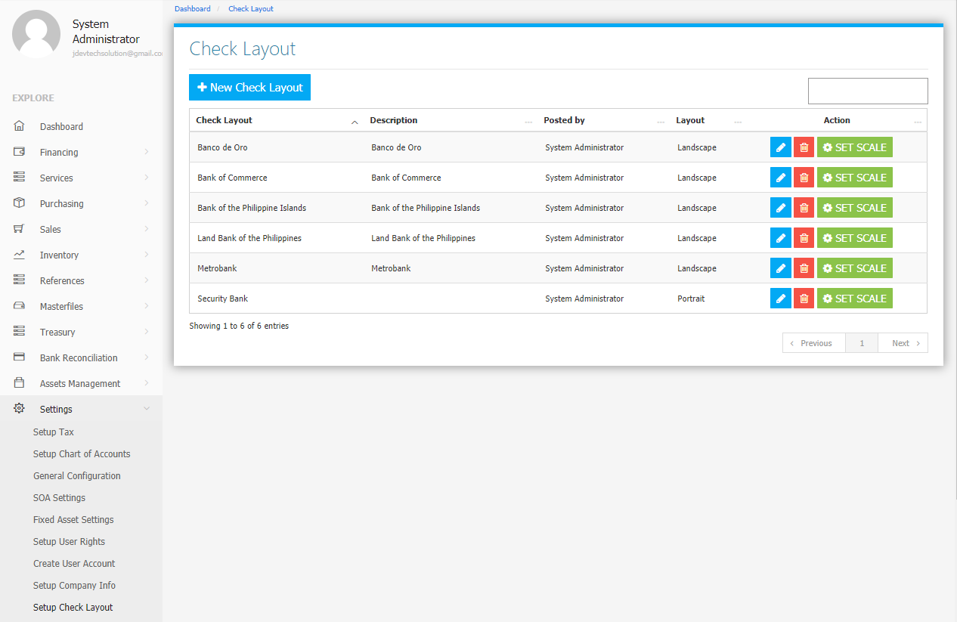

Use the **Search Field** to search for the information from inside the table. Click the **Pencil Button** to edit the layout information, and **Trash Button** to delete the layout. Click the **New** **Check Layout Button** to create a new *layout (Figure 2).* Fill the required fields then click the **Save Check Layout Button** to save.

**Figure 2**

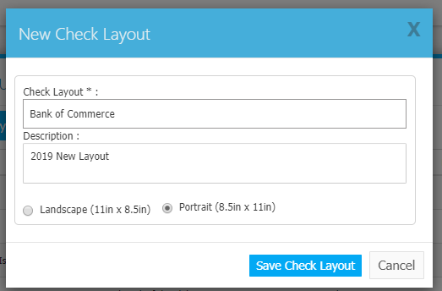

Click the **Set Scale Button** to show the current check layout positions *(Figure 3)*. Reposition *(Drag and Drop)* the check details such as Particular, Date, Amount in Words, and the Amount to your preference. Click the **X Button** at the top right corner to save and exit.

**Figure 3**

