**SETUP COMPANY INFORMATION** Used when printing reports, journals, and invoices.

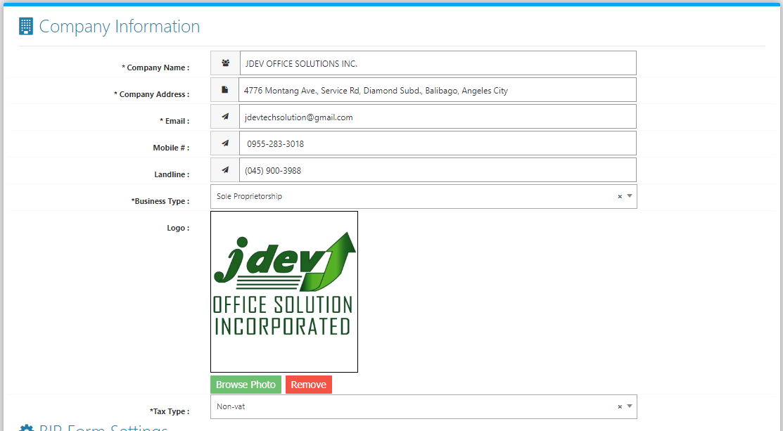

**BIR FORM SETTINGS** Used when printing BIR FORMS 2307, 2551M, and 2551Q.

