**TAX SETUP**

Listed in the *Figure 1* are the Tax Types created in the Accounting System. These tax types are used when setting up a Product in the Product Management Module for the computation of invoices in the Purchasing and Sales Modules.

**Figure 1**

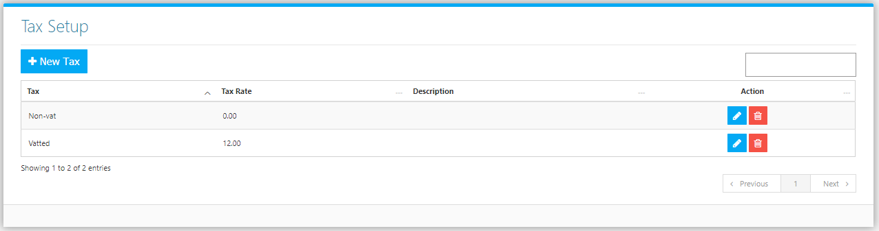

Use the **Search Field** to search for the information from inside the table. Click the **Trash Button** to delete, **Pencil Button** to edit. Click the **New Tax Button** to create. Fill the Form *(figure 2), and* click the **Save Button** to save.

**Figure 2**

