**USER GROUP RIGHTS**

**User Group Rights Module** is the process of granting authorized users the *right* to use a module, while *preventing* access to non-authorized users. In this page, you can create groups to categorize the access rights. Listed in the *Figure 1* are the User Groups created in the Accounting System.

**Figure 1**

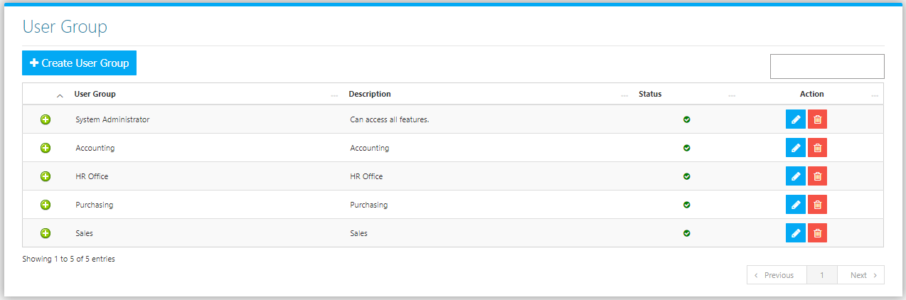

Click the **Create User Group Button** to create new. Fill the Form (Figure 2) and click the **Save Button** to save.

**Figure 2**

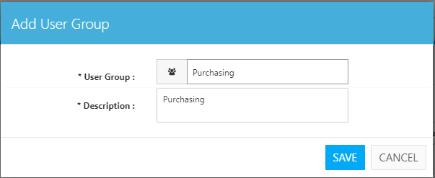

Clicking the **+ Button** will show the current Permissions of the user *(Figure 3)*. Choose *Enable* or *Disable* for each module as per your preference. Click **Save User Group Rights Button** at the bottom to save.

**Figure 3**

