**TREASURY**

Listed below are the *Checks* created from the **Cash Disbursement Journal**. In this Module, checks are separated into two tables, the **For Check Assignment Table** *(Figure 1)* for the Unprinted Checks, and **For Release Table** *(Figure 2)* for the Printed Checks.

**Figure 1 Figure 2**

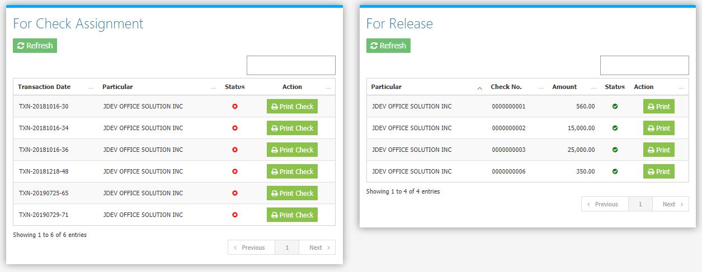

Clicking the **Print Check Button** will show a list of available check layouts *(Figure 3)*. Choose a layout then click the **Preview Check Button** to Print *(Figure 4 and 5)*.

**Figure 3 Figure 4**

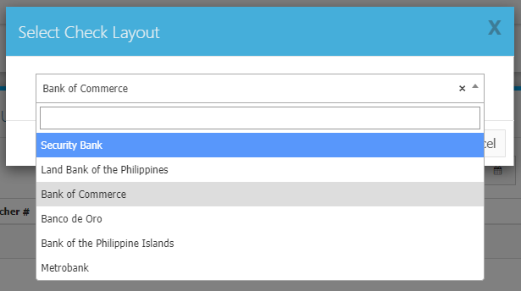 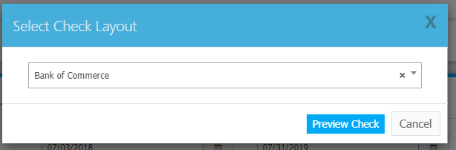

**Figure 5**

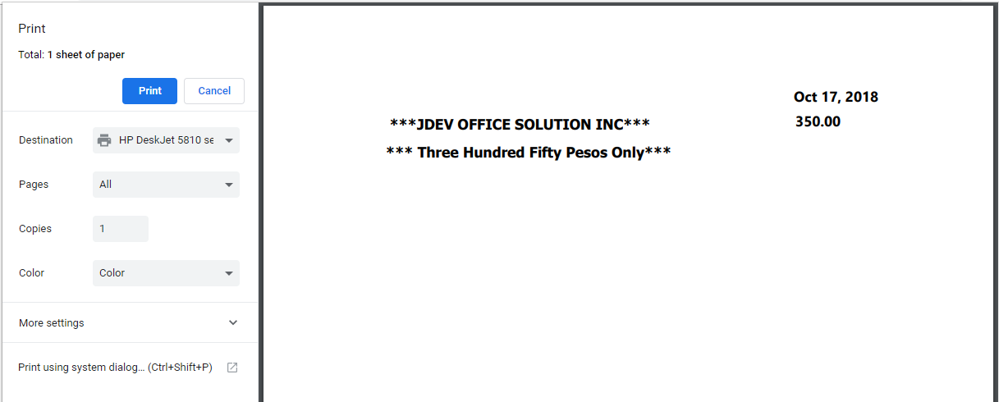

The List of Check Layouts *(Figure 6)* can be found in the **Settings Menu -> Setup Check Layout**.

**Figure 6**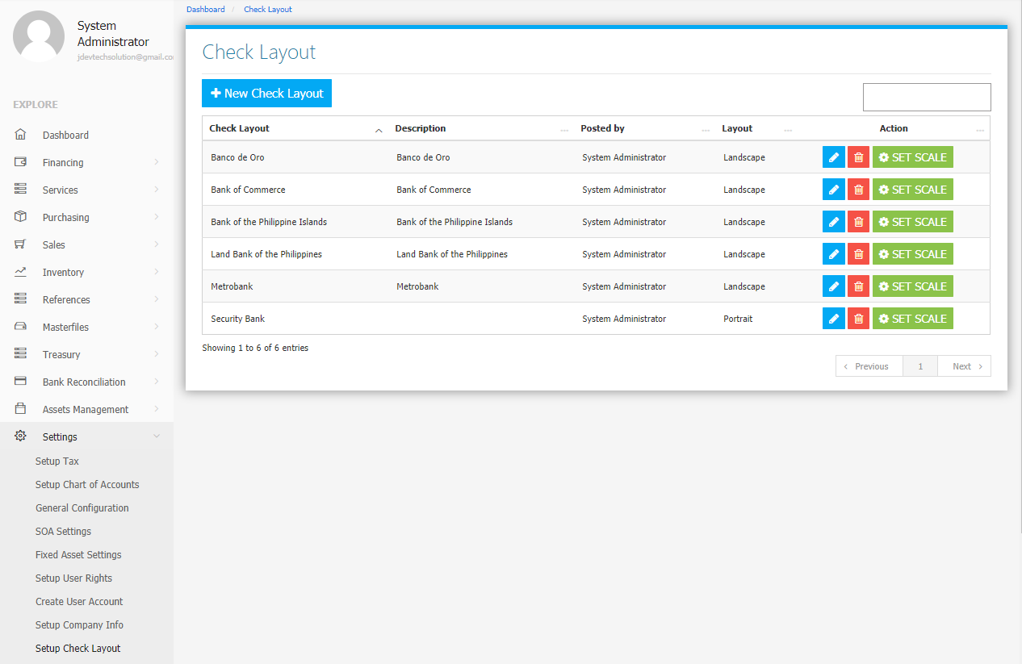

Use the **Search Field** to search for the information from inside the table. Click the **Pencil Button** to edit the layout information, and **Trash Button** to delete the layout. Click the **New** **Check Layout Button** to create a new *layout (Figure 7).* Fill the required fields then click the **Save Check Layout Button** to save.

**Figure 7**

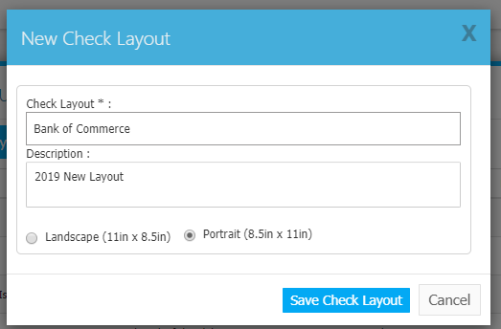

Click the **Set Scale Button** to show the current check layout positions *(Figure 8)*. Reposition *(Drag and Drop)* the check details such as Particular, Date, Amount in Words, and the Amount to your preference. Click the **X Button** at the top right corner to save and exit.

**Figure 8**

