1打印输出自己的名字：

package bao;

import java.util.Scanner;

public class First {

public static void main(String[] args)

{

Scanner sc=new Scanner(System.in);

String name=sc.next();

System.out.println("hello "+name+" !");

}

}

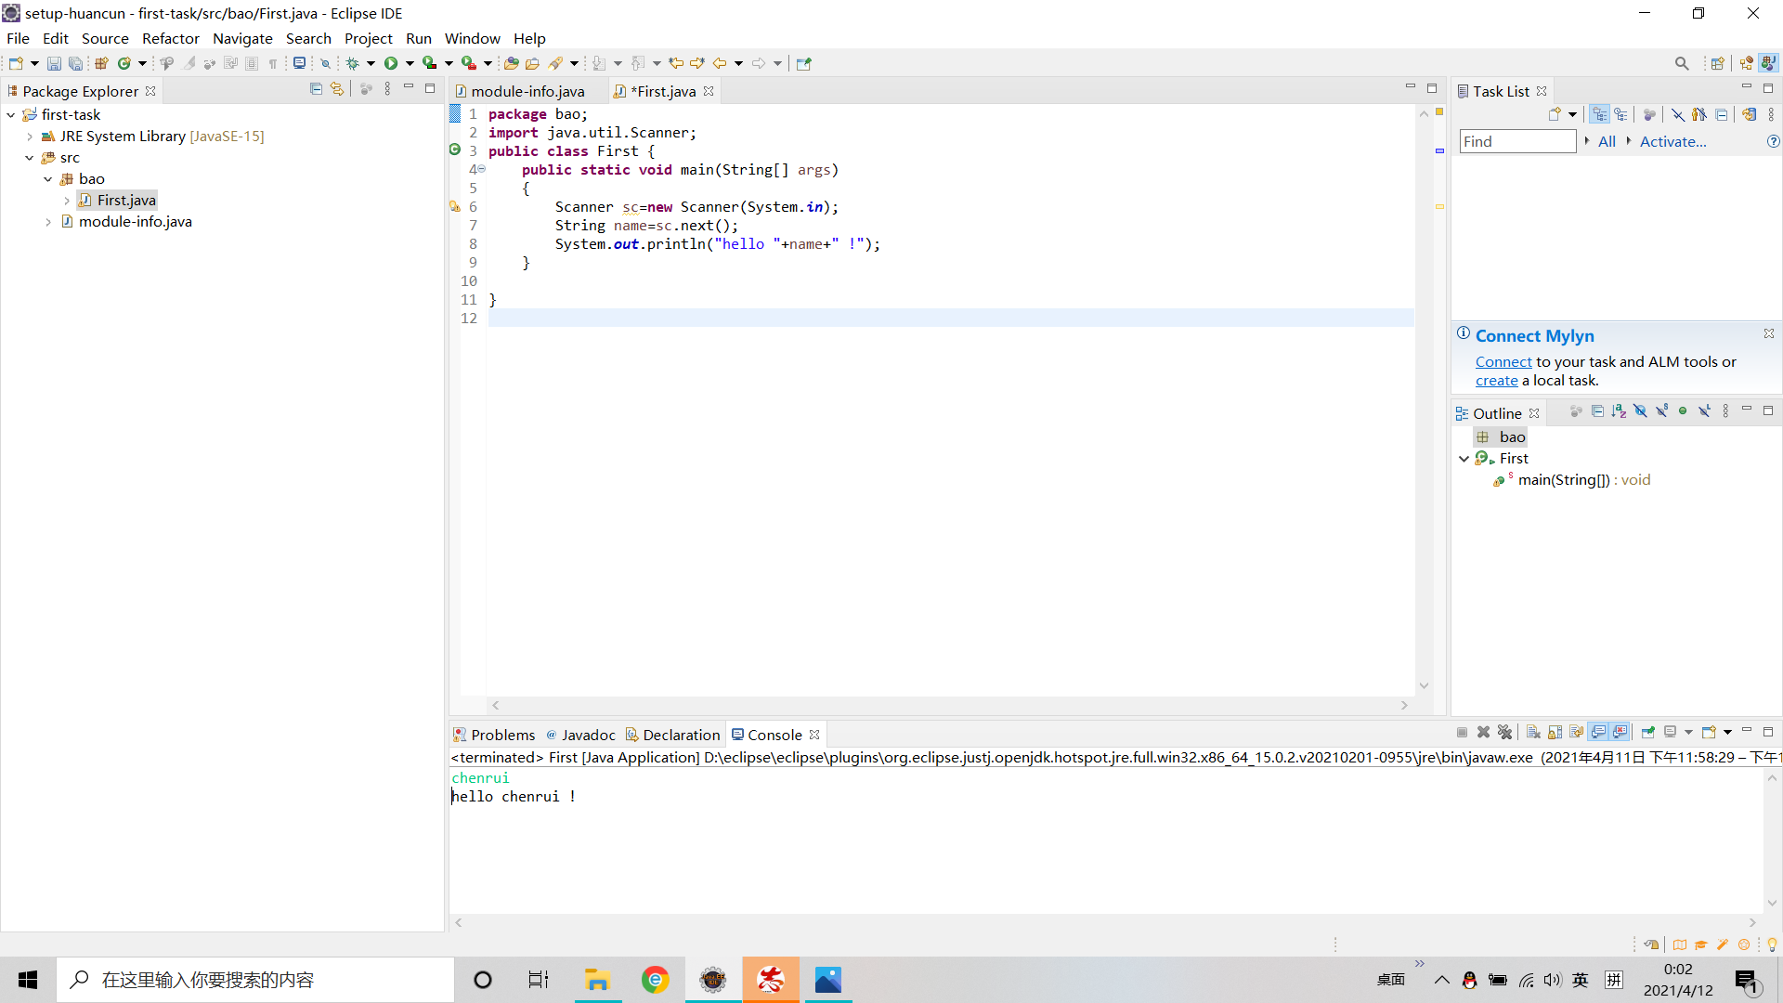

2.温度转换：

**package** bao;

**import** java.util.Scanner;

**public** **class** First {

**public** **static** **void** main(String[] args)

{

Scanner sc=**new** Scanner(System.***in***);

Double wendu=sc.nextDouble();

Double change=(wendu-32)/1.8;

System.***out***.println(wendu+"F="+change+"C");

}

}

