Oracle 11g XE Install
Here’s the Oracle Database 11g Express Edition step-by-step installation. I did the installation on Window 7 64-bit, and did run into a problem with the Windows Registry on a fresh installation (posted earlier on the blog).
When you download the software from Oracle, you’ll need an account and you’ll need to accept the license agreement.
- You’re prompted to accept the license agreement and can’t proceed without doing it.
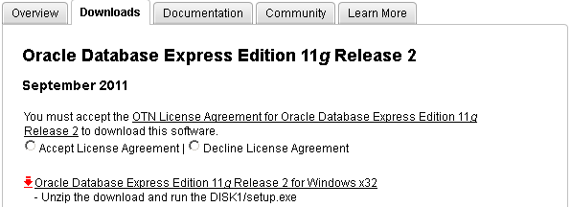
- After accepting the license agreement you can download the software.
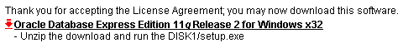
- Unlike, the Oracle 10g XE MSI file, you’ve downloaded a compressed (OracleXE112_Win32.zip) file, and you’ll need to explode the zip file and write it to a directory. When you write it to a directory, it looks like the following and you double click on the setup.msi file.
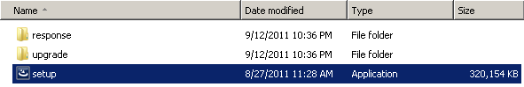
It’s recommended that you right click on the setup.msi program and run it as the Administrator. If you’ve not disabled Microsoft User Access Controls (UAC), I’d do that first.
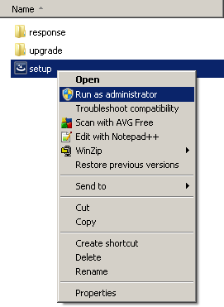
- After launching the setup.msi file, you see the Install Shield wizard screen while the file loads, like this:
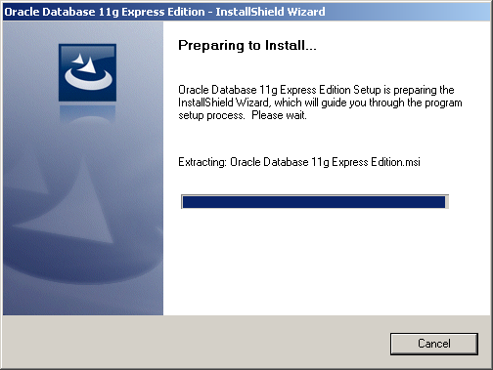
After launching the setup.msi file, and loading the MSI file, you see the first dialog box of the installation. Click the Next button to start the installation.
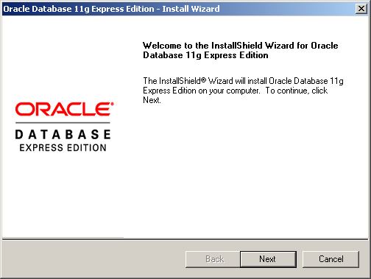
- The second dialog box is the license for the installation. Click the I accept the terms in the license agreement. radio button and then the Next button.
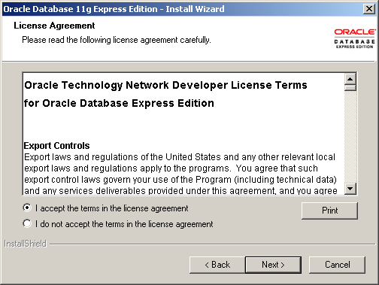
- The third dialog box lets you accept the default location or provide an override location. If you accept the default location, click the Next button to continue.
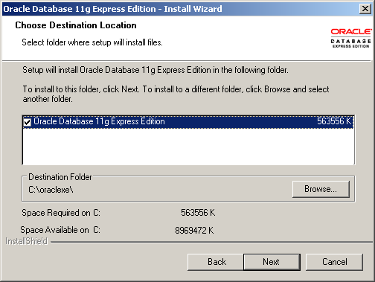
- The fourth dialog box lets you specify the TNS, MTS, and HTTP Ports. The default values are shown in the following screen shot but I’ve change my TNS port to 1621, which you’ll see later. Click the Next button to continue.
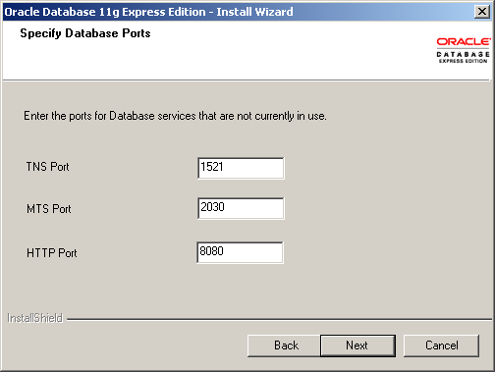
- The fifth dialog box lets you enter the password for the SYS and SYSTEM users. You must enter it twice and naturally they must match each other. Click the Next button to continue.
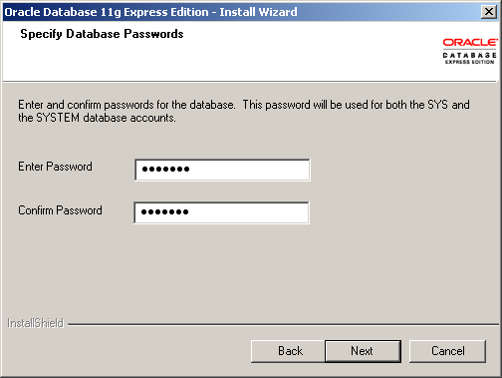
- The sixth dialog box lets you see the configuration options you’ve chosen. Note that this installation is using a TNS port of 1621 rather than the default of 1521. Click the Next button to continue.
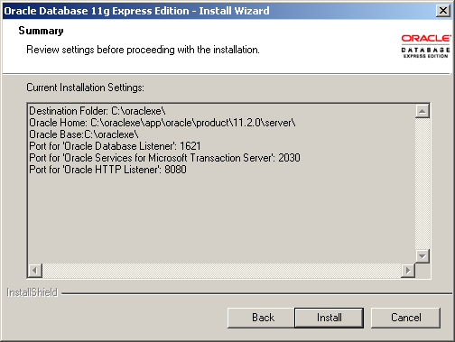
- The seventh dialog box lets you see the progress bar, take a break it can run for two or three minutes. Click the Next button to continue.
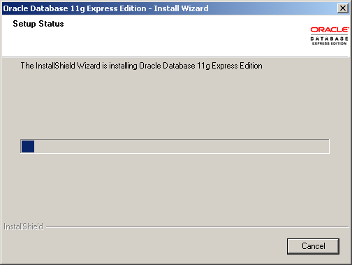
- The last dialog box lets you see that you’ve installed the product. Click the Finish button to complete the installation.
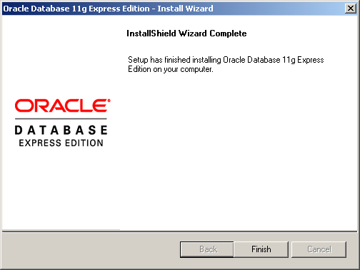
You’ve now installed Oracle Database 11g Express Edition. You can start the command line by typing sqlplus system/password in command shell or the Get Started option in your Program Menus, as shown below.
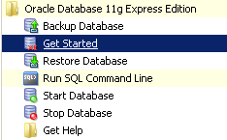
You should see this console when you launch Get Started or manually type http://localhost:8080/apex. There’s more to the web page but I scrunched it to fit into the blog. Alas, space is always at a premium.
