THE “AUSTRIAN ECONOMICS” FREEDOM FLYER
LibertySpeaks.World
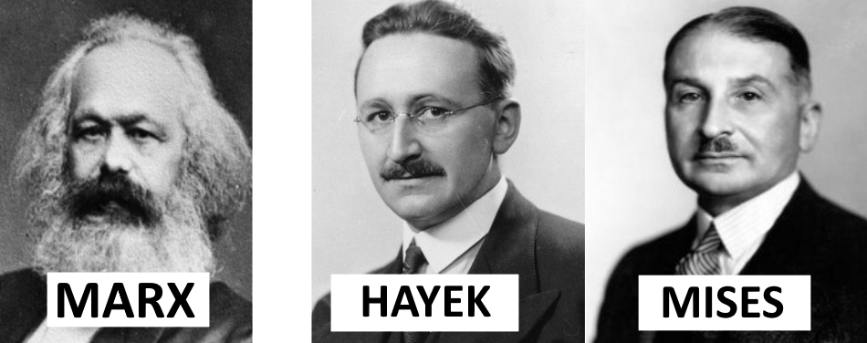
How can mankind today build mindbogglingly complex microchips, airplanes, satellites, the Internet and so much more, yet still not have figured out something as simple as world peace, and with the encouragement of “experts” and “great leaders” always be one spark away from another world-wide tribalistic tyrannical calamity as WWI/II, CovidMania and the Russia-Ukraine war are clearly showing? There is something missing from our understanding of how the world works, something that our “leading intellectuals” and “experts” have yet to discover and spread accordingly. Fortunately for mankind that “something” has already been discovered and explained by a group of little-known and widely misunderstood intellectuals often-times referred to as ‘The Austrian School of Economics’ whose vital contributions we attempt to summarize in this flyer.
CIVILIZATION EMERGES FROM PRIVATE PROPERTY
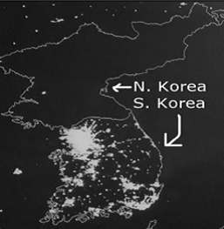
Free people are motivated to discover the best information with which to increase the rate at which they transform or reorder the matter they exclusively control (their private property) to create wealth. Most of us transform our bodies in a manner that maximizes the value of the wealth in terms of labor, services, or products we produce and then trade with companies (employers) or the public. From our freedom to use or transform our private property emerges the ‘freedom to trade’ it with anyone in the entire planet which inadvertently transforms mankind into a global supercomputer where companies are motivated to innovate and learn from each other(competitors) thus inadvertently cooperate to create and spread superior information and subsequent social order. It is our freedom as consumers to trade our life-and-order-sustaining wealth for the best cars with the latest innovations, and as producers to go into the auto-manufacturing business, which motivates existing auto manufacturers(competitors) to innovate-compete-copy-learn to produce the best cars. Just like in the Olympics we can discover the best athletes in the world due to global competition, so does having the ‘freedom to trade’ with everyone in the world allows the best ideas to compete and spread globally thus ensuring the best possible global order. Via advertising, competitors are motivated to spread the potential usefulness and superiority of their products-ideas as well as the defects-inferiority of their competitors thus accelerating the need to compete-copy-spread superior information and subsequent order. As cost-cutting ideas emerge and inevitably spread via competition leading relative prices to continuously fall, new profitable ideas easily arise and once again spread via competition in an endless cycle of knowledge generation-innovation. For example, computers were once very expensive, but once the price of making them came down enough, people easily realized that every home could have them, which gave birth to our computerized world and the Internet and all the great things that flow from it. The more wealth is produced, the more wealth must be offered in exchange for labor as companies compete against each other for the labor they need which helps explain why the economic pie grows for everyone. Morals are ways of acting; they too are knowledge which also emerges and spreads via economic competition to considerable degrees. It is hard-working, tolerant, courteous people who thanks to competition inevitably motivate everyone else to be likewise. As Hayek writes:
“Competition is, after all, always a process in which a small number makes it necessary for larger numbers to do what they do not like, be it to work harder, to change habits, or to devote a degree of attention, continuous application, or regularity to their work which without competition would not be needed.”
As millions of Italians, Britons, Germans and others from all over the world came to America, it was ultimately the competition which grows from ‘private property’ and thus individual liberty which stripped these people of their otherwise nationalistic, ethnocentric, tribalistic “identities” and evolved what came to be seen as the classic American character of wanting to be seen as a reputable and honest businessman or professional who treats everyone with respect and wears a business suit as opposed to older ethnocentric attires. Thus freedom and emerging “competitive knowledge discovery”, as opposed to leading to chaos, is what 1) enables and motivates the discovery and spread of superior information and subsequent social order, 2) civilizes us, 3) protects us from being coerced into doing something we don’t want and thus allows us to live our lives as we wish, 4) and is vital for discovering the truth. Freedom is the ultimate algorithm!
UNDERSTANDING GOVERNMENT AND REGULATIONS
The role of governments and thus coercion should be minimized because governmental or ‘public sector’ bureaucracies, being coercive monopolies which get their life or order-sustaining wealth through taxes and compulsion are immune to the competitive-information-spreading incentives which motivate private sector entities to keep up with the competition in terms of information and hustle. Government plans can’t work if people are free to not go along with or fund them, so they inevitably require compulsion. Refusing to pay a single dollar that goes to the NYC public(monopolistic) school bureaucracy which consumes about $30,000 per year to “educate” a K-12 student is a criminal act. Taxes and all transfers of wealth to the government, besides being an obvious coercive burden to the people that had to sacrifice a part of their lives to earn such wealth and now have less wealth to trade for the things they want, simply destroy the more productive and efficient private sector jobs the taxed-away spending or wealth would have sustained and replaces such productive and efficient jobs for inefficient government(monopoly) ones, or worse, things like militarism and wars. The former Soviet Union had plenty of highly educated scientists and ‘experts’ whose plans required the coercion of millions as still happens in Cuba, but they were thoroughly crushed by free Americans and their ‘competitive knowledge discovery’. The “classic” night-time image below helps explain the difference between competitive-private-free orders and monopolistic-government-coerced orders. Keep your eye on how information arises and spreads via competition and continuously restructures the social order. Government regulations are coercive-competitionless-monopoly information which is not subject to continuous improvement-replacement via competition so they paralyze entire industries slowing down ‘competitive knowledge discovery’, driving up costs (more lawyers-regulators-bureaucrats), and potentially making criminals out of people who harm nobody but just prefer to do things differently. This explains why the increasingly regulated/paralyzed healthcare sector has grown from consuming 5% of the economy in 1960 to over 20% today culminating in the current CovidMania tyranny. By comparison the Software/IT sector has few regulations, there is no American Computer Programmer’s Association monopolizing/paralyzing the knowledge relating to software like the American Medical Association does for medicine so free competition motivates the creation and spread of innovations at breakneck speed.
UNDERSTANDING MONEY
The production of wealth requires the consumption of existing wealth, and money-creation by governments via their central banks obviously does NOT create such wealth. For example, if 1,000 men are to produce a skyscraper, they must consume or use real existing wealth like food, materials, energy, etc. in order to produce it. Government money-creation just allows the government-connected entities that get the newly-created money to consume wealth while leaving the rest of society with less wealth and more money per unit of existing wealth and thus higher prices which eventually cause the original profit-loss calculations of many businessmen to no longer be profitable leading to economic downturns/‘busts’. Due to the higher prices, people's savings and wages will buy them less wealth. How much less? An amount similar to that which the receivers of the government-created money were able to consume. For example, during CovidMania lockdows, just from March to May 2020, the US government created over 3 trillion dollars so that many people could stay home and consume without working/producing leading to prices rising(+20% in real estate and meat, +40% in gasoline…). A gold standard prevents clueless politicians/technocrats from acquiring wealth by just creating the money to trade for it. It forces them to tax the gold directly from citizens thus preventing unlimited taxation and government growth which is enabled by money-creation.
CULTURAL EVOLUTION AND LEARING FROM HISTORY
Knowing that 'private property' is the simple tradition from which emerges a chain-reaction of incentives which creates civilization, we can look at the past and easily see that those cultures whose customs inadvertently became more peaceful and thus less violent, extended peace, friendship, trade to those outside the tribe, etc., in other words, respected ‘private property’ and thus individual liberty more and more, would inadvertently gain the benefits of superior ‘competitive knowledge discovery’, become more advanced-powerful, and as they grew, they would inadvertently spread the very customs and evolving economic system (capitalism) that allowed them to reach such relative heights. This ‘cultural evolution’ happened mostly without the design, intention, or the “reason” of the slightly smarter apes. A great example of this process was the ‘Protestant Reformation’. For centuries the Catholic Church’s traditions-myths held immense coercive-monopoly-competitionless power which prevented or retarded individual freedom and resulting ‘competitive knowledge discovery’. In the early 1500s, among other religious reinterpretations, Martin Luther preached that indulgences (payments to the Catholic Church to help one go to heaven) were unnecessary, that a person could go to heaven by believing in Christ without the Catholic Church’s approval, and that the Bible itself, not the Church’s edicts-interpretations was what mattered. This helped reduce the coercive-monopoly power of the Catholic Church and spark a pro-freedom and thus emergent ‘competitive knowledge discovery’ that would lead to skyrocketing rates of innovation-production-prosperity in Europe-Christendom. Now, very important! Did Martin Luther “reason” that his religious reinterpretations would accelerate ‘competitive knowledge discovery’ leading to global Capitalism and Homo sapiens’ recent sky-rocketing prosperity? Of course not! Just like solitary cells millions of years ago inadvertently created the respiratory-circulatory-nervous-etc. “systems” that led to multicellular organisms without ‘designing them’, so is the free-market/Capitalism “indeed the result of human action, but not the execution of any human design” (Adam Ferguson) or as Carl Menger writes, it arose “as the unintended product of historical development” Hayek elaborates:
“We have never designed our economic system. We were not intelligent enough for that. We have stumbled into it and it has carried us to unforeseen heights and given rise to ambitions which may yet lead us to destroy it.”
By the late 1800s, the bewildering complexity of modern cities coupled with, per above, man not having the slightest clue how the ‘competitive knowledge discovery’ that creates civilization “emerges” from “private property” and thus personal liberty since this amazing mechanism had been designed, not by clever men, but by an evolutionary process we didn’t even really understand at the time, the apes understandably fell for all the usual anti-Capitalist, pro-Socialist-Nationalist central planning-tribal fallacies which still dominate popular thinking to this day. The environment was ripe for the emergence of a new religion-mythology-Priesthood, Socialism-Communism-Statism-Scientism. Eventually a slightly smarter ape would describe these fallacies-myths in a manner that was bound to go viral and that is what happened with Karl Marx and his bite-sized ‘Communist Manifesto’:
“the theory of the Communists may be summed up in the single sentence: Abolition of private property”… “Abolition of the family!”
The apes via Lenin’s Bolshevik revolution in Russia (1918) and other ‘Great Leaders’ throughout the world (Mao-China, Castro-Cuba, Pol Pot-Cambodia, Roosevelt-USA), created massive central-planning-coercive bureaucracies that paralyzed or destroyed ‘competitive knowledge discovery’ and thus their own socioeconomic order that was sustained by it. It is vitally important that we see our socioeconomic chaos not as conspiracies by nefarious “elites”, nor “bad politicians”, or stupidity, but as an almost inevitable spread of viral self-reinforcing ‘echo chambers’ of economic fallacies spread by clueless “well-meaning scholars” and disastrous ‘incentive structures’ that inadvertently cause the apes to self-destroy via central planning and run-away government growth enabled by central-bank money-creation. As F.A. Hayek tells us:
“It is necessary to realize that the sources of many of the most harmful agents in this world are often not evil men but high-minded idealists[Gates/Trudeau/Schwab], and that in particular the foundations of totalitarian barbarism have been laid by honourable and well-meaning scholars who never recognized the offspring they produced.” ...
“Most people are still unwilling to face the most alarming lesson of modern history: that the greatest crimes of our time have been committed by governments that had the enthusiastic support of millions of people who were guided by moral impulses. It is simply not true that Hitler or Mussolini, Lenin or Stalin, appealed only to the worst instincts of their people: they also appealed to some of the feelings which also dominate contemporary democracies.”
Miraculously for mankind Mises nearly single-handedly stopped Socialist intellectual expansion when he showed the impossibility of central planning via his essay “Economic Calculation in the Socialist Commonwealth” and also persuaded Austrian politicians away from Communism in 1919:
“I knew what was at stake. Bolshevism would lead Vienna to starvation and terror within a few days. Plundering hordes would take to the streets and a second blood bath would destroy what was left of Viennese culture.”.. “The most important task I undertook…was the forestalling of a Bolshevist takeover… The fact that events did not lead to such a regime in Vienna was my success and mine alone.” –Mises (Memoirs)
Later in 1944, Hayek would publish "The Road to Serfdom" which would be read by millions and inspire future champions of Capitalism like British PM Margaret Thatcher and 3x US Pres. Candidate Ron Paul. Mises:
“The issues of society’s economic organization are every citizen’s business. To master them…is the duty of everyone”
“forgive them, for they do not know what they are doing” Christ

